Experiment 7: A. INSTALLATION OF DOCKER, MINIKUBE, ACCOUNT IN DOCKERHUB B. DOCKER CLI COMMANDS

C. MODIFYAND PUSH DOCKER IMAGE D. CREATE AND PUSH DOCKER FILE IMAGE

E. RUNNING MULTIPLE CONTAINERS USING DOCKER COMPOSE

F. DEPLOYING AND SCALING APPLICATIONS USING MINIKUBE

G. DEPLOYING AND MANAGING MONITORING SYSTEMS USING NAGIOS IN DOCKER

Docker desktop

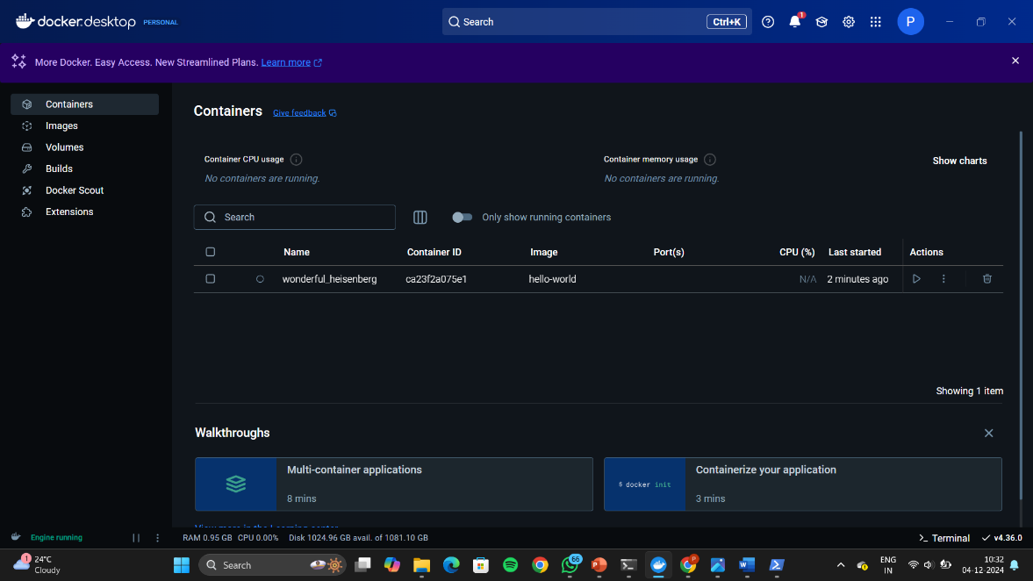

Setting Up Docker

Step 1: Choose the Right Terminal

Step 2: Verify Docker Installation

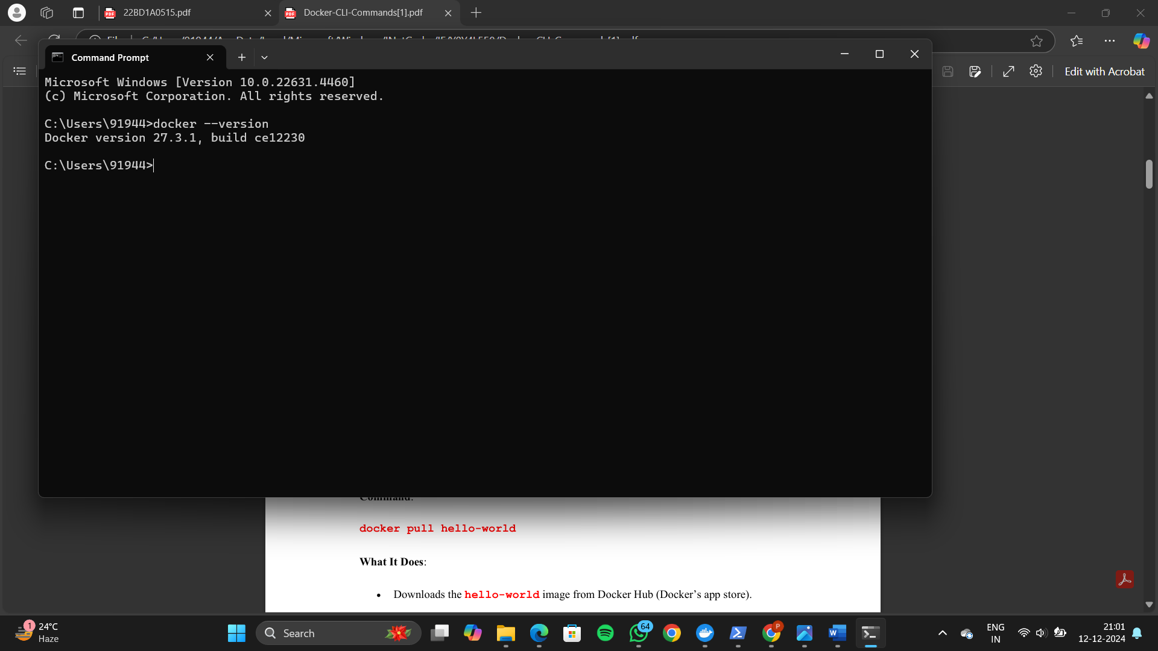

Docker CLI Commands with hello-world

Step 1: Pull the hello-world Image -- Command: docker pull hello-world

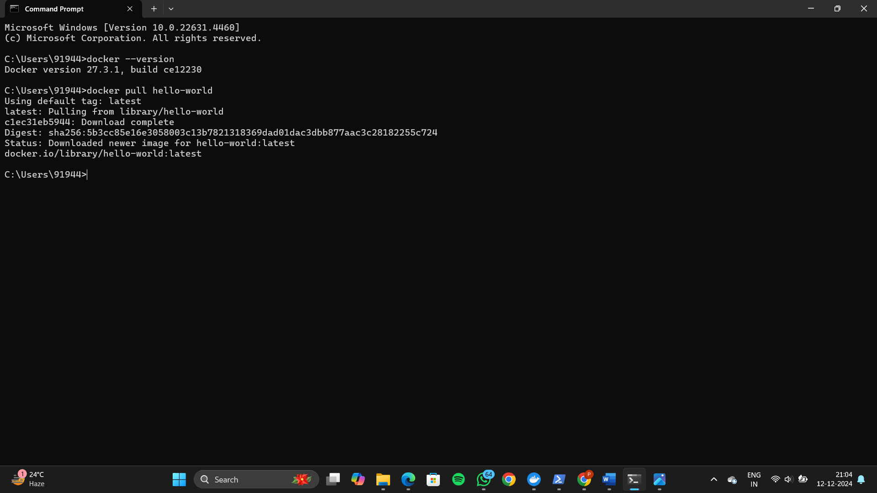

Step 2: Run the hello-world Image – Command : docker run hello-world

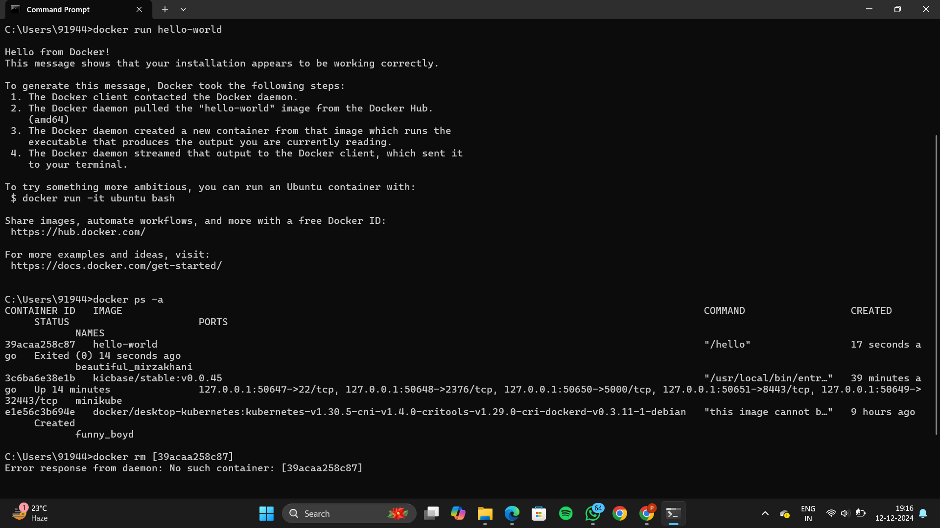

Step 3: View All Containers -- Command : docker ps -a



Step 4: Remove the hello-world Container -- Command : docker rm [container-id]

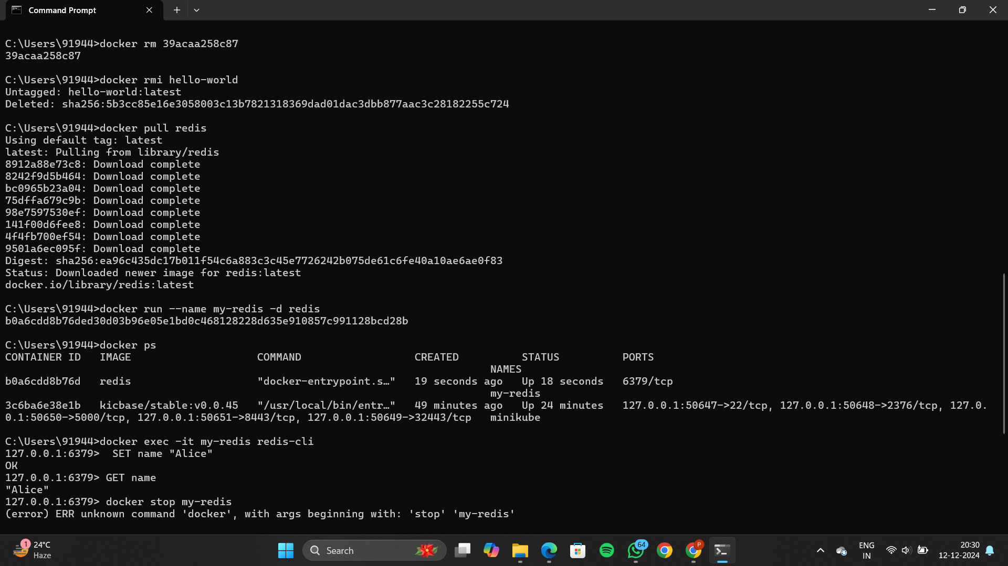

Step 5: Remove the hello-world Image -- Command: docker rmi hello-world



Docker CLI Commands with redis

Step 1: Pull the redis Image -- Command: docker pull redis



Step 2: Run a Redis Container -- Command: docker run --name my-redis -d redis

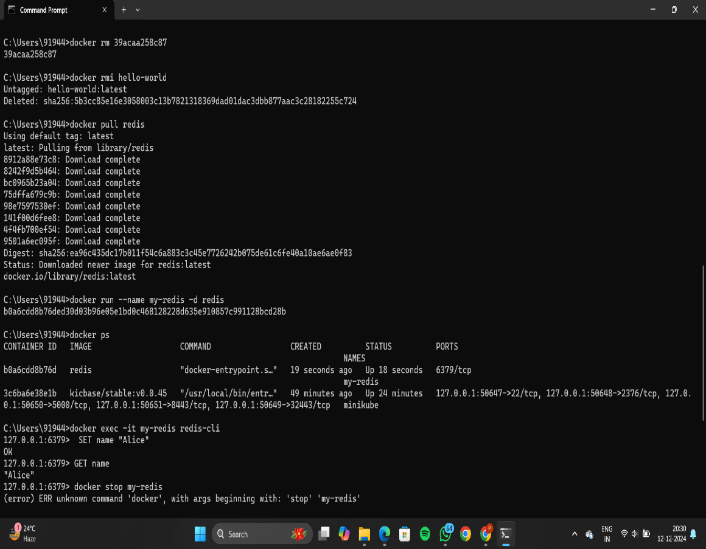

Step 3: Check Running Containers -- Command: docker ps



Step 4: Access Redis -- Command: docker exec -it my-redis redis-cli

Or winpty docker exec -it myredis redis-cli



Step 5: Stop the Redis Container -- Command: docker stop my-redis

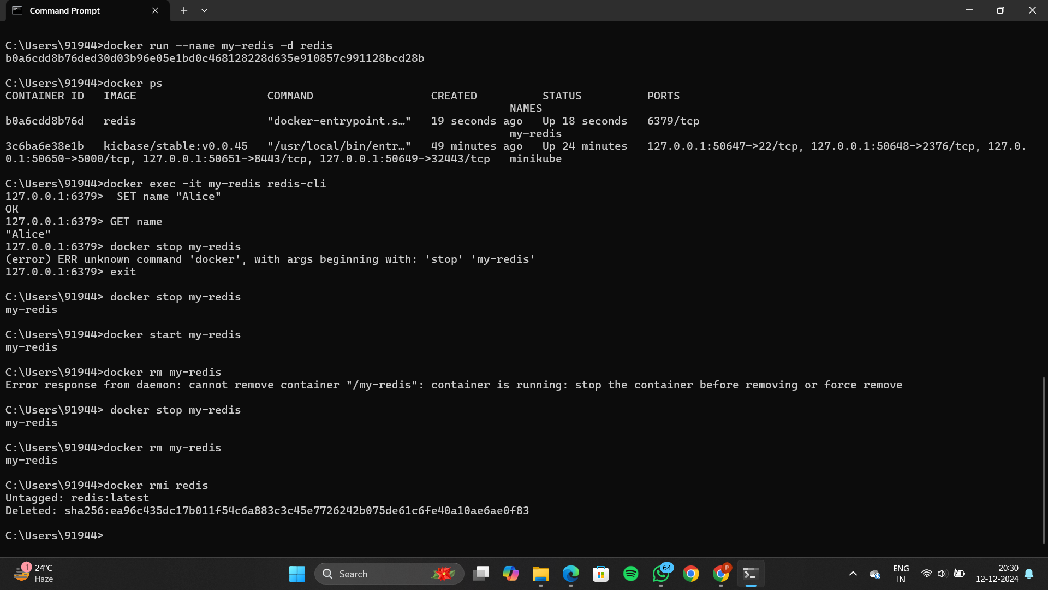

Step 6: Restart the Redis Container -- Command: docker start my-redis



Step 7: Remove the Redis Container -- Command: docker rm my-redis



Step 8: Remove the Redis Image -- Command: docker rmi redis



Using a Dockerfile

Step 1: Set Up Your Folder

Create a folder like C:\DockerProjects\Redis.

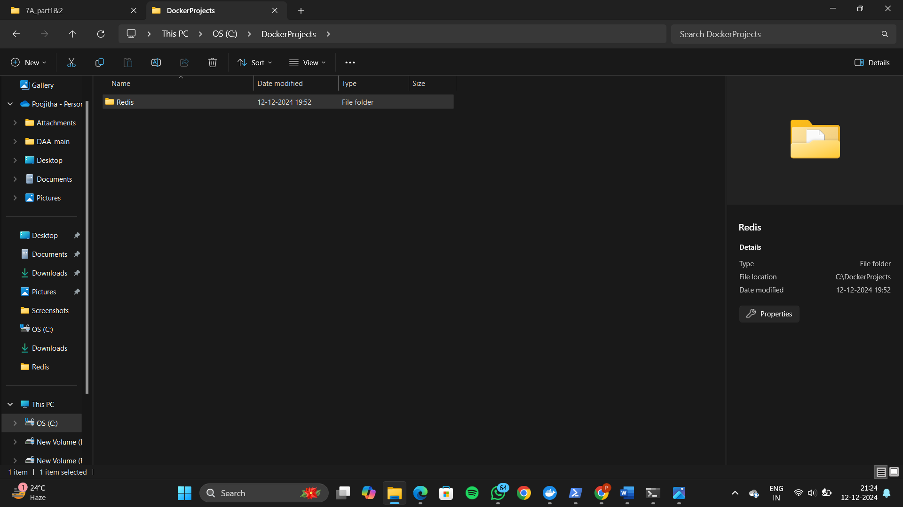

Step 2: Write the Dockerfile

1. Inside the folder, create a file named Dockerfile (no extension).

2. Add the following content:

FROM redis:latest

CMD ["redis-server"]

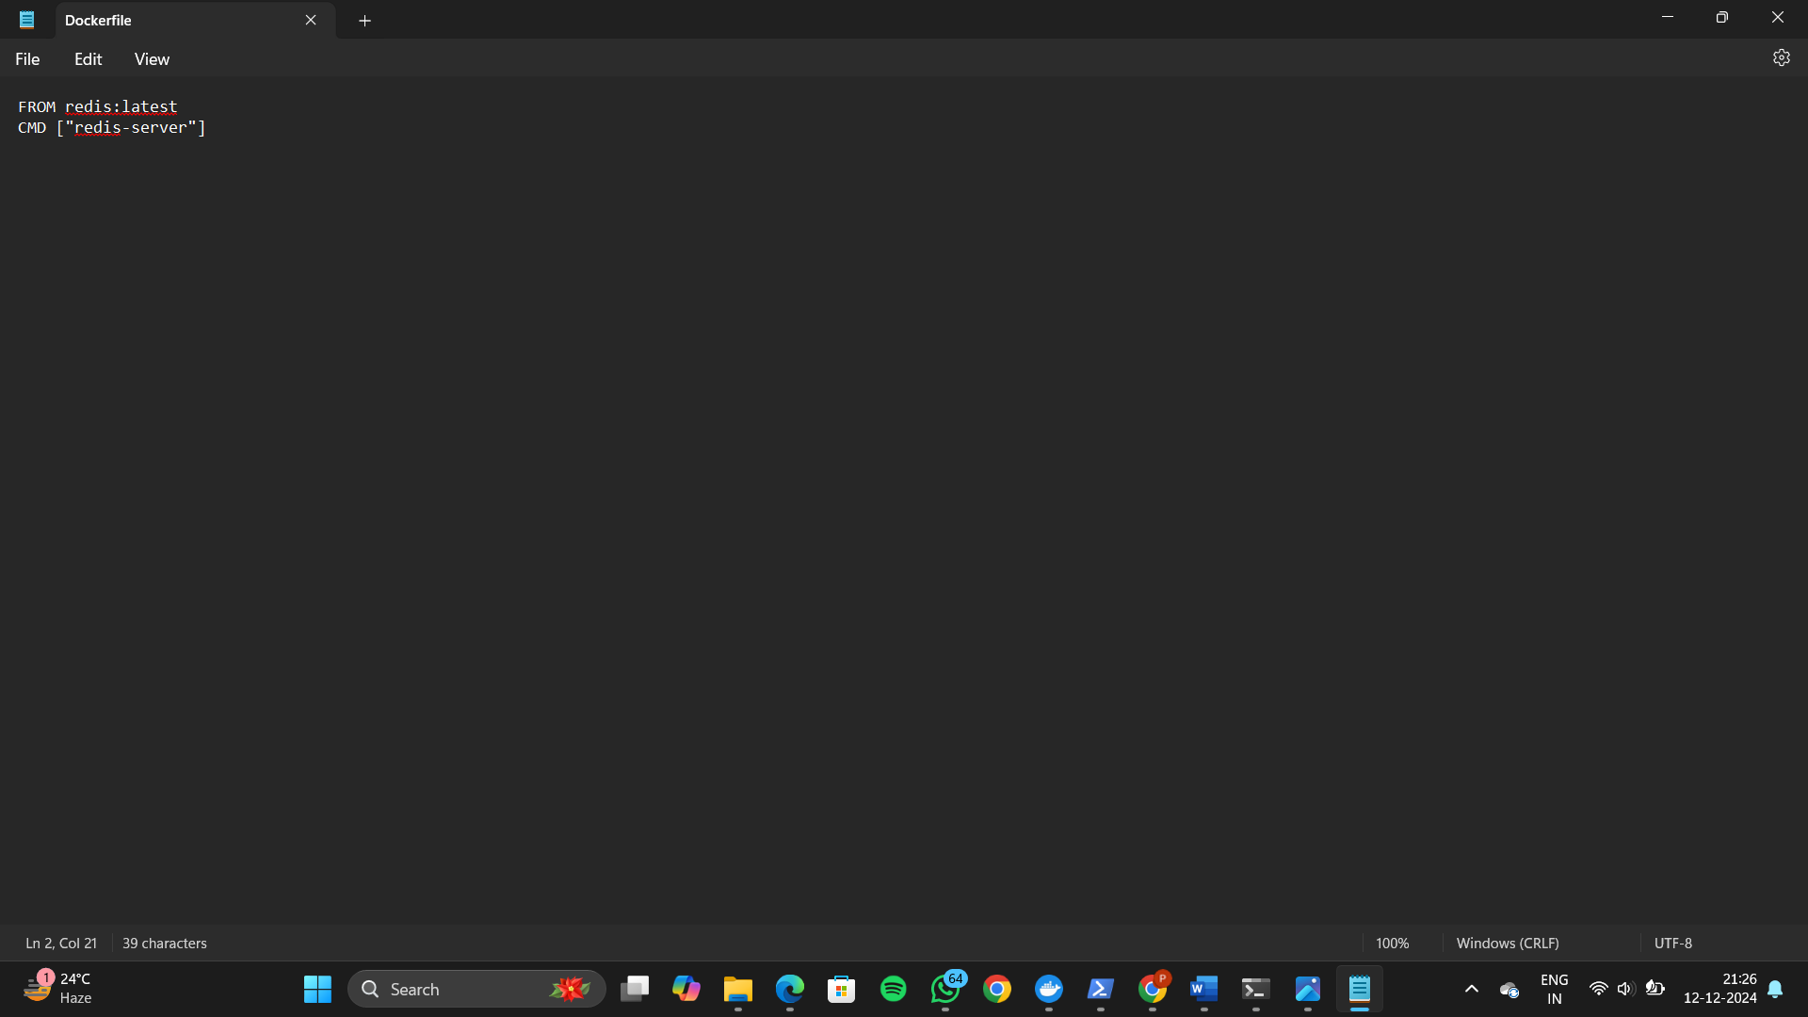

Open powershell as administrator

Open the file location

Docker build

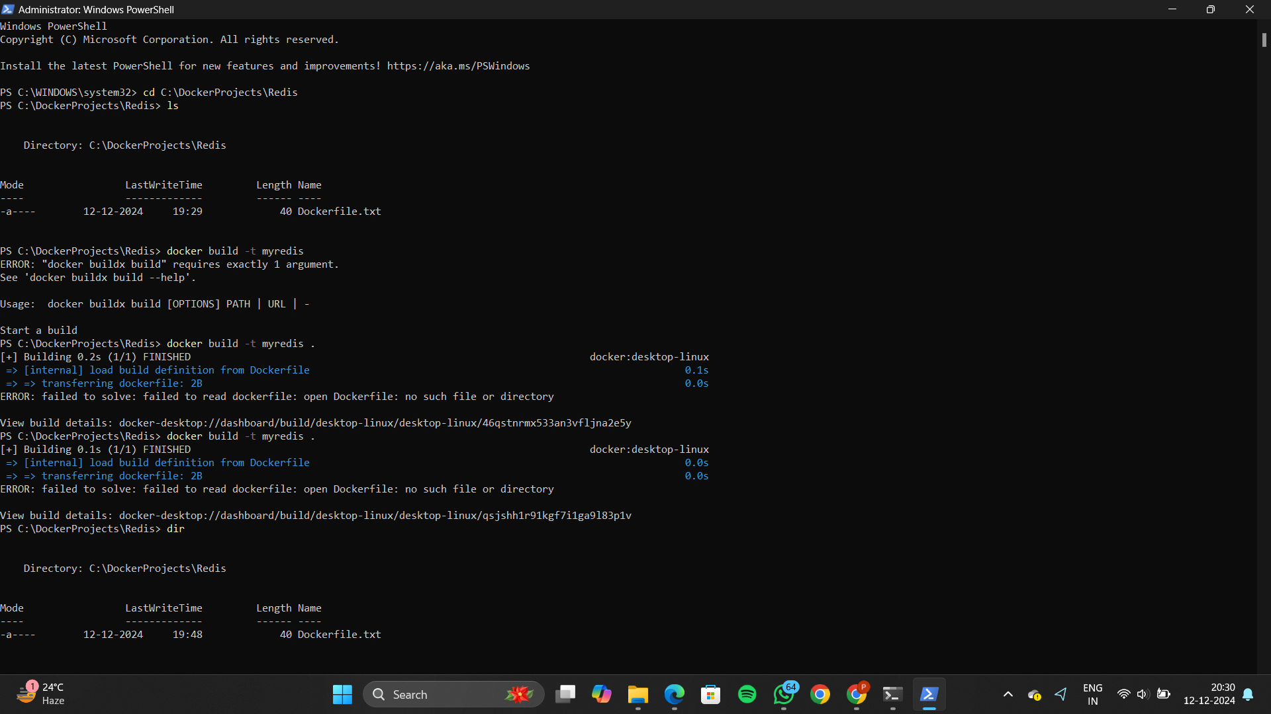

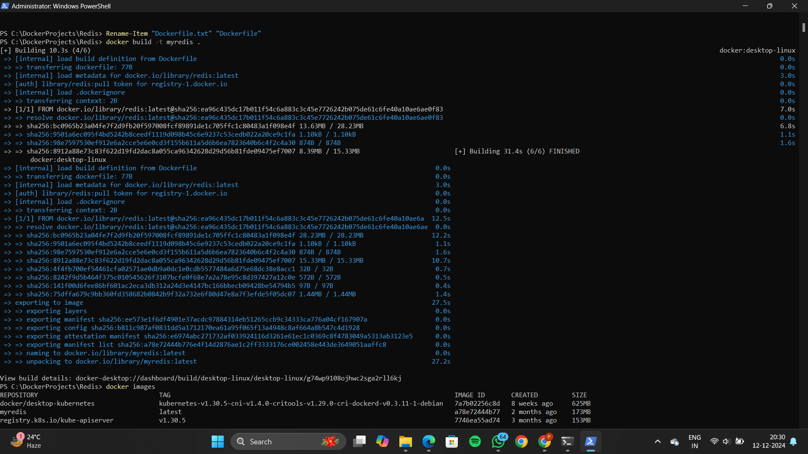

Docker images

Docker run

Docker ps

Docker stop

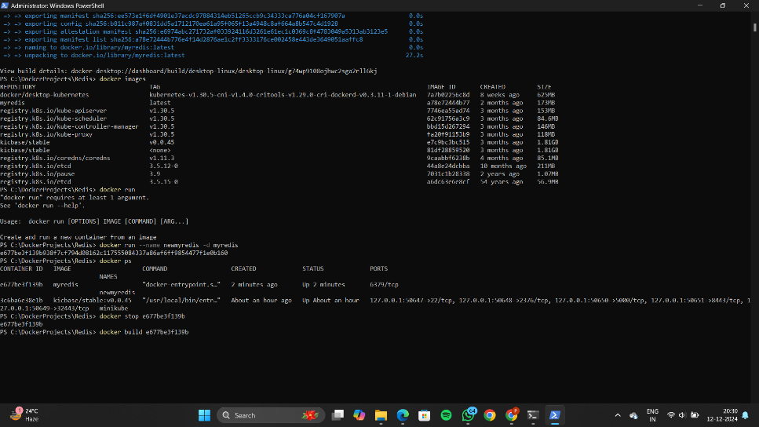

Docker commit

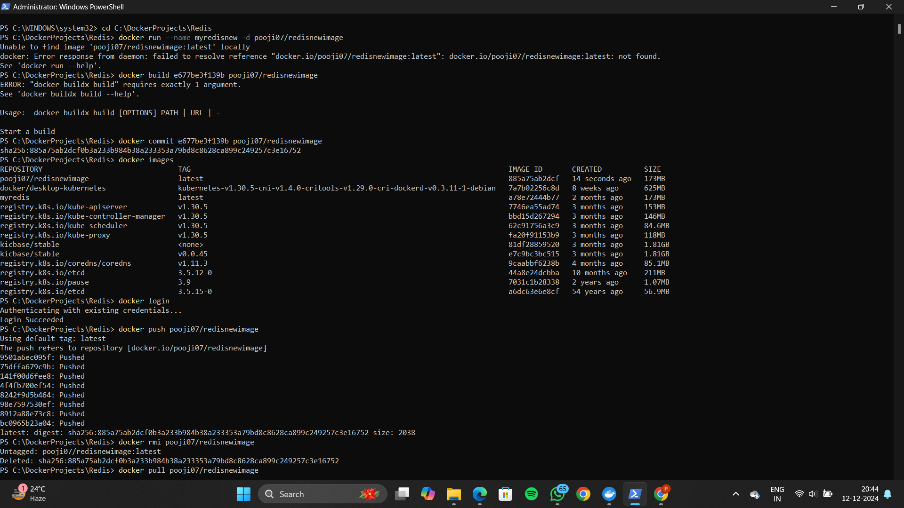

Docker images



Docker login

Docker push



Docker desktop local images

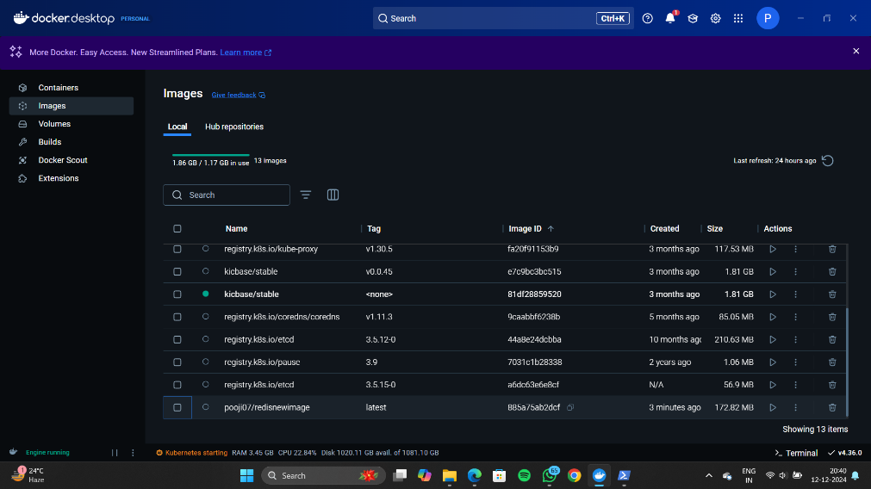

Docker image in docker hub repository

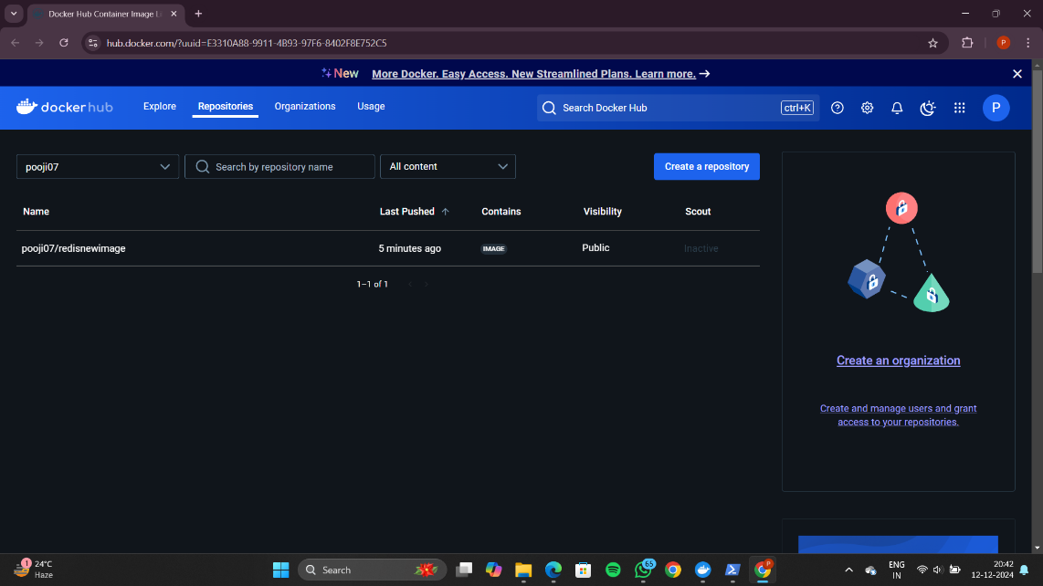

Docker remove container and image

Pull the image to docker

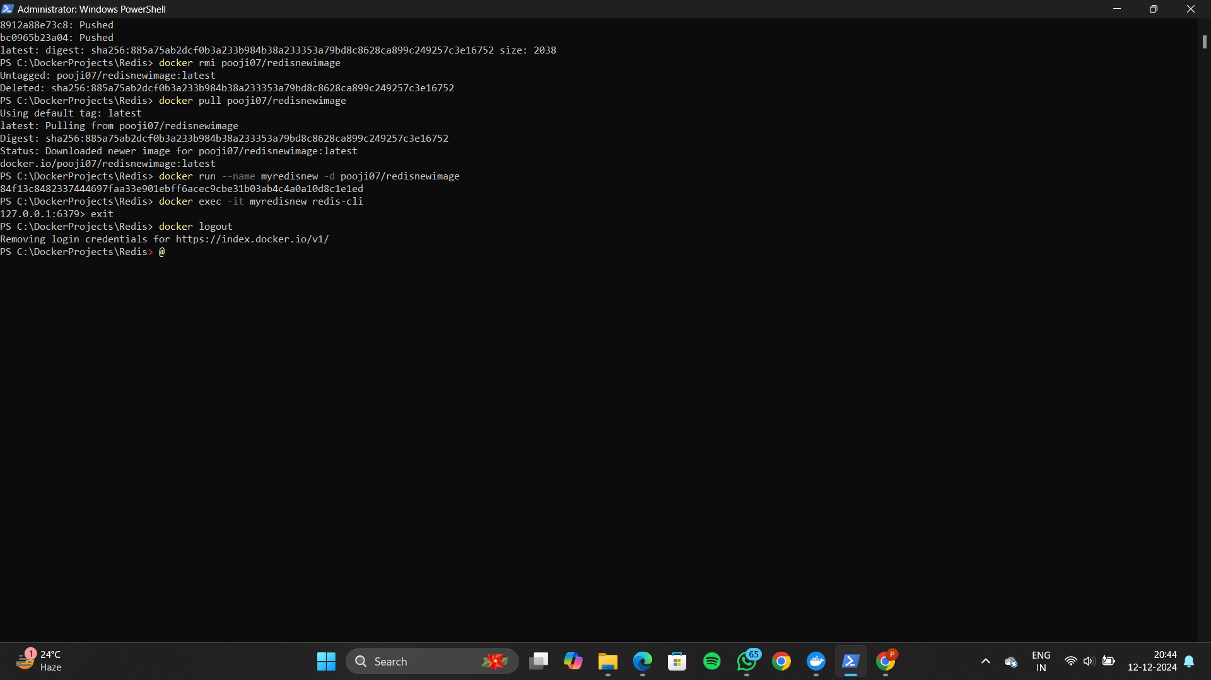

Docker run and exec

Docker logout



Docker pull ubuntu

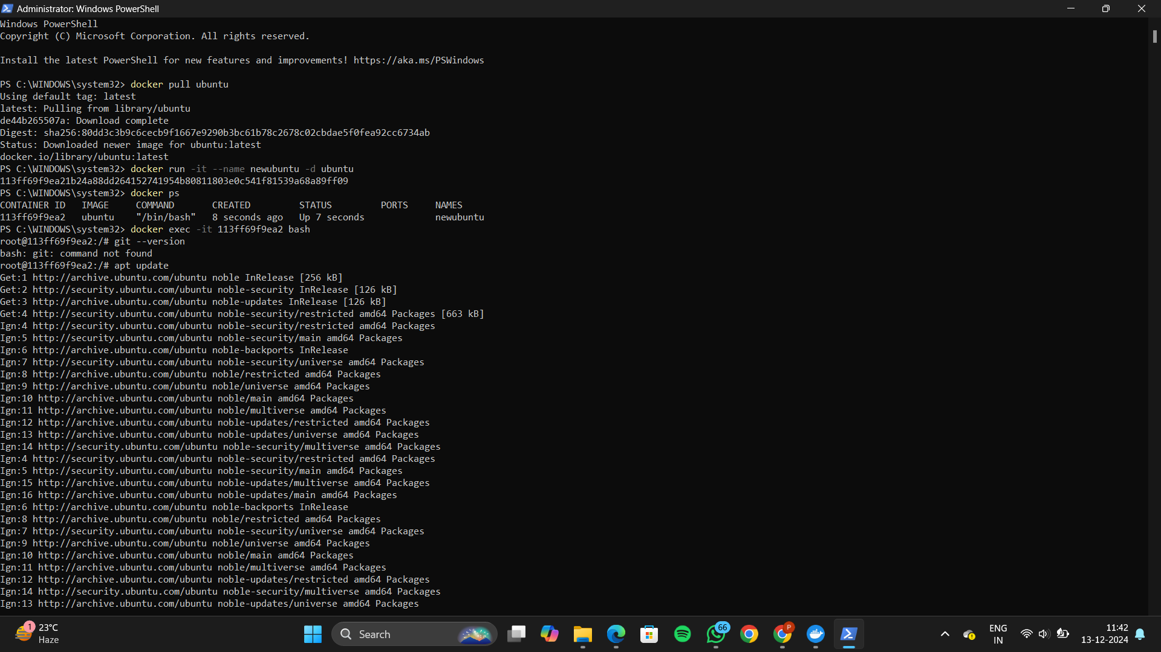

Docker exec

Checking if git is installed



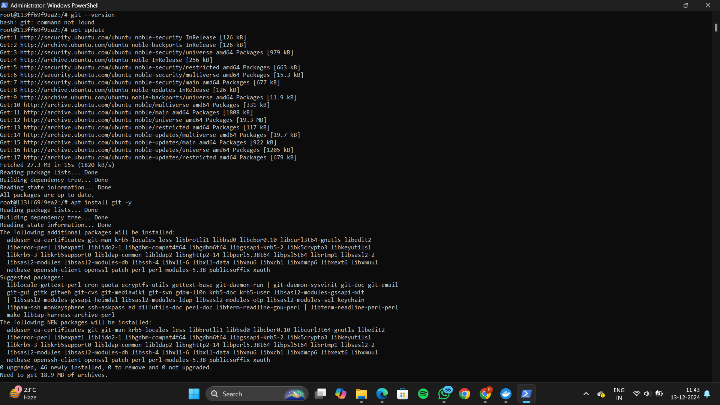

Installing git



Checking git version after installation

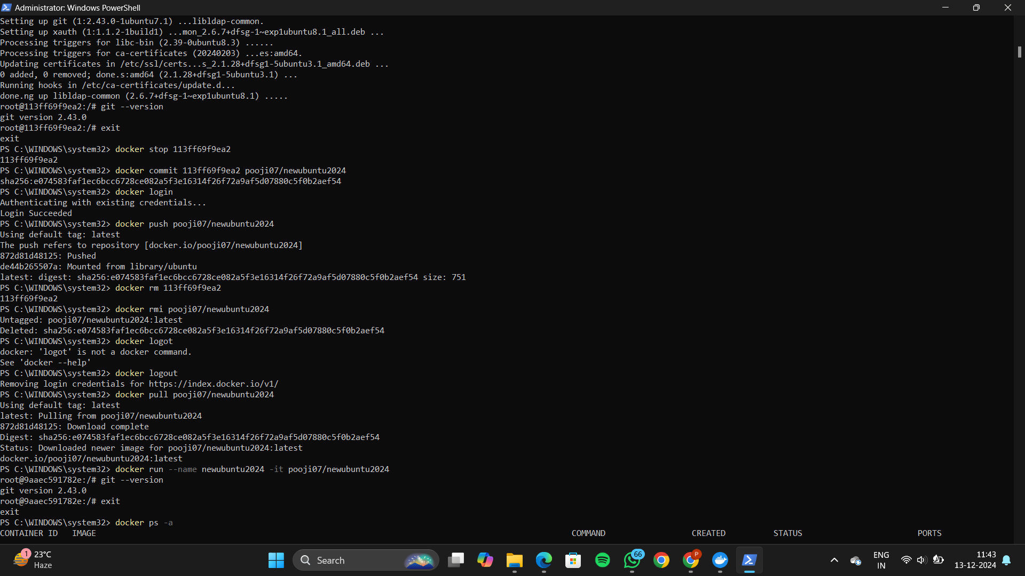

Docker stop

Committing the changes made



Checking Docker desktop to see if the changes are reflected

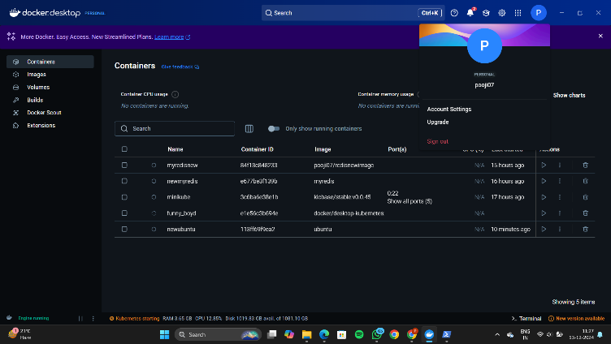

Docker login



Docker push



Checking docker hub to see if the changes are reflected

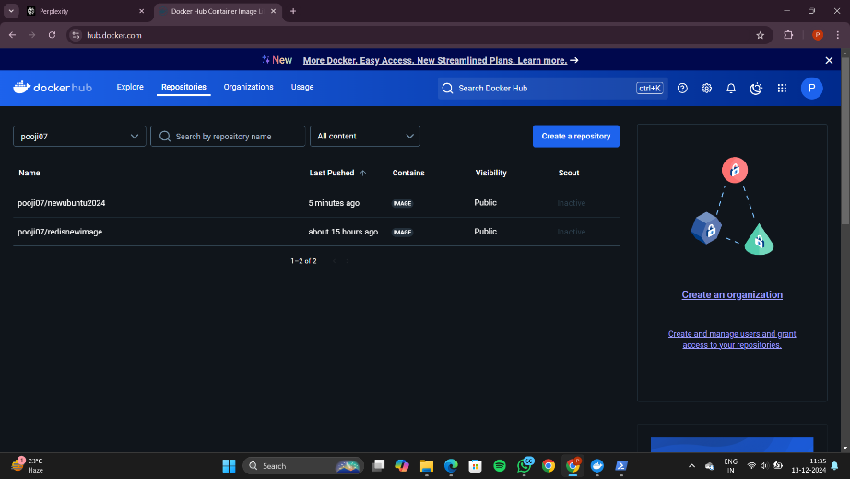

Docker rm

Docker rmi



Logging out

Docker pull



Checking Docker desktop

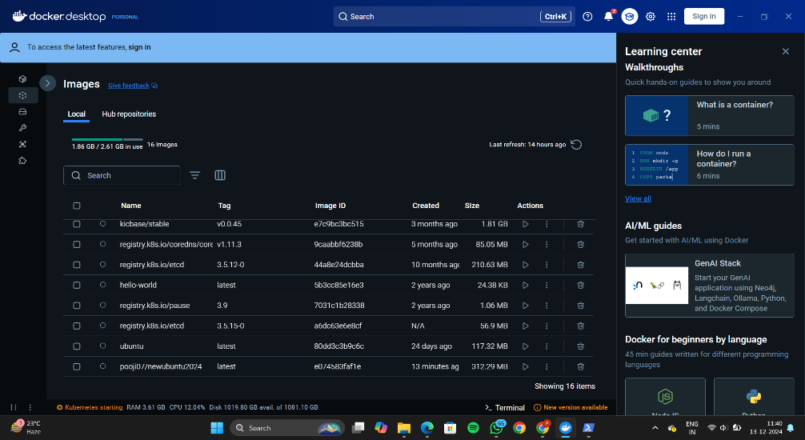

Docker run

Checking git version

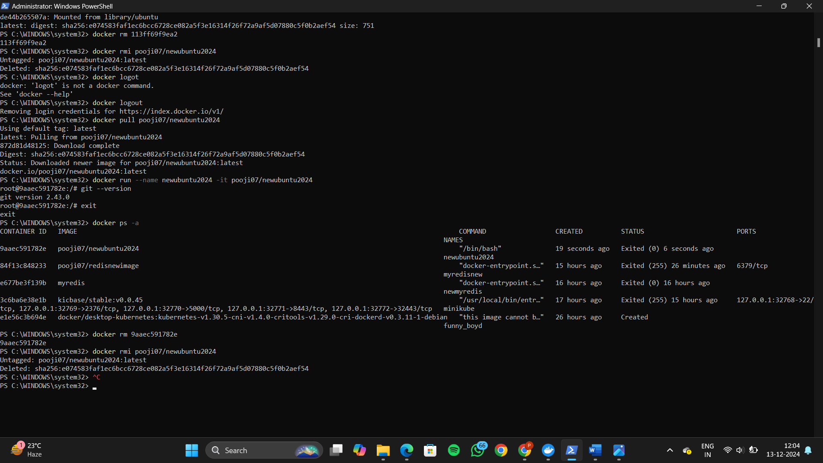

Docker rm

Docker rmi

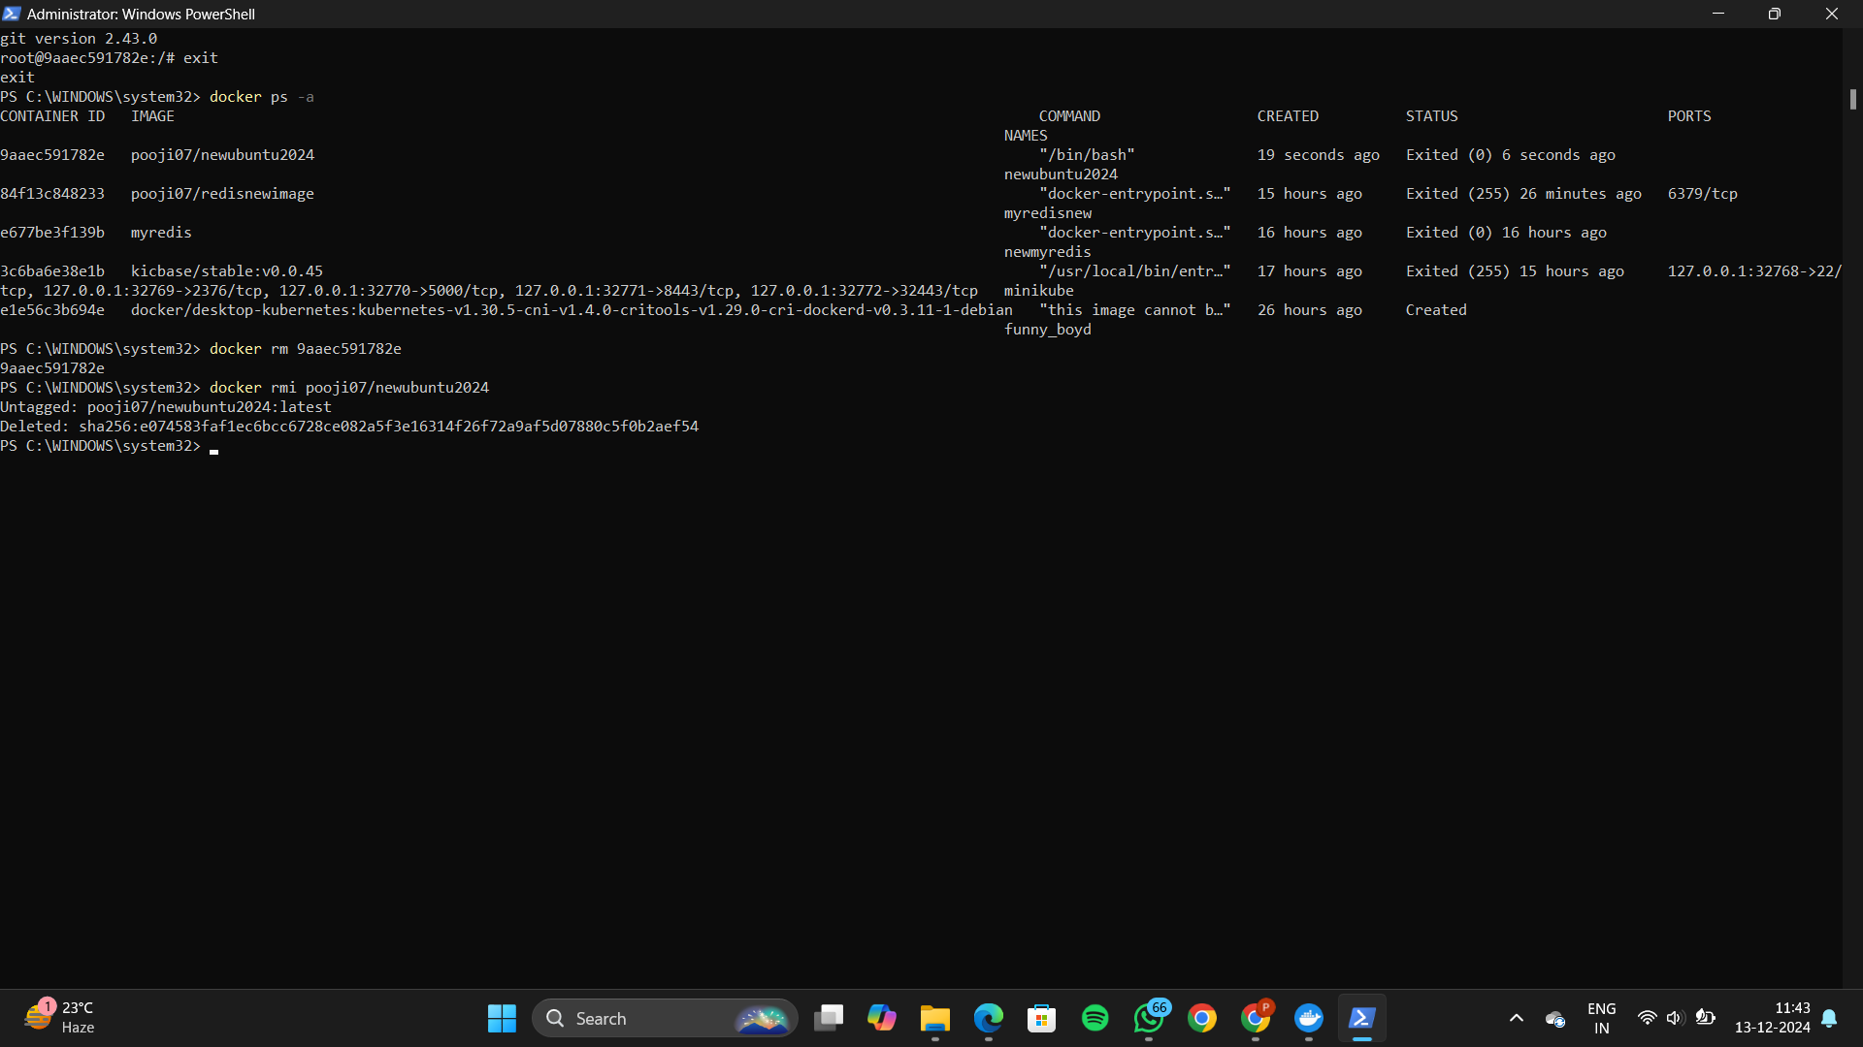

**Docker Compose**

Create a compose folder

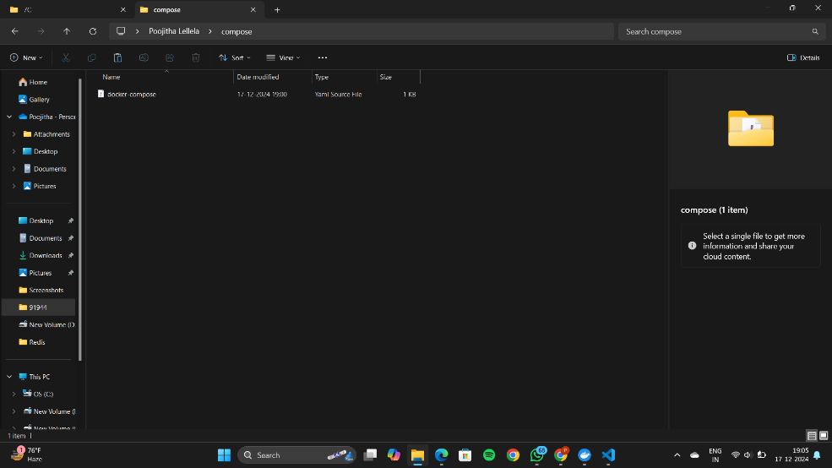

Docker compose yaml file

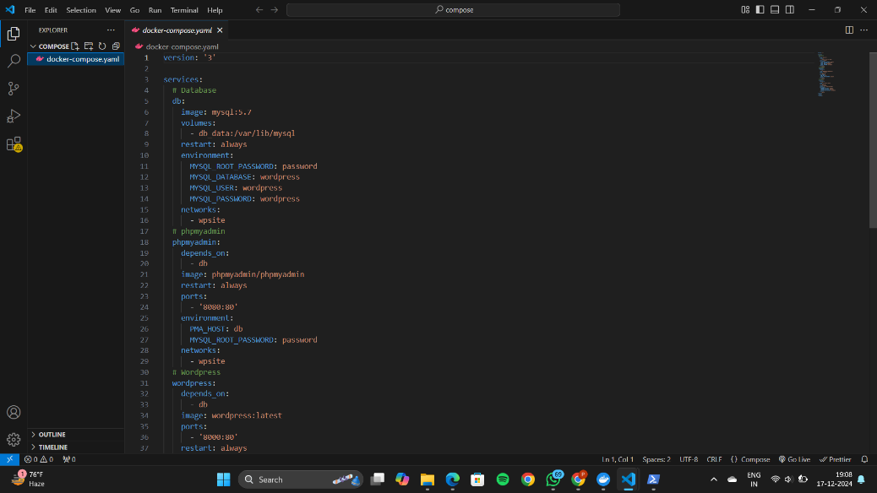

Docker-compose up -d

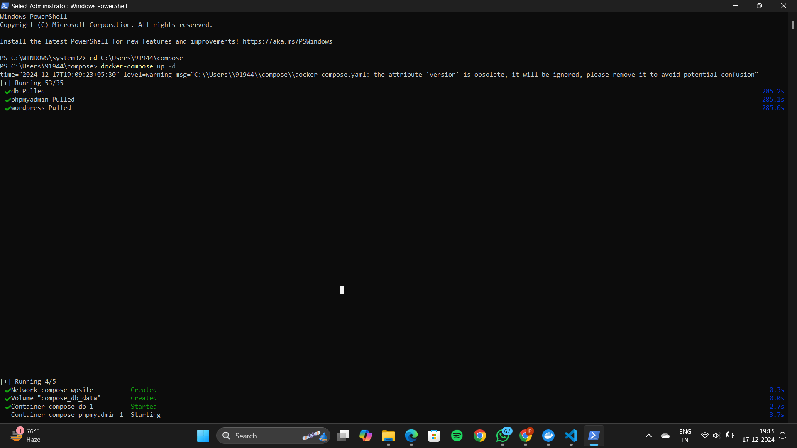

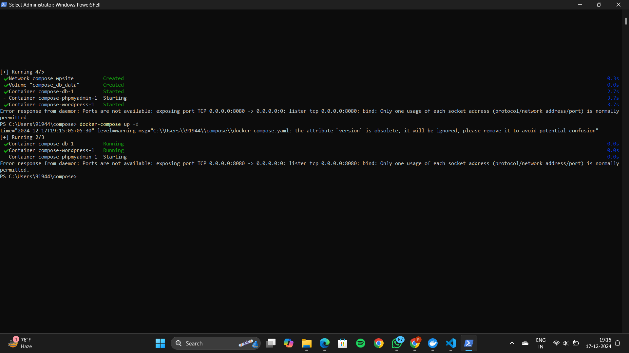

Local host 8000

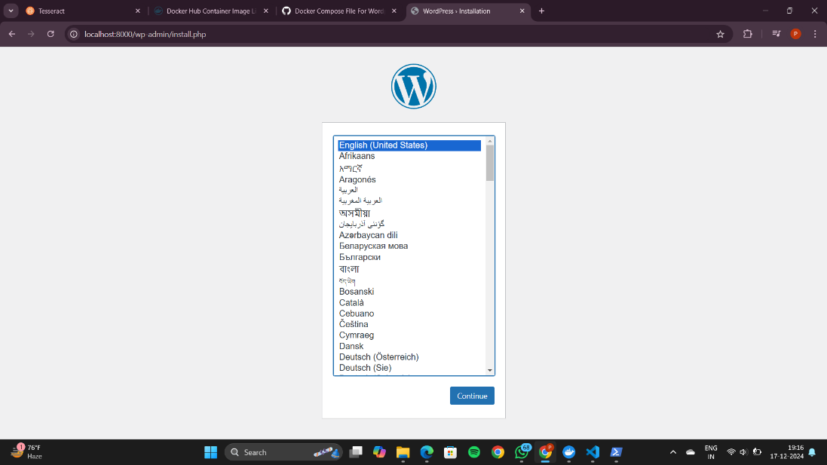

Create word press account

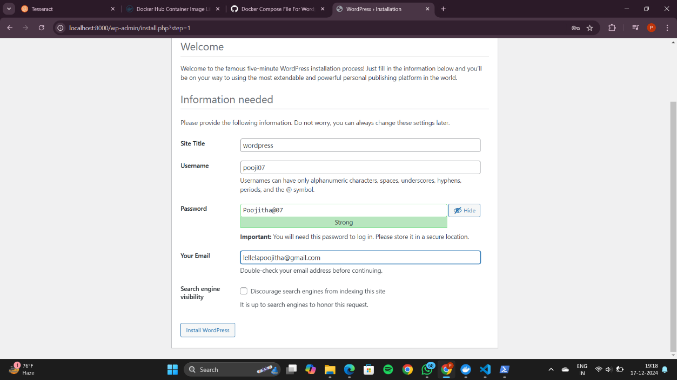

Log into word press

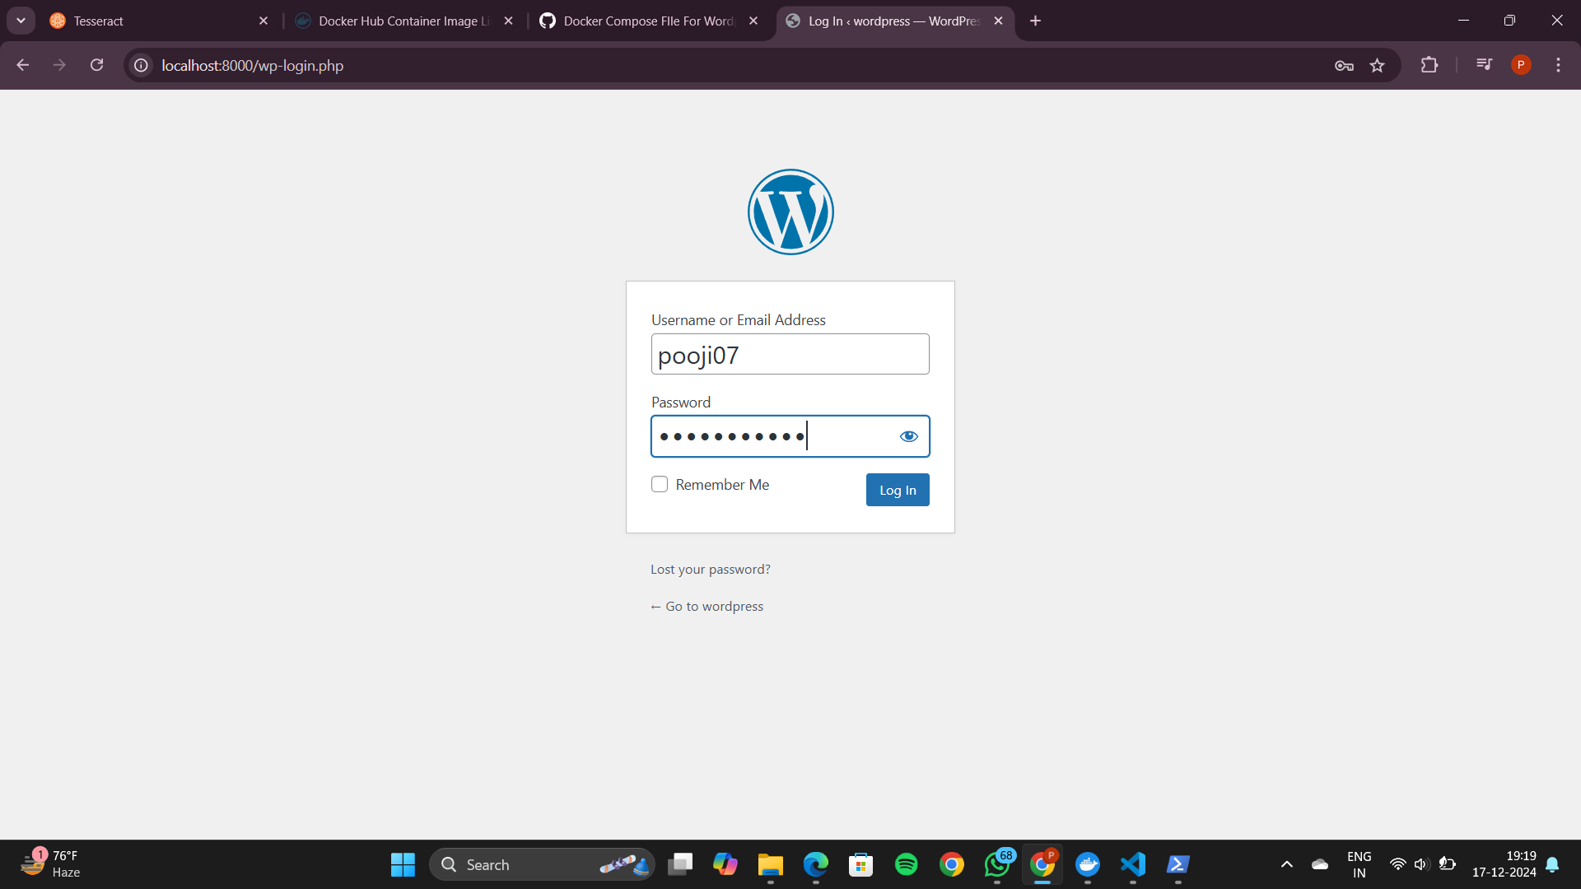

Word press dashboard

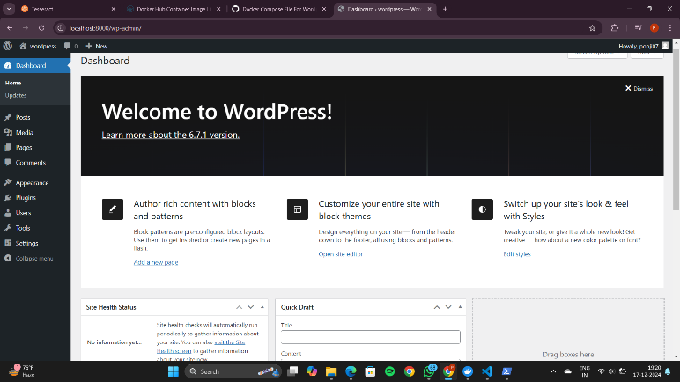

Docker-compose stop

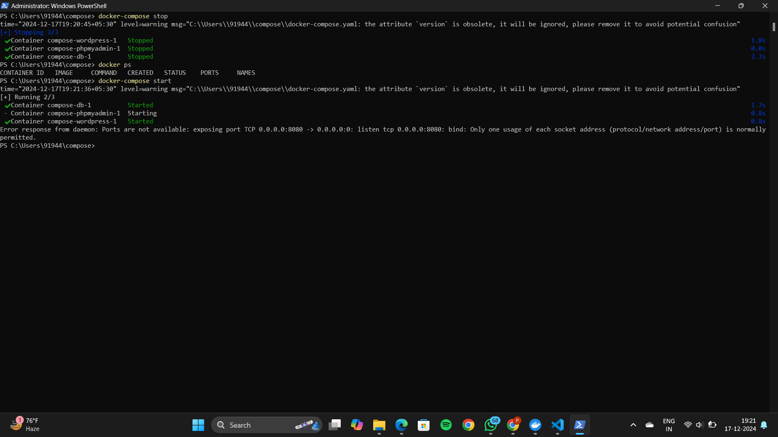

localhost:8000

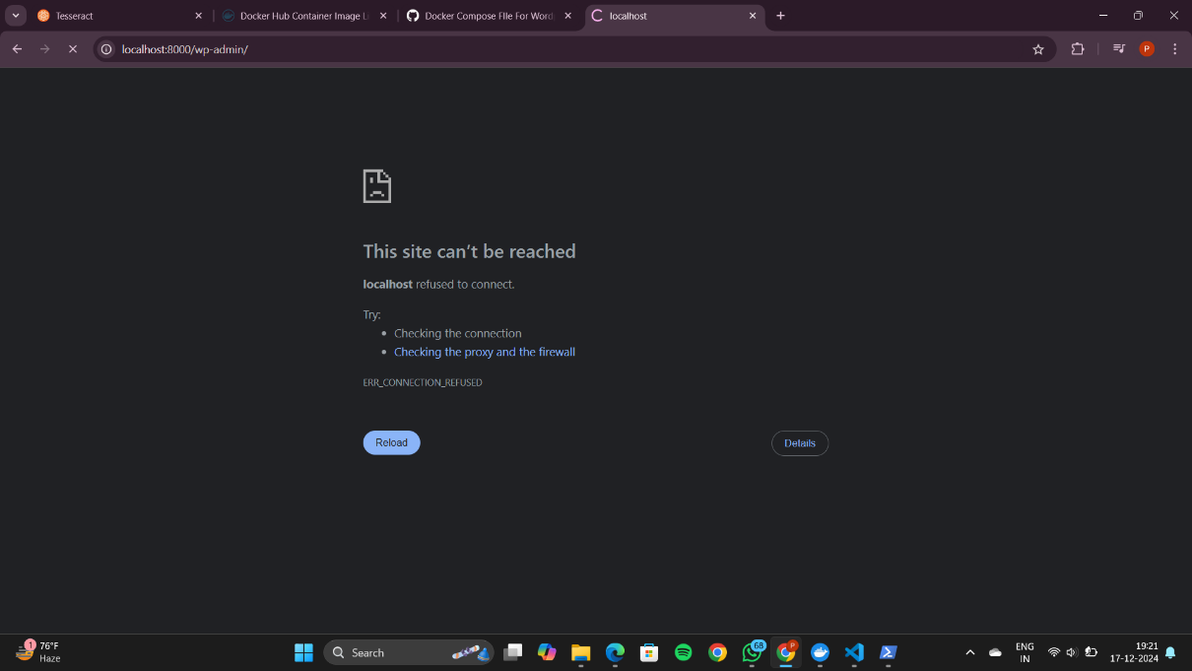

Docker-compose start

Docker-compose down

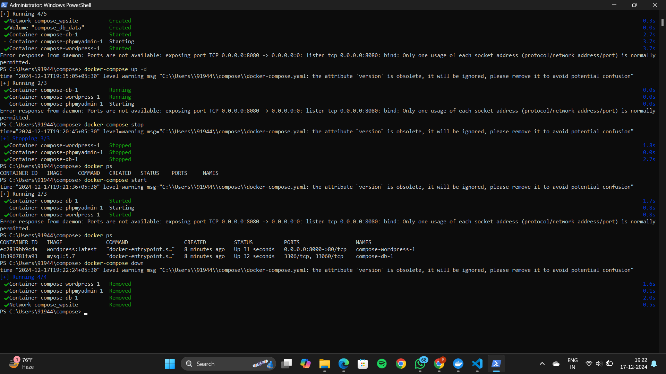

Deploying and scaling applications using minikube

1.Setting up minikube and Kubernetes

Minikube start

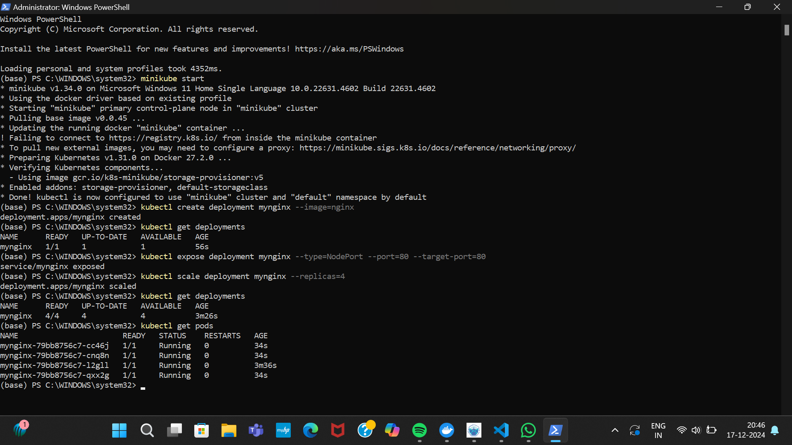

2.create and management deployment

Kubectl create deployment mynginx –image=nginx



Kubectl get deployments



Expose the niginx deployment to outside world

Kubectl expose deployment mynginx –type=NodePort –port=80 –target -port =80

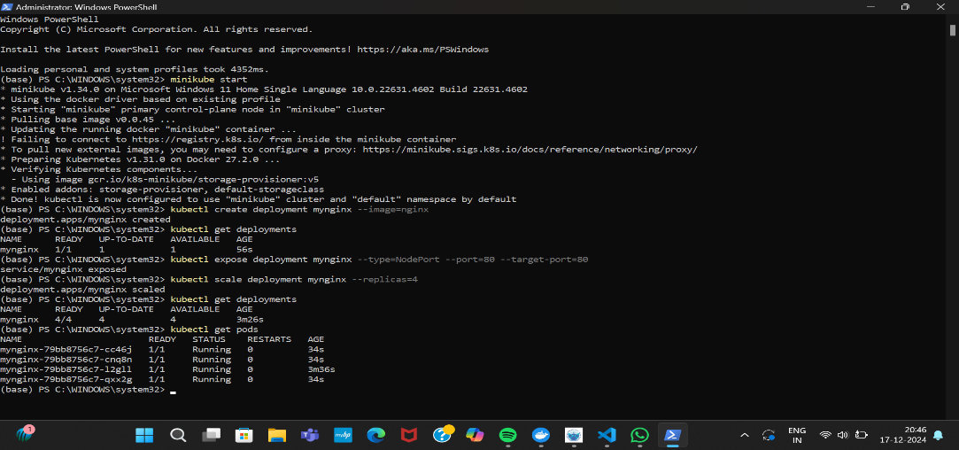

Kubectl scale deployment mynginx –replicas=4



3. accessing nginx app

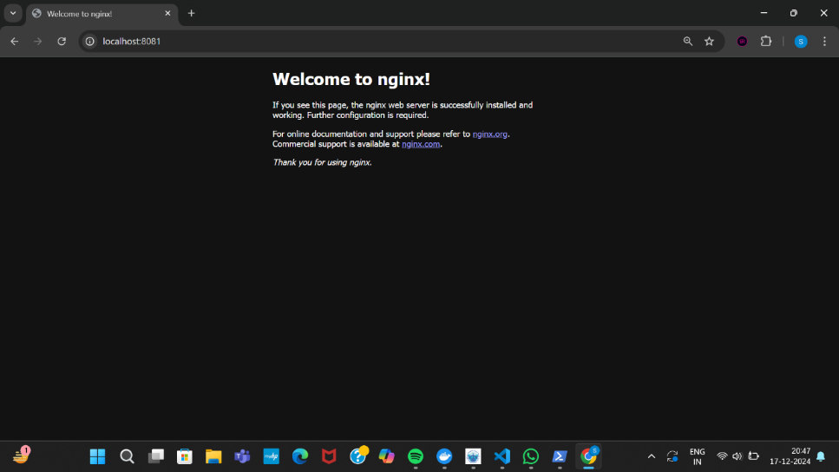

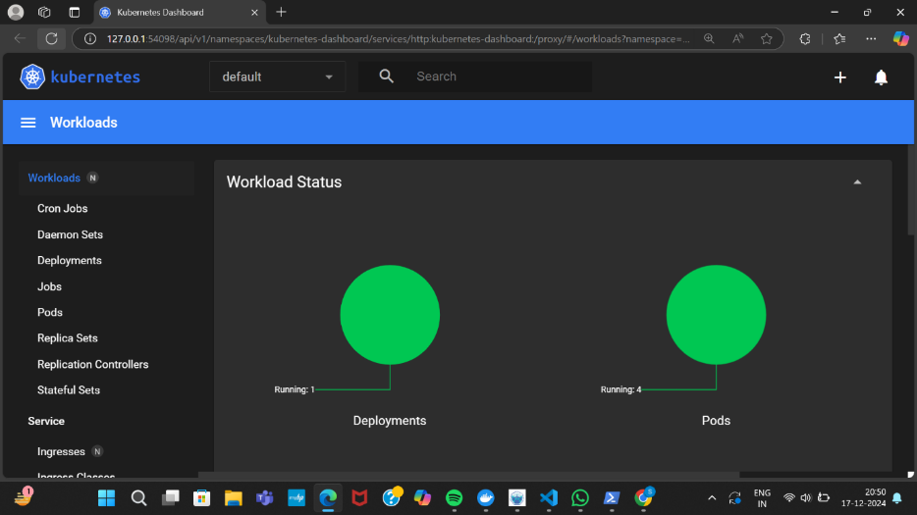

4. stopping and cleaning up everything

Kubectl delete deployment mynginx

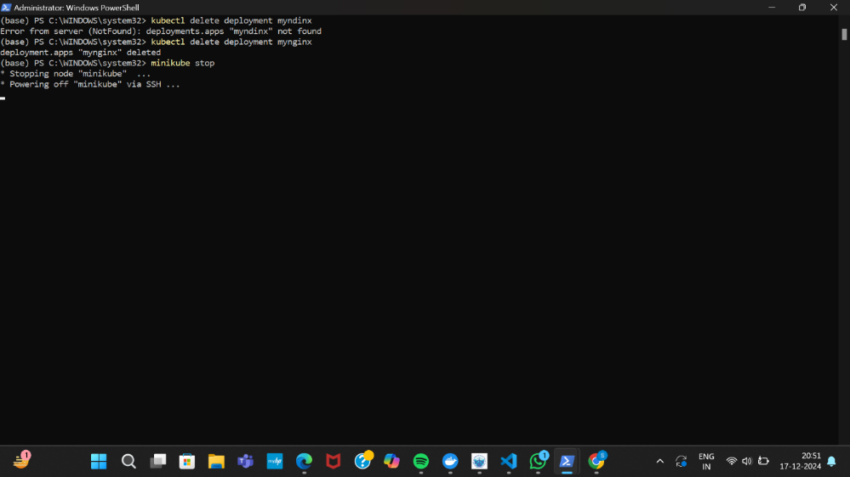

Minikube stop

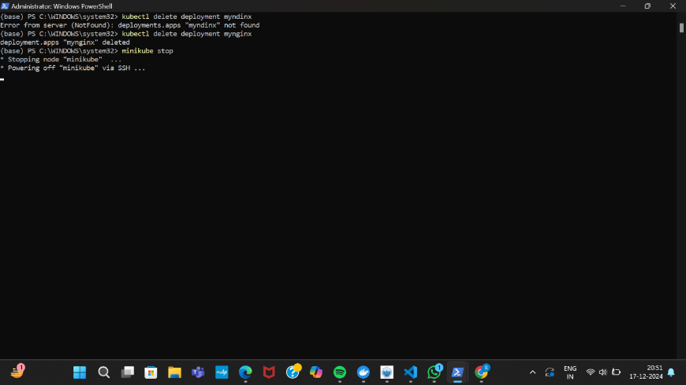

**DEPLOYING AND MANAGING MONITORING SYSTEMS USING NAGIOS IN DOCKER**

**1.pulling nagios image**

**docker pull jasonrivers/nagios:latest**

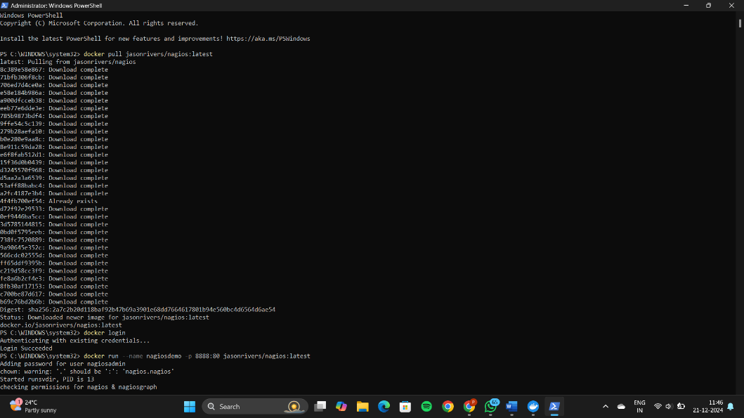

**Running nagios**

**doceker run –name nagios -p 8888:80 jasonrivers/nagios:latest**

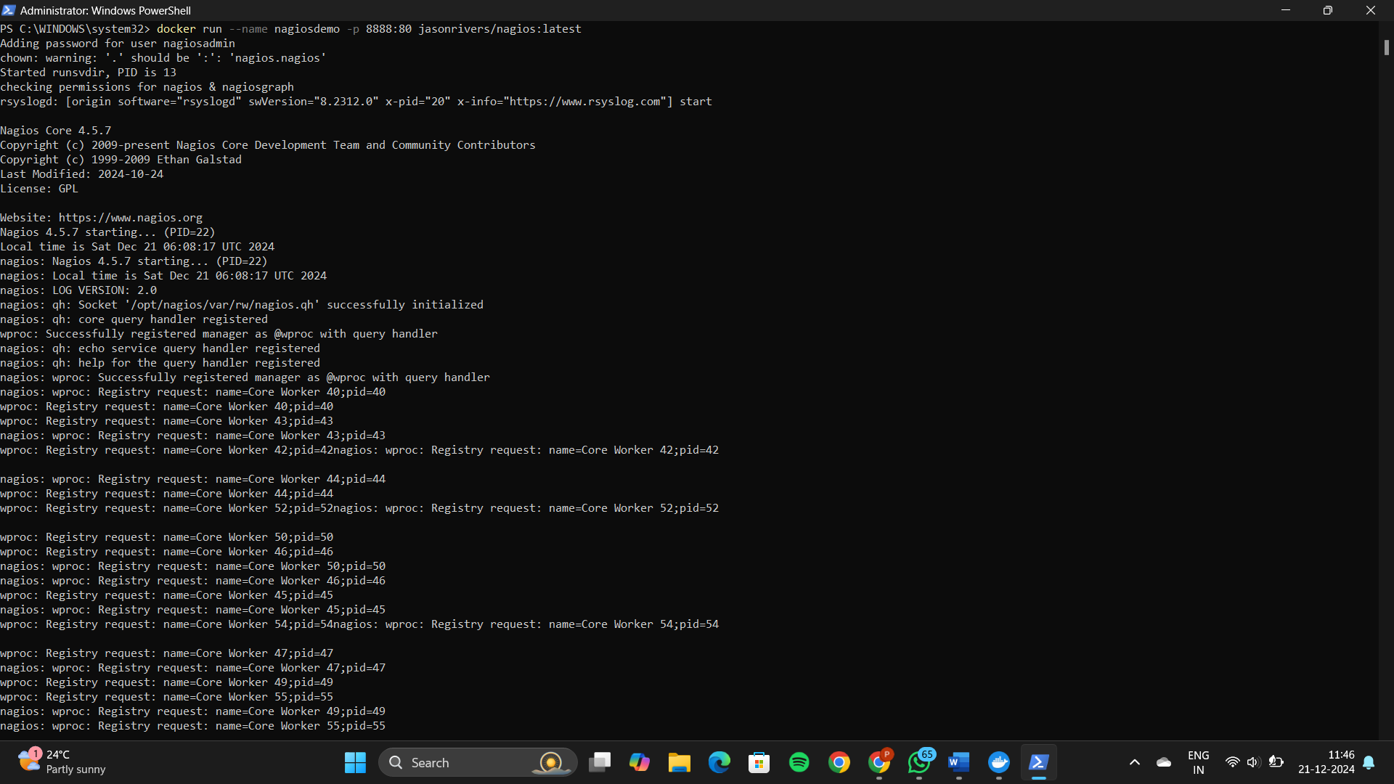

**3. Accessing nagios**

**Fill the credentials**

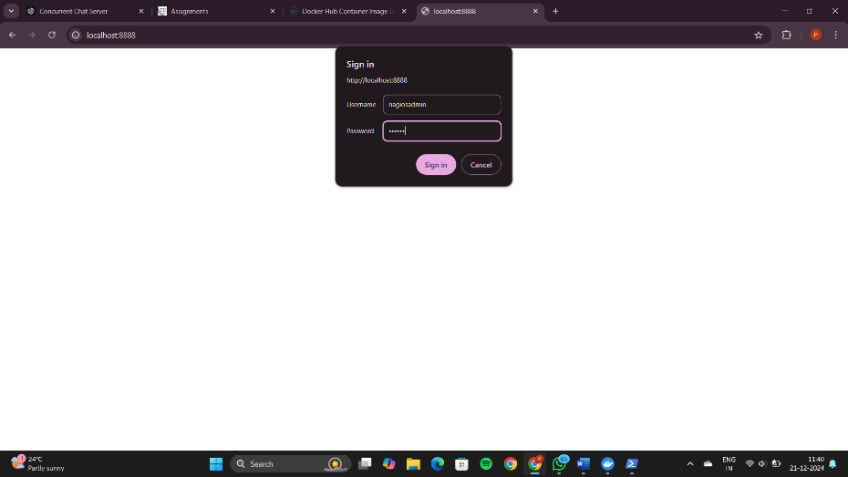

**The nagios dashboard**

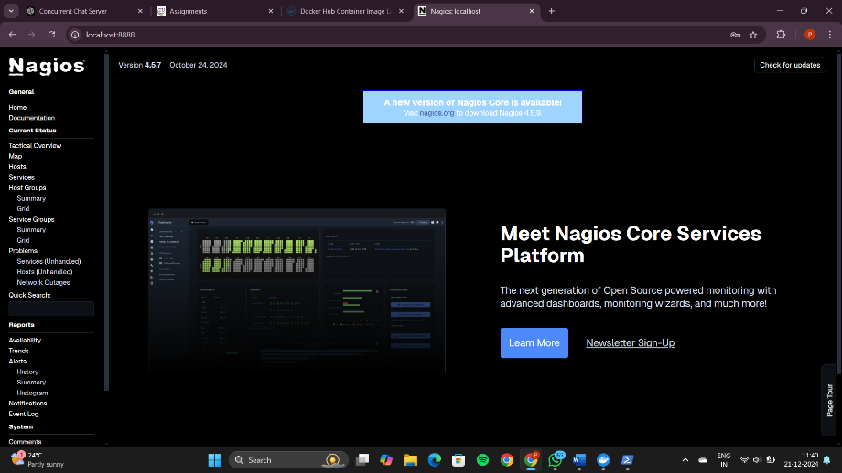

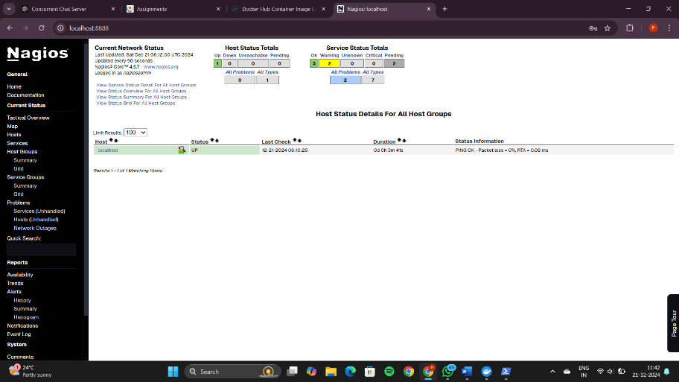

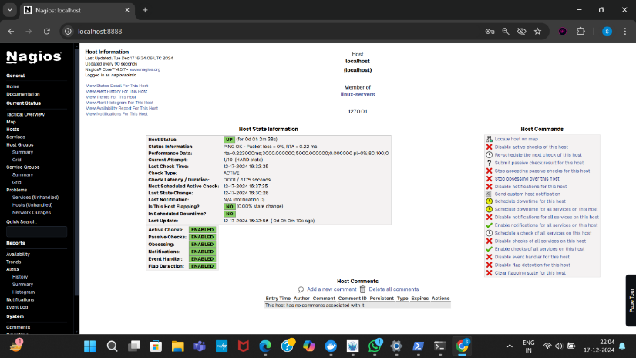

**Stopping nagios**

**docker ps**

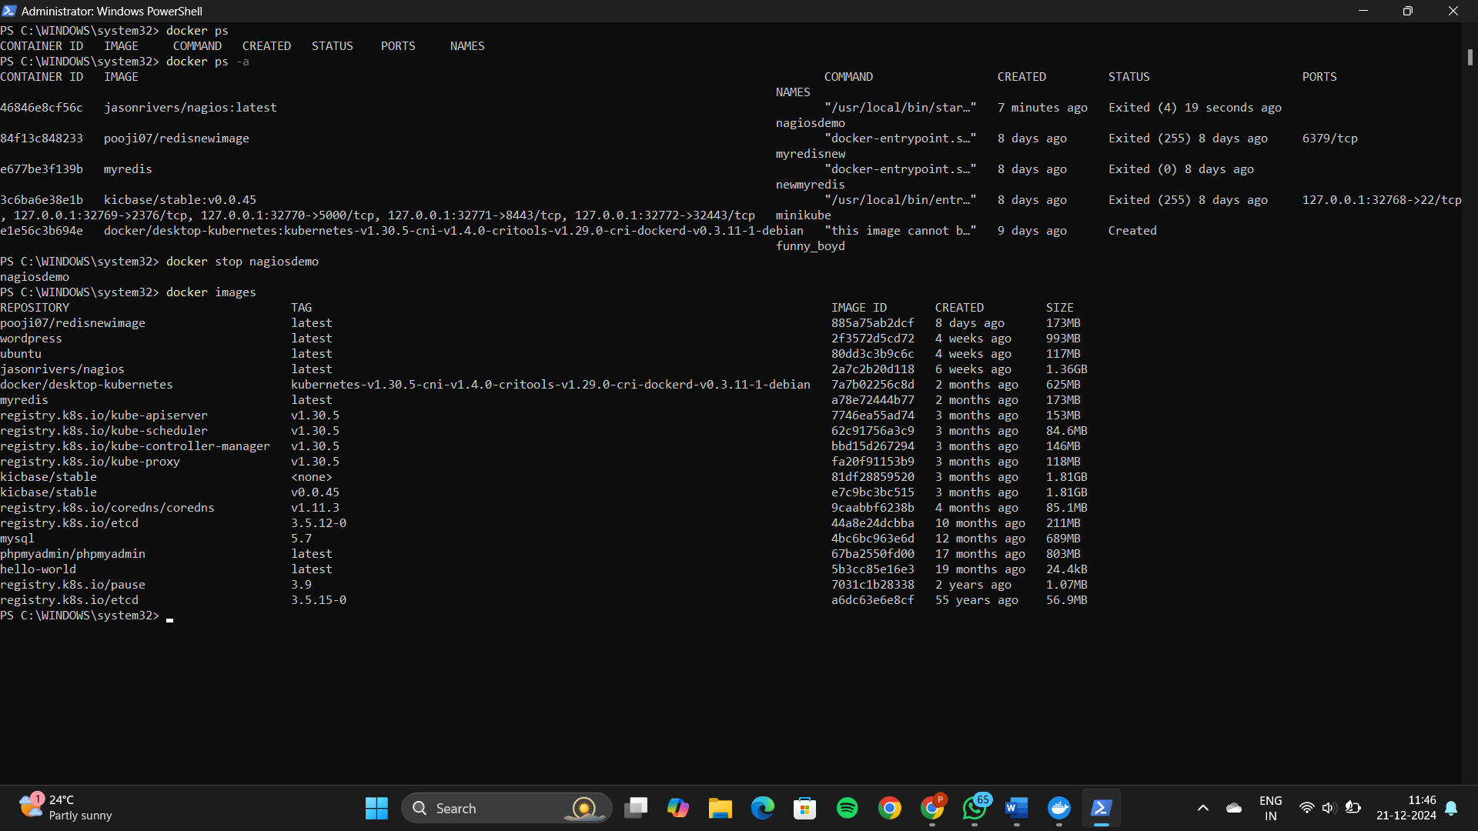

**docker ps-a**



**Docker stop nagiosdemo**



**Docker images**



**The image will get deleted**

Experiment 8 : A. AWS ACADEMY LEARNING ACCOUNT CREATION

B. PROJECT DEPLOYMENT IN THE AWS CLOUD USING EC2 INSTANCE

C. MAVEN WEB PROJECT DEPLOYMENT IN THE AWS CLOUD USING EC2 INSTANCE

**AWS Account Creation**

Click on Get Started from the invitation

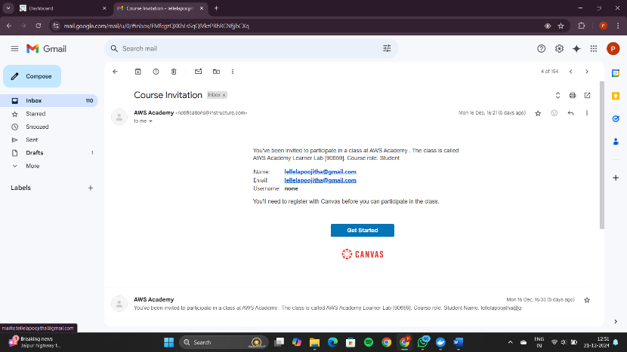

Click on Create My account

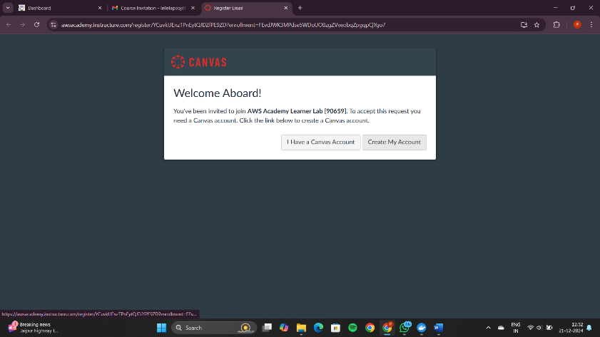

Provide a password for the AWS account

Click on the terms and conditions

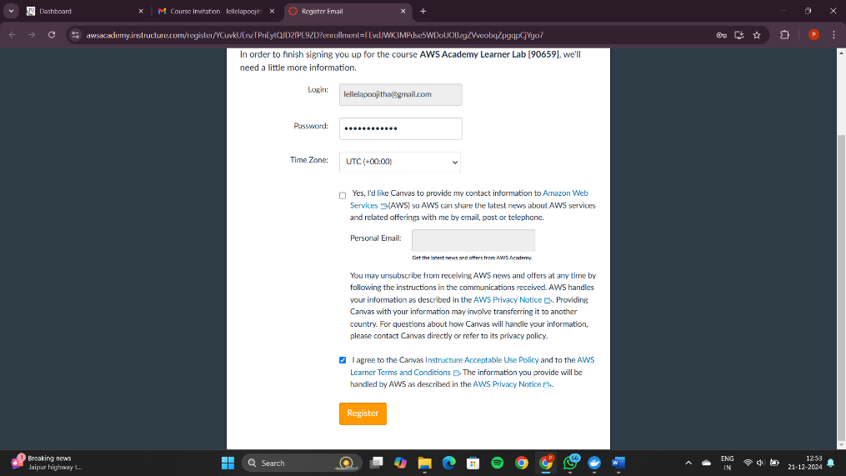

Scroll down and click on Register

You will direct the following page

Click on Account

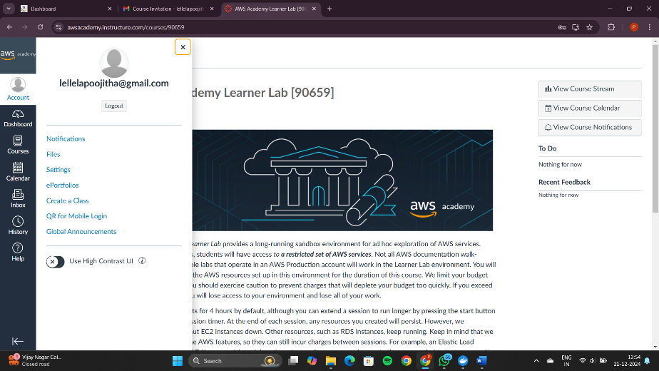

Let's see how to logout and login again 🡪CLICK on logout

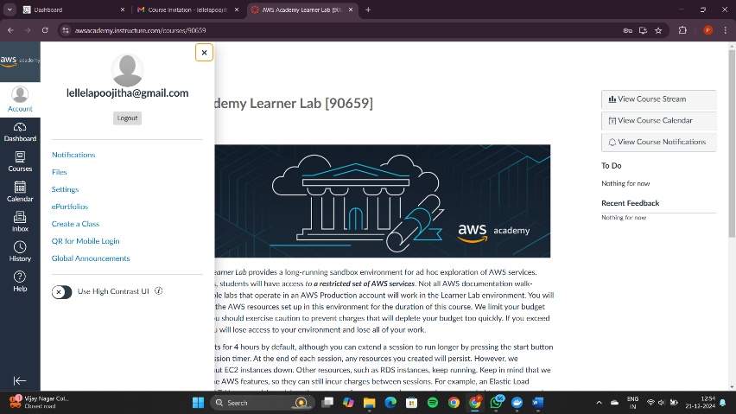

Click on student login

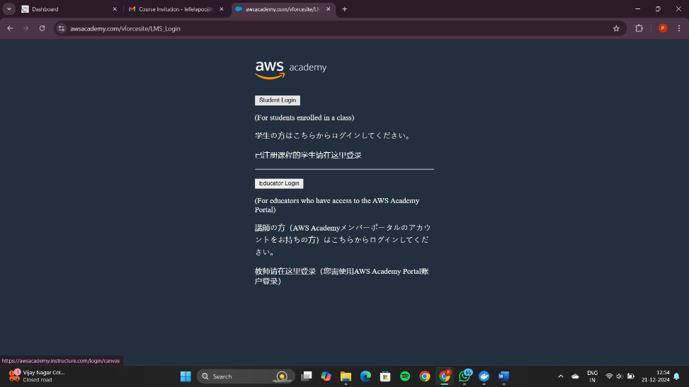

Fill the Username and password

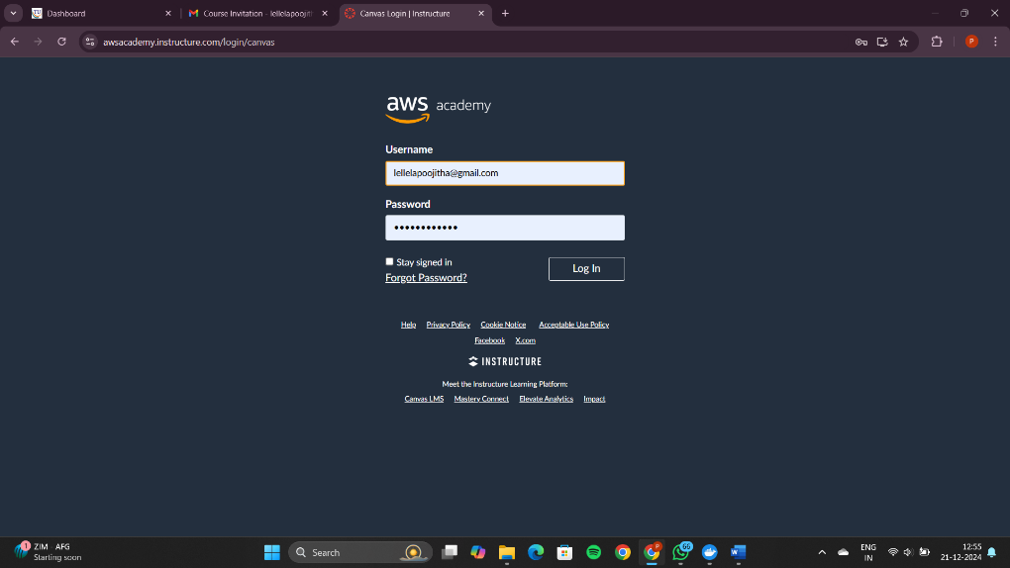

After login,you will direct to dashboard

Click on the AWS academy learner lab

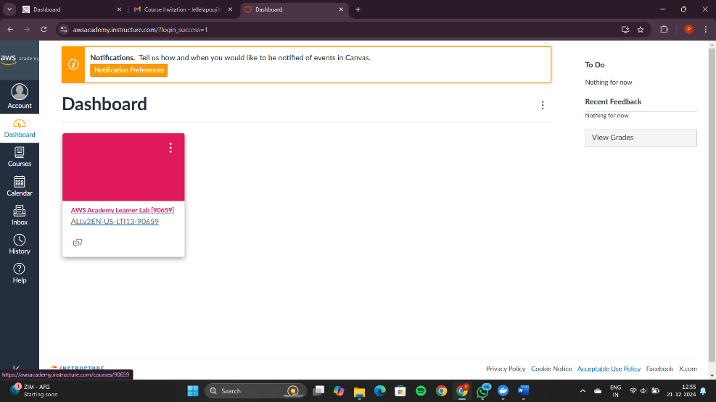

Click on Modules

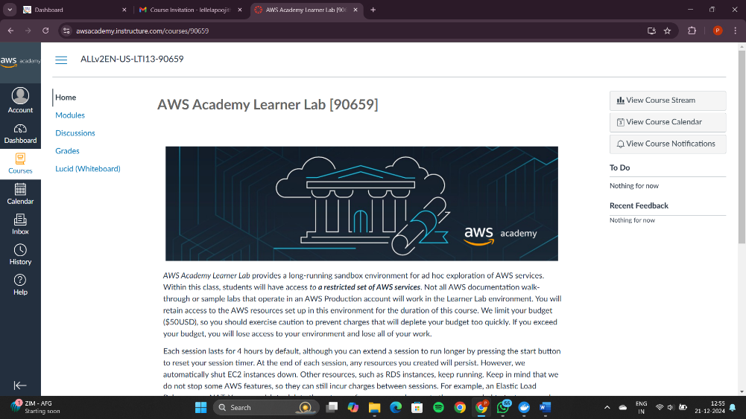

Scroll down and click on AWS Academy Learner lab

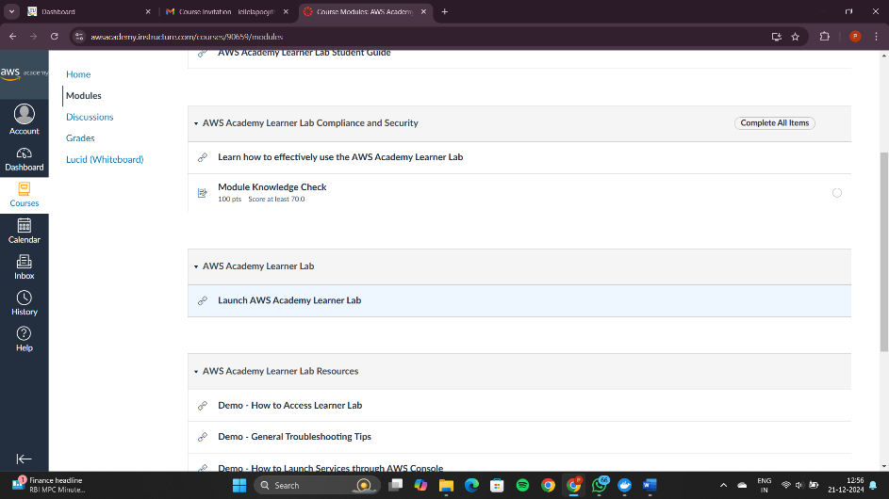

Accept all the terms and conditions

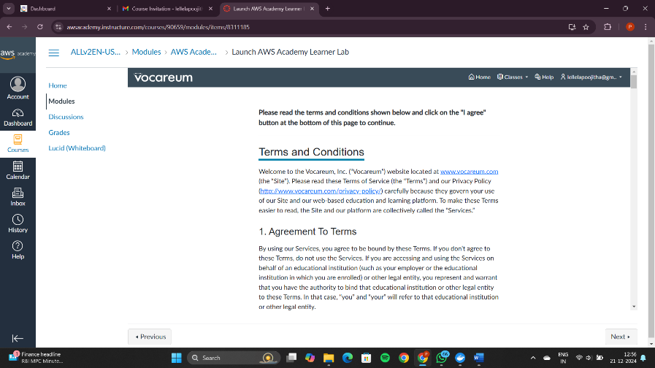

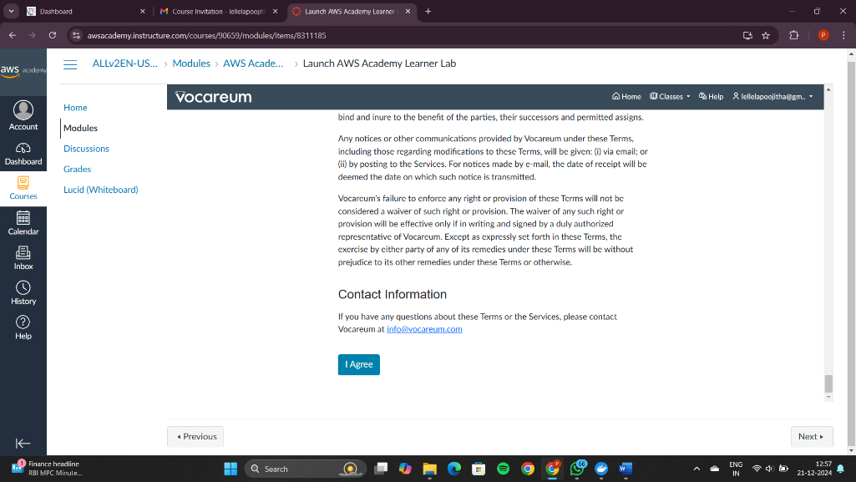

If there is red dot beside AWS it means the sandbox (AWS Learning Environment) is in stop state, click on Start Lab

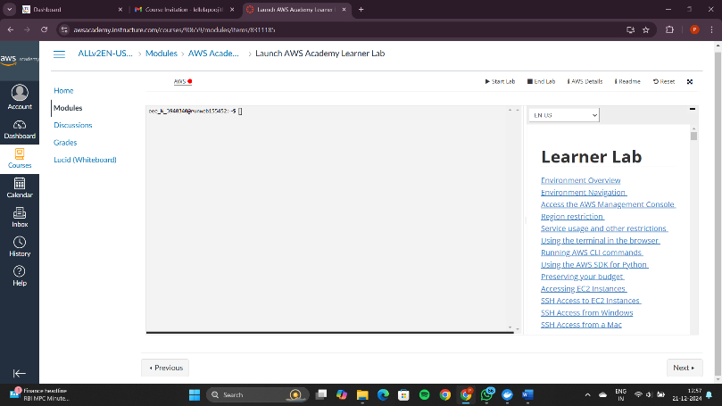

Once the AWS turns green , click on it

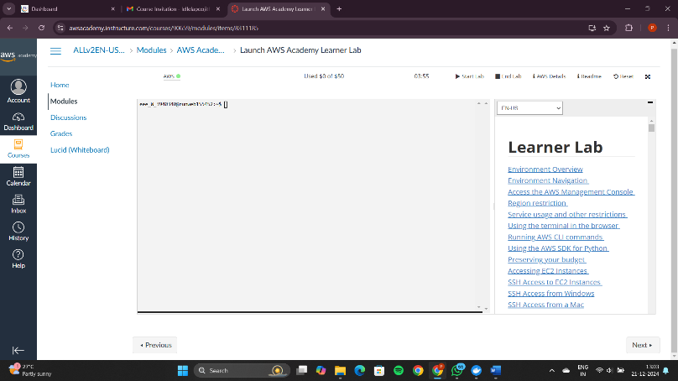

You will land to the AWS Dashboard

Click in EC2 in the recent visited box

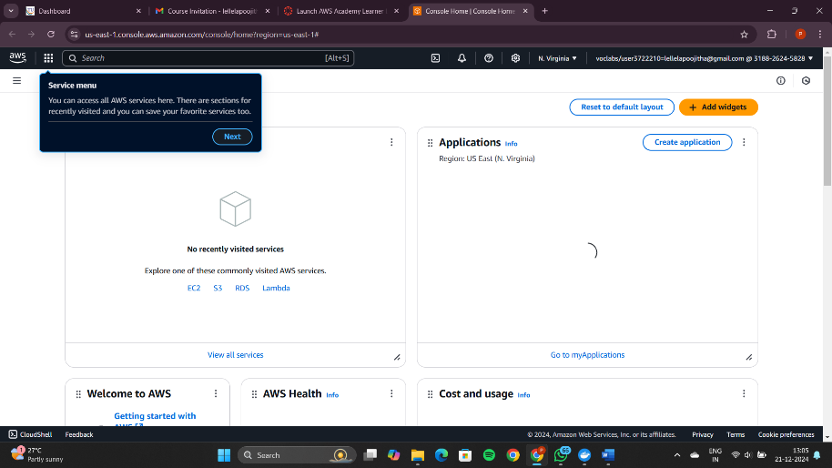

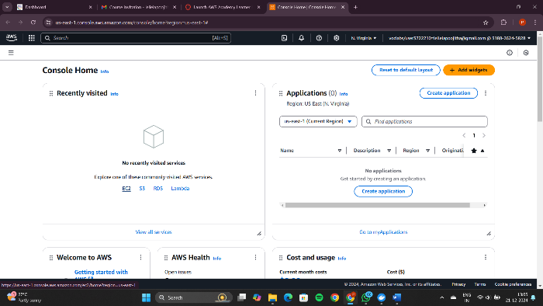

We can start exercises from here

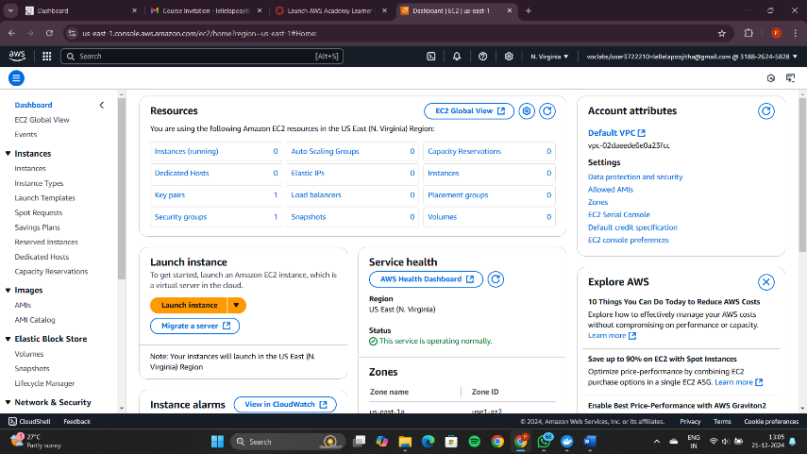

Once your lab work is done, click on end lab

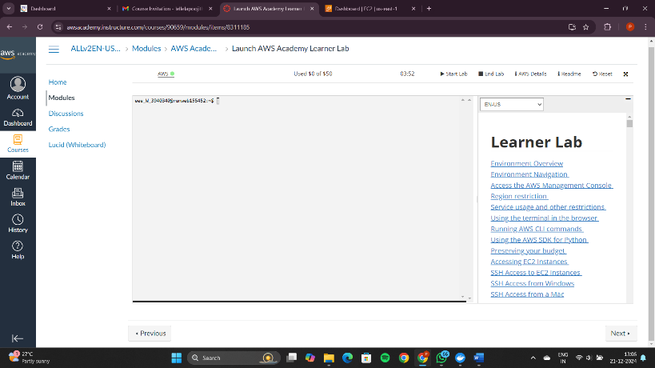

Click on yes to end the lab

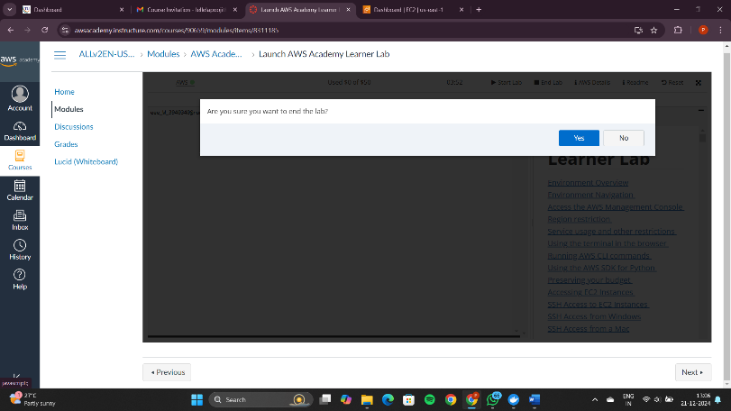

Once you get the red color dot besi

de the AWS, it indicates that the lab has been stopped

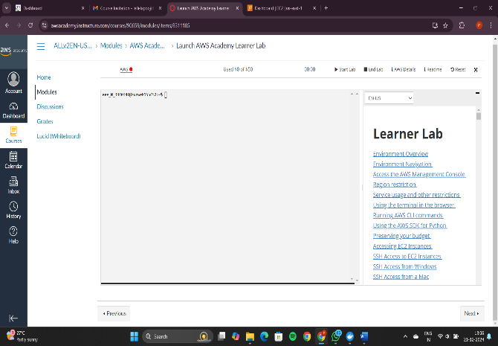

**AWS Project – To deploy a web page**

Enter to the AWS Dashboard

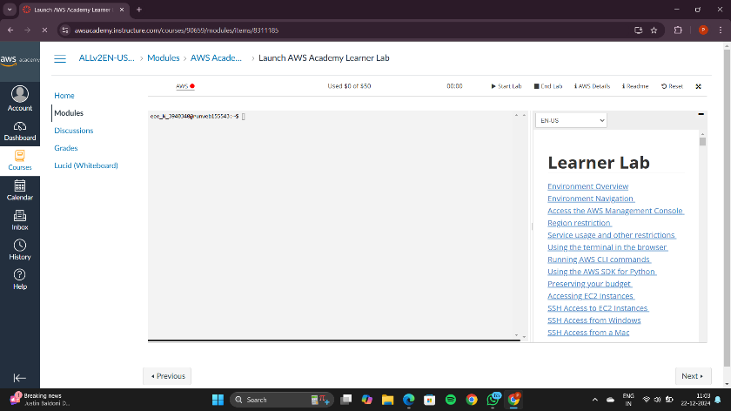

Click on start lab and wait until the red dot turns to green

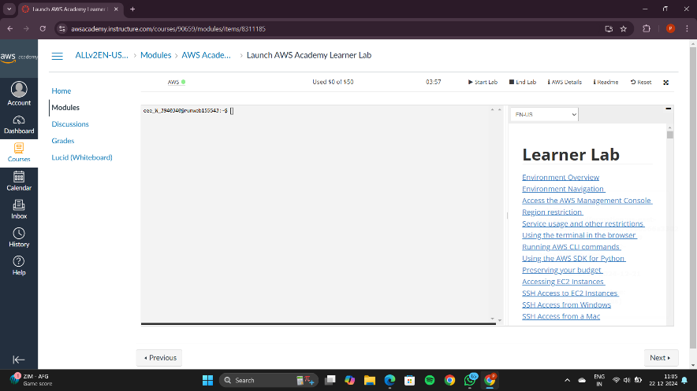

Go to the AWS and click on EC2

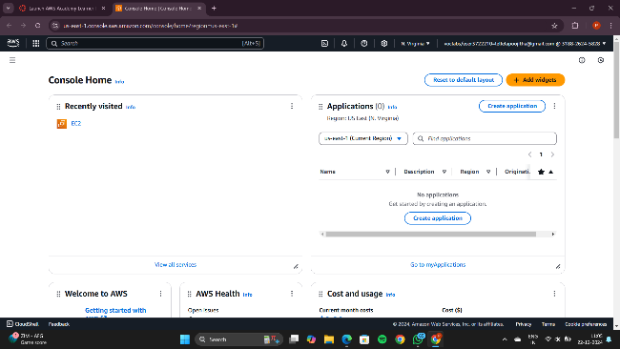

This is the EC2 Dashboard

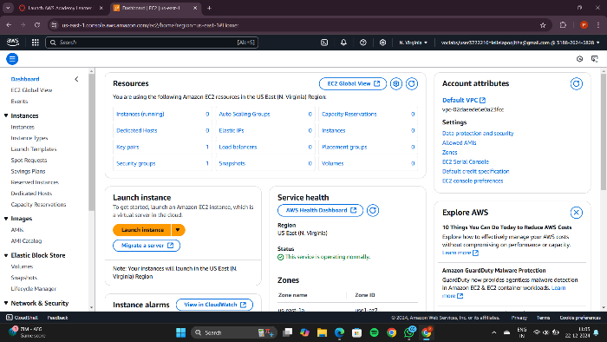

Now click on the Launch Instance button

You can view the page like this

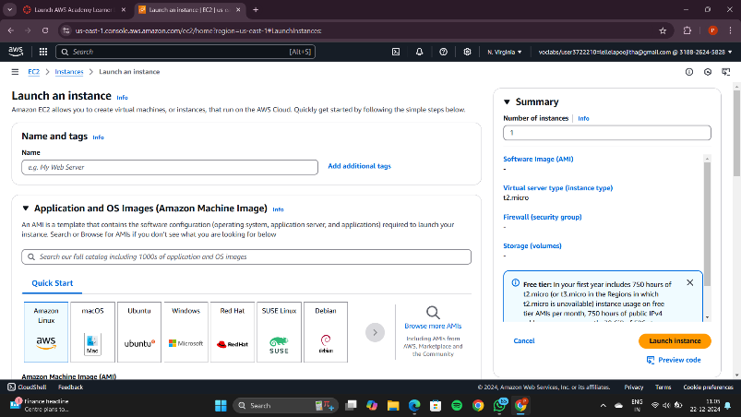

Now, add a name

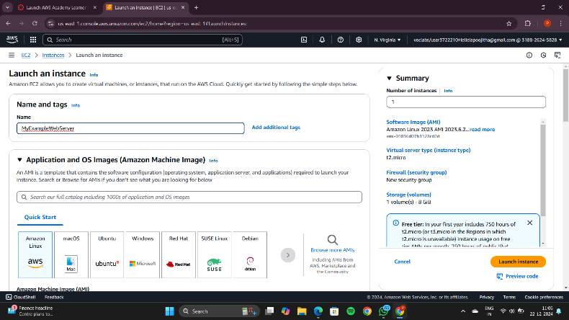

In the application and OS Images section, select ubuntu

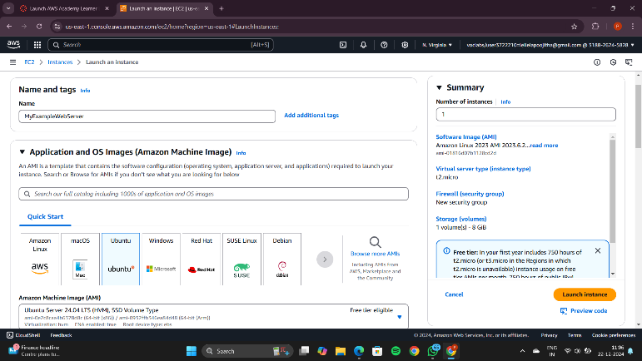

In the Amazon Machine Image select any free tier one

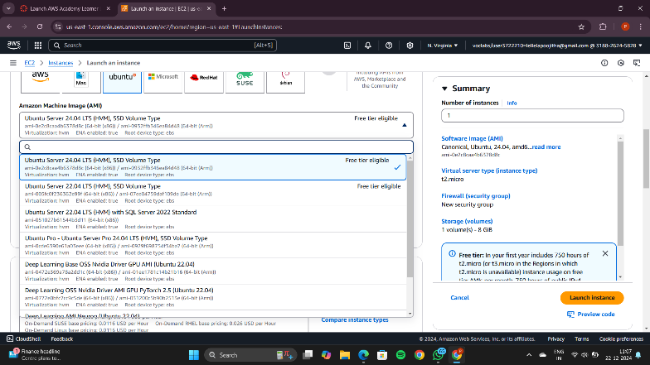

The Instance type should be t2.micro

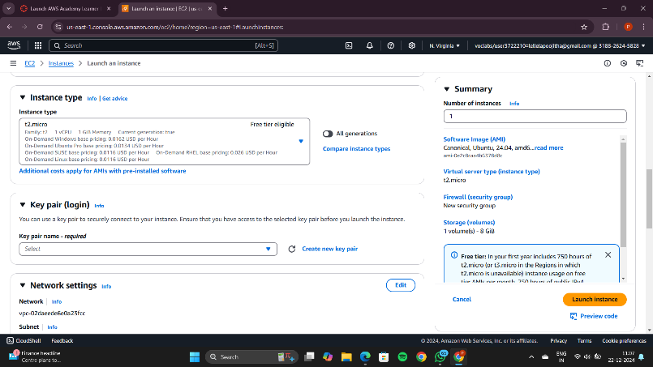

Click on Create new key pair in the Key Pair section

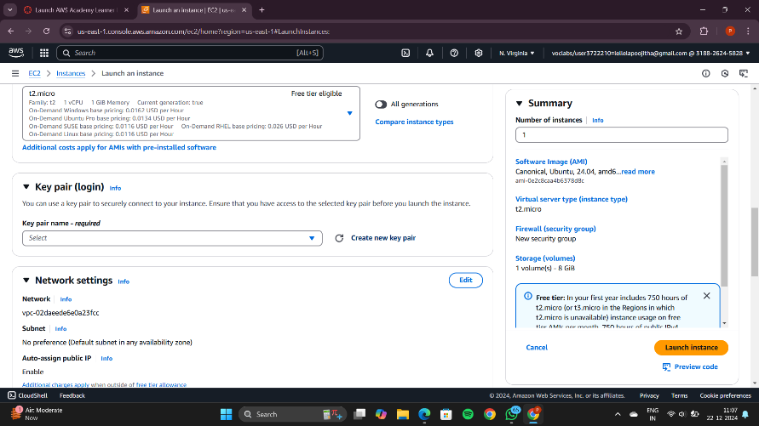

Give a name to the key pair like MyExampleKeyPair

and click on Create key pair

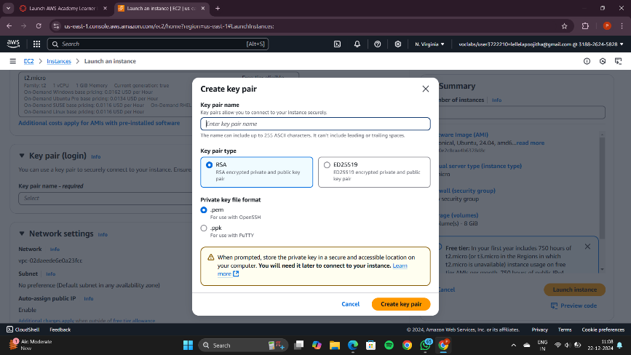

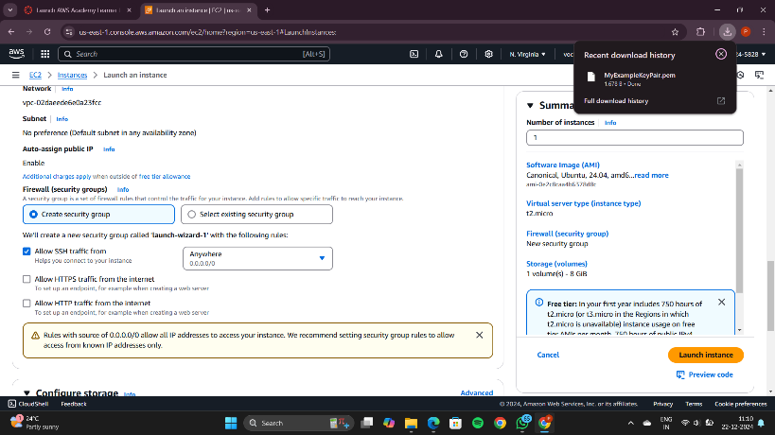

Create a new folder and make sure that the .pem file is present there

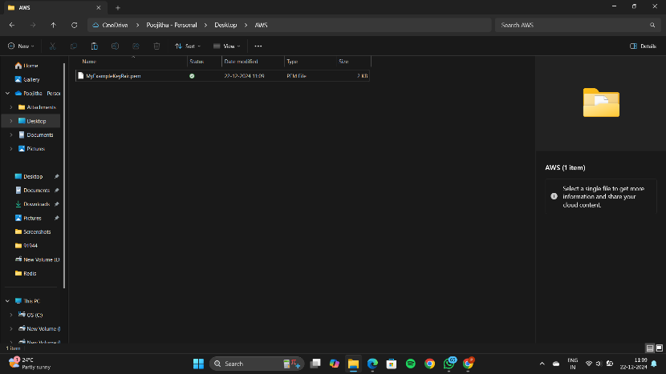

Make sure that the all the boxes should be checked under Network Settings

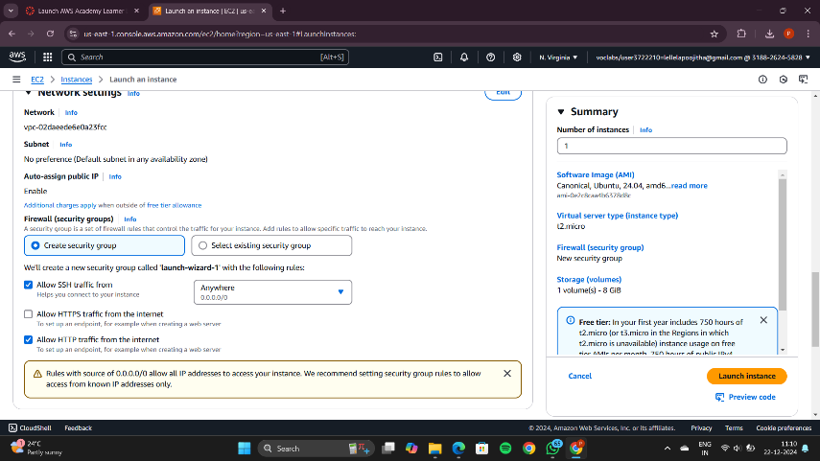

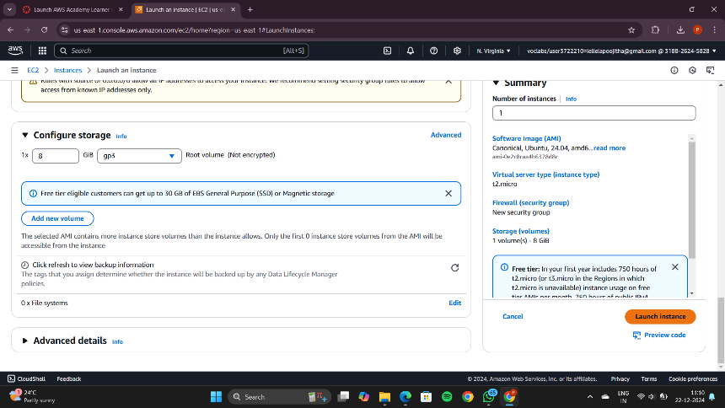

Then click on launch instance button present in the bottom right corner

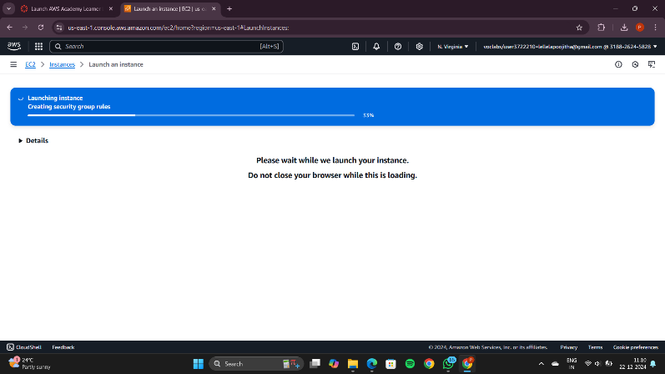

Wait until it turns green

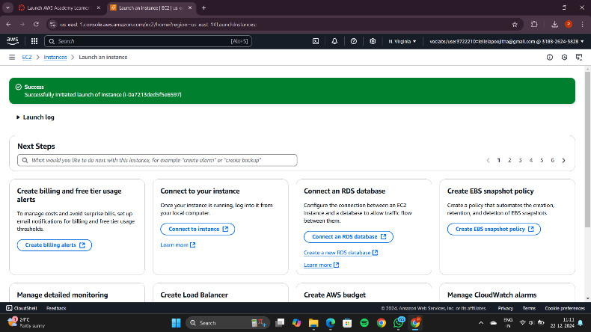

Click on Instances button and you will be redirected to this page

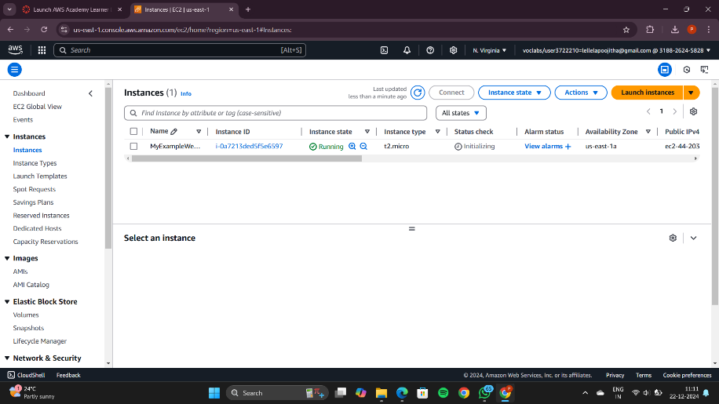

Wait until the status check gives the following message and turns green

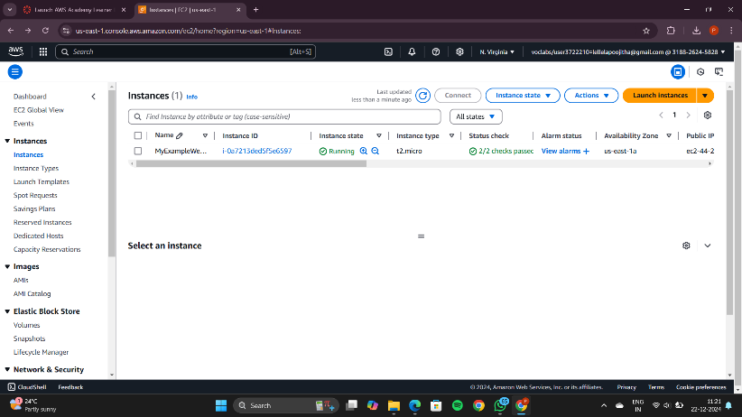

Then click on the check box on the left and click connect

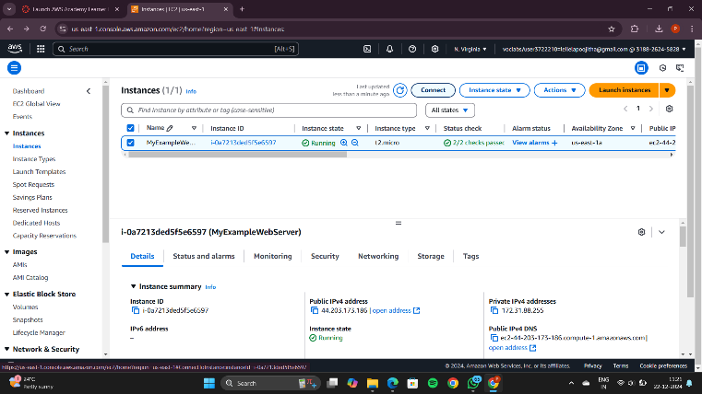

You will be redirected to this page

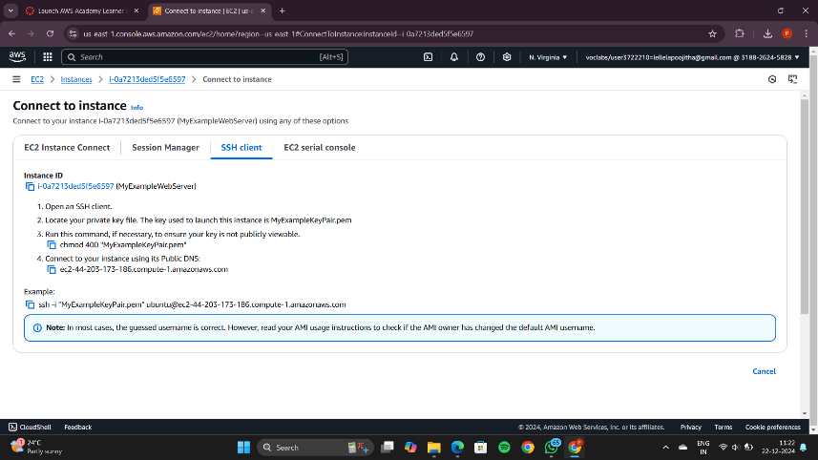

Open Command prompt in administrator mode

redirect to the folder where the .pem file is present

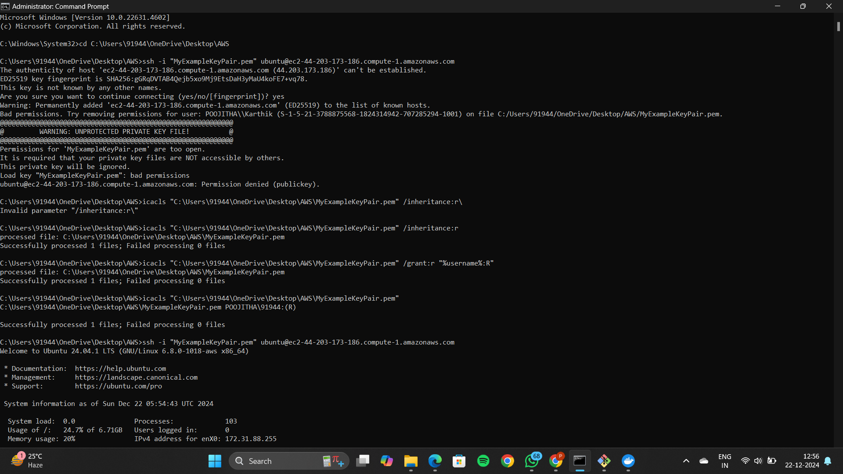

Now go to the folder where you have saved .pem file and copy the path

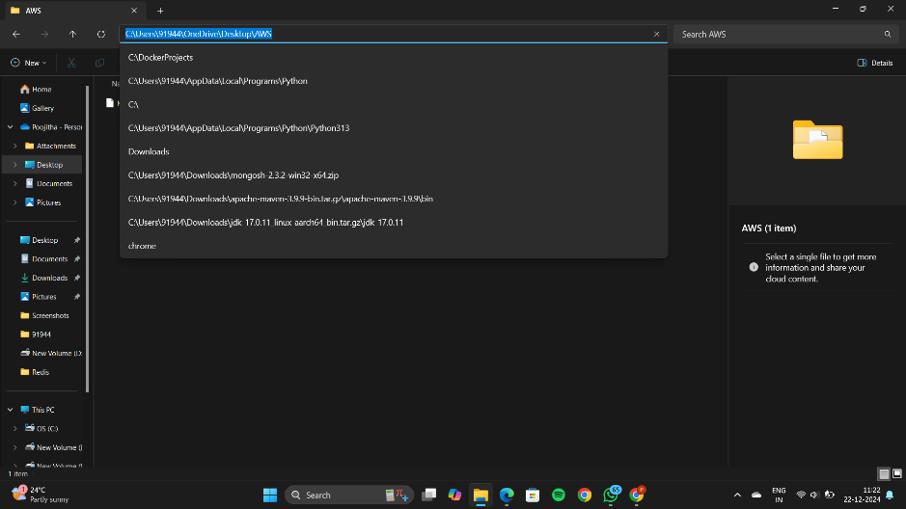

Copy the example command below

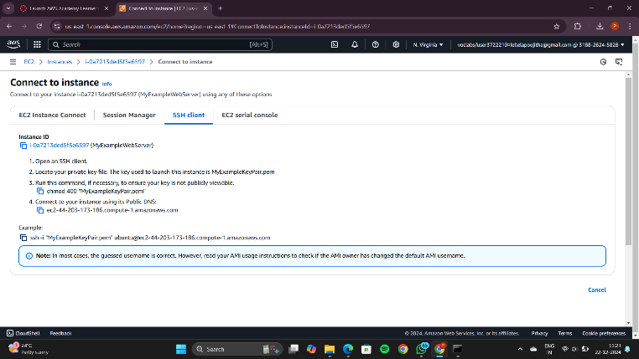

The command is copied as shown

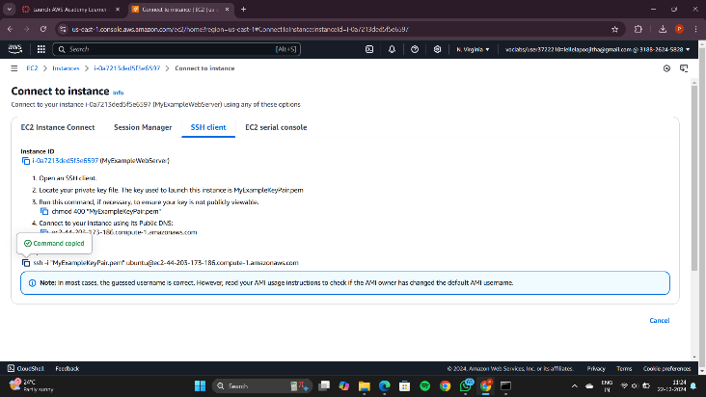

Paste the example command copied from the AWS instance

Type Yes to establish the connection

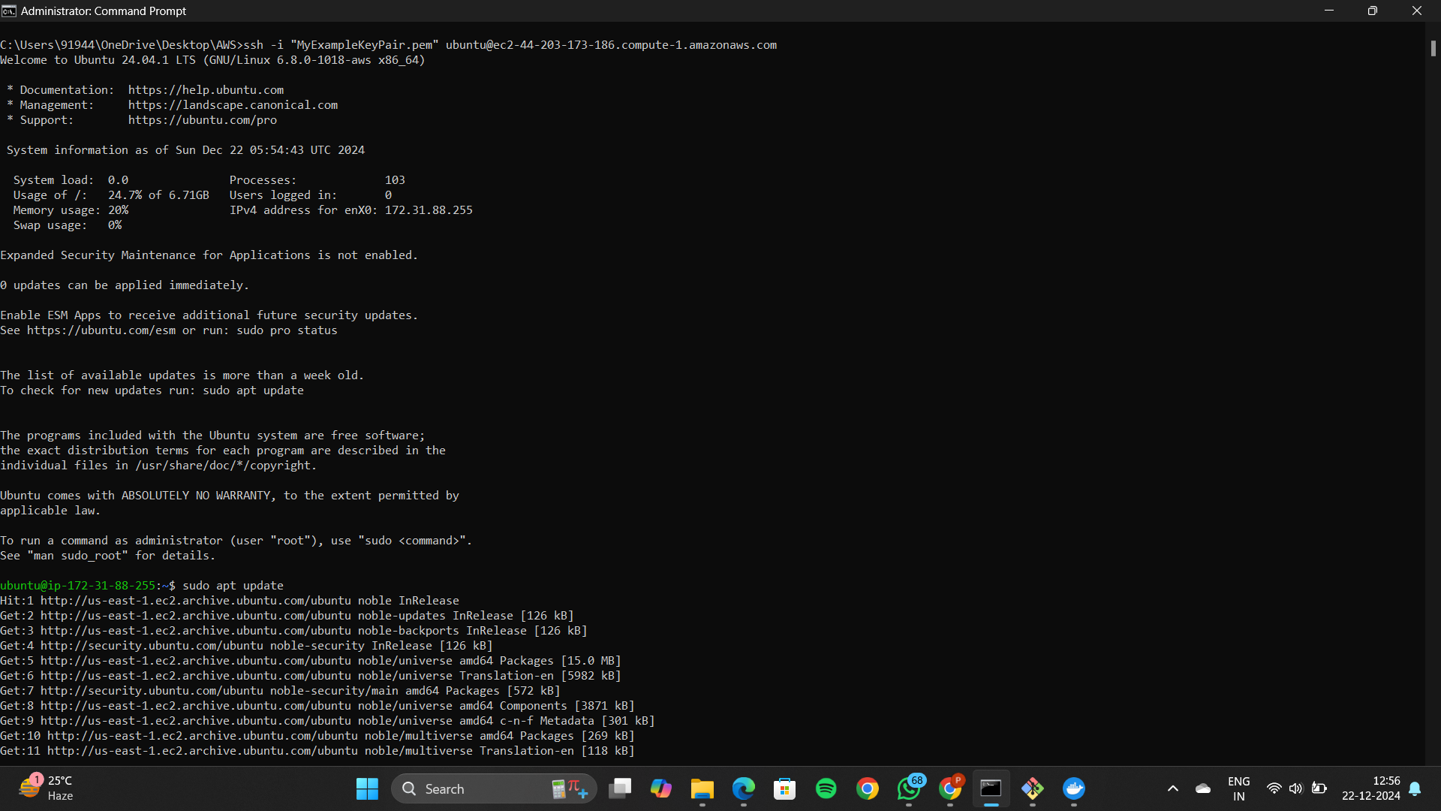

Update Ubuntu using the highlighted command: sudo apt update

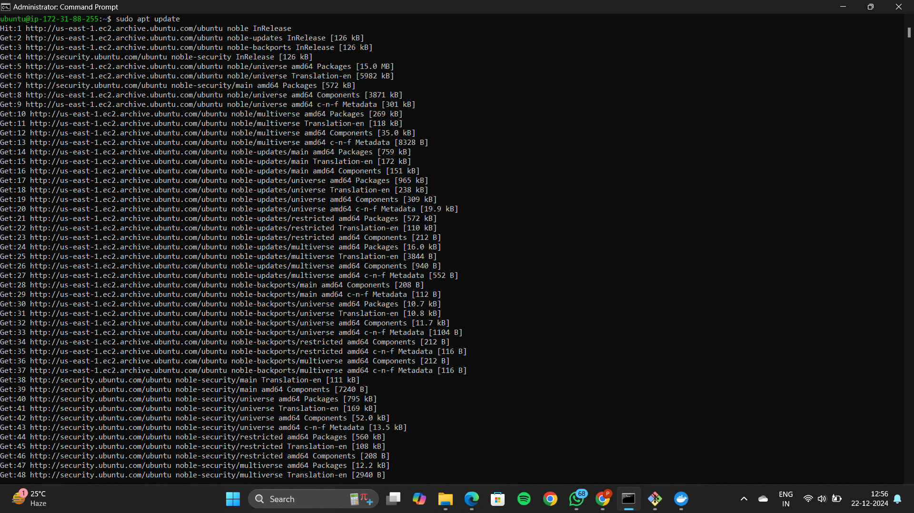

After updating Ubuntu install Docker using the command:   
sudo apt-get install docker.io  
Click Y to continue

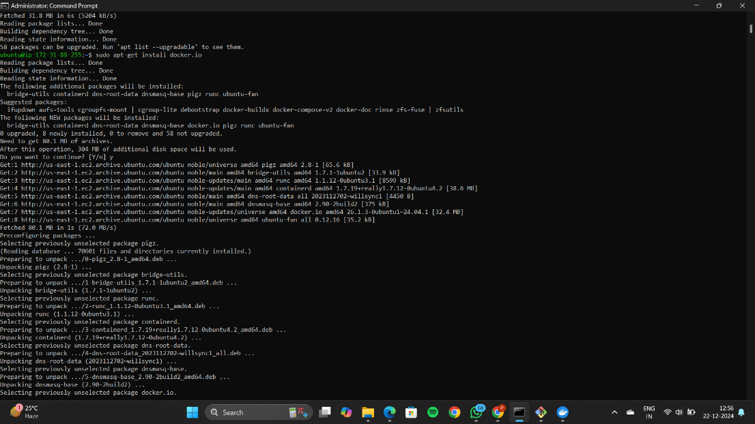

Docker is successfully installed

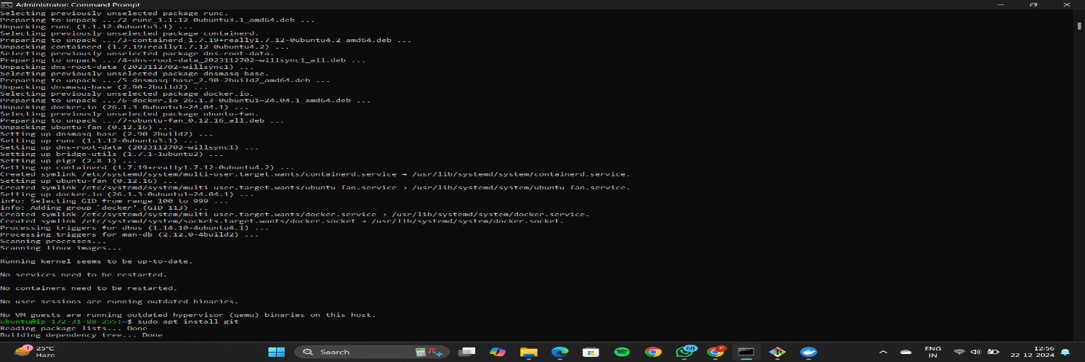

Install git using the following command:  
sudo apt install git

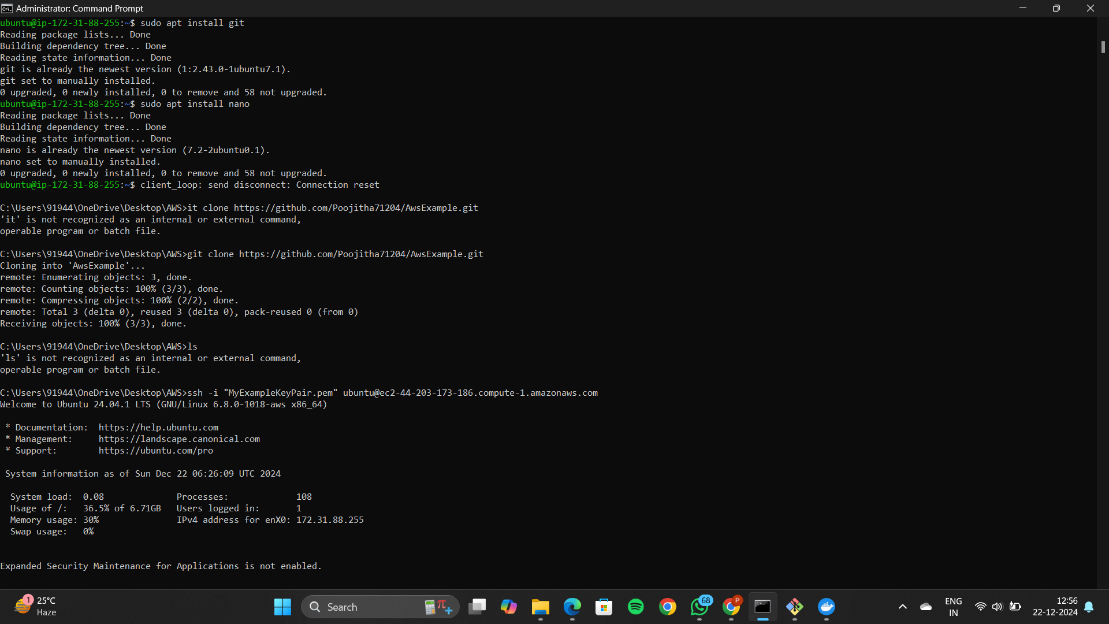

Now install nano editor using the command:  
sudo apt install nano



Open any editor like notepad or vs code and write a simple web-application

using html and save the file as index.html only

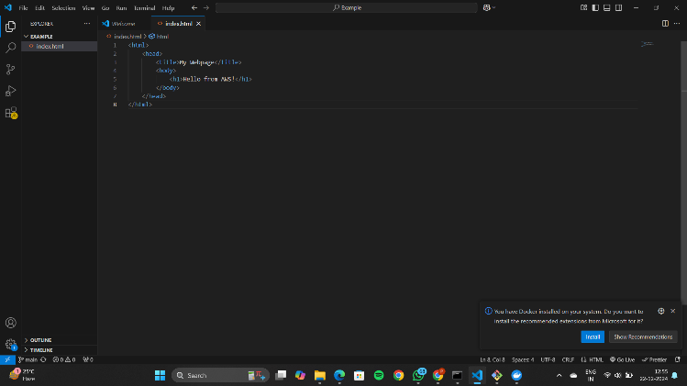

Open the folder where your index.html file is located 🡪 right click and open GitBash here

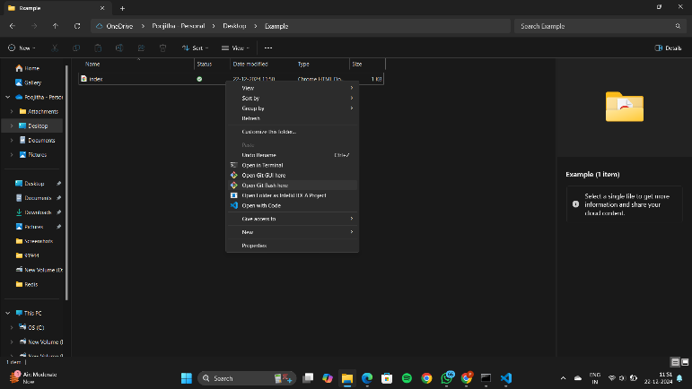

Type the following Git commands:  
git init  
git add .  
git commit

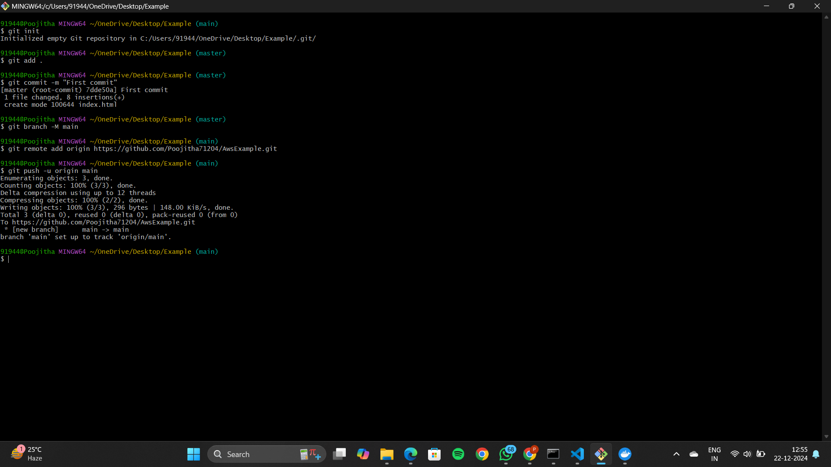

Create a repository in GitHub

Give any name of your choice and click on create

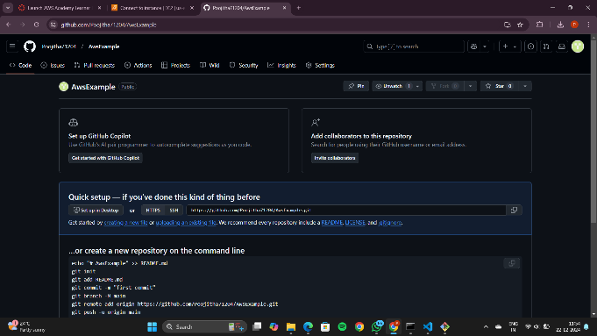

Copy the commands from the git hub and paste it in the git bash

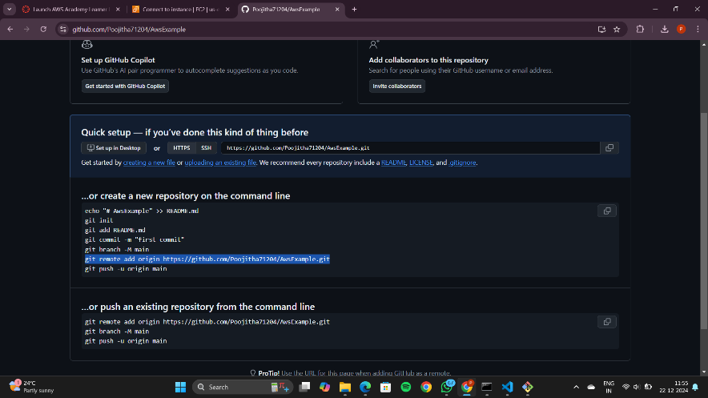



Refresh the GitHub page to see the pushed file

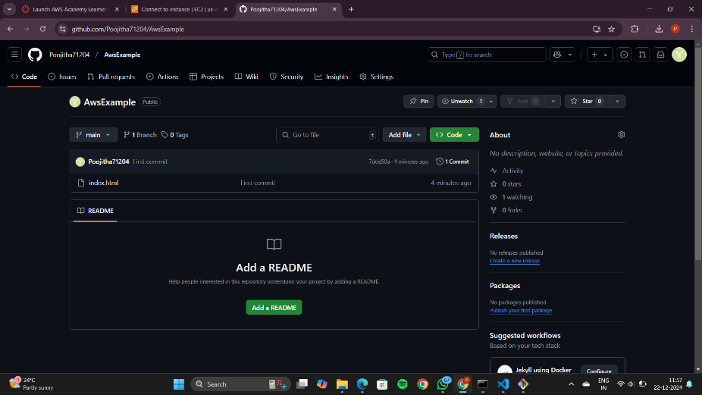

Now copy the HTTPS URL as shown

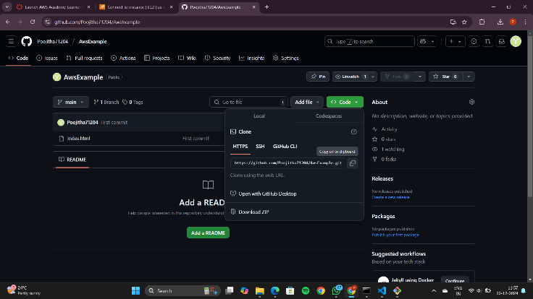

Go back to PowerShell and paste the URL as shown

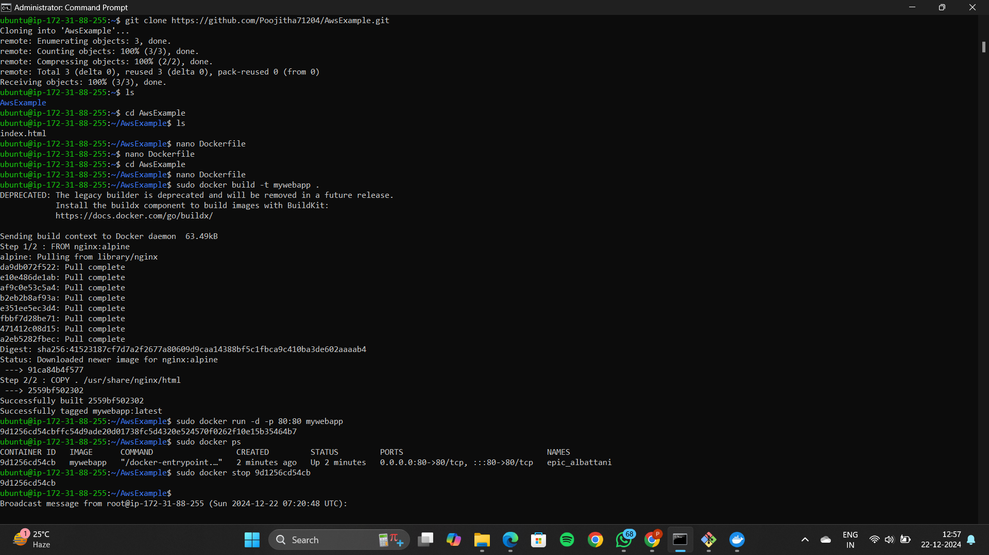

Once cloning is completed🡪 Move into the folder as shown



Inside this folder🡪 create a Dockerfile as shown



This line of code is like making a special box using NGINX (a type of web server) and

Alpine Linux (a lightweight system). The "COPY . /usr/share/nginx/html" part is putting our website files

(whatever is in the current folder) into the box, so when it runs, NGINX shows our custom content from that folder.

It's a way of saying, "Hey, NGINX, use these files for the website!"

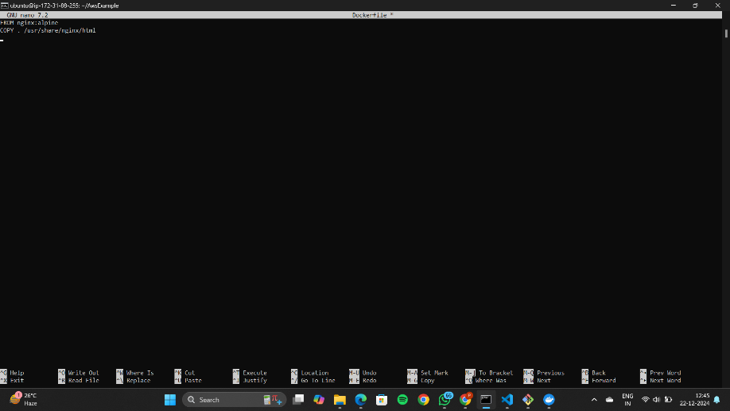

To come out of nano editor type CTRL+O and CTRL+X



Build a Docker image as shown:  
The command "sudo docker build -t html-mywebapp .



Next🡪 Run the Docker container as shown:  
The command "sudo docker run -d -p 80:80 html-mywebapp:latest



Now, we can access the web-application using the Public IP address as shown

Go to the instances🡪 Copy the address and paste in any browser

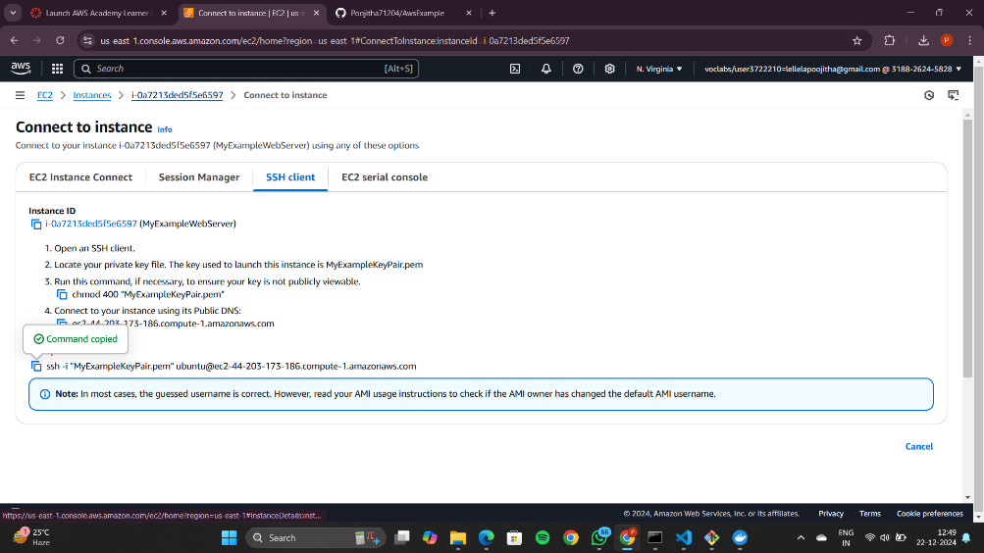

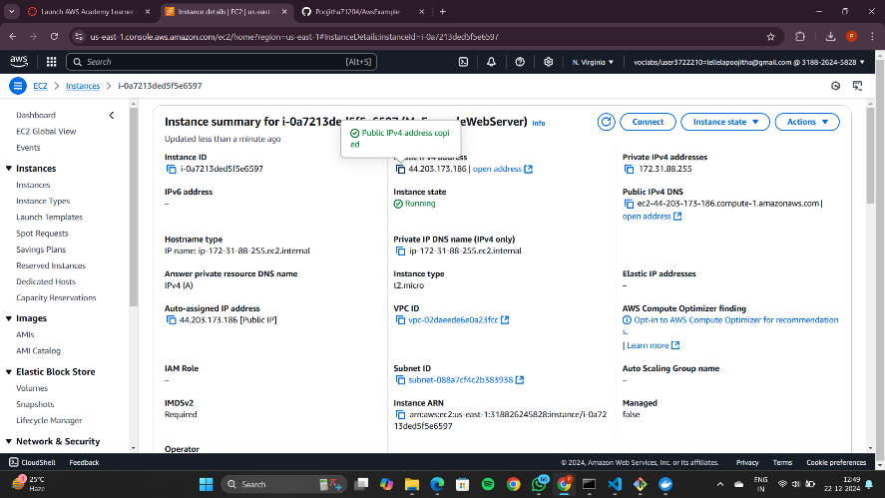

If https is not running change it to http

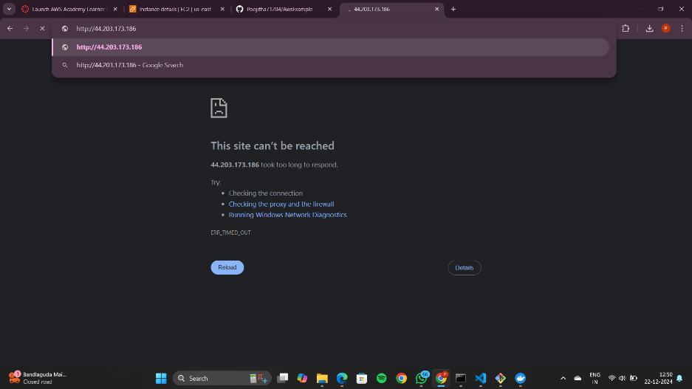

We can now see the deployed web application

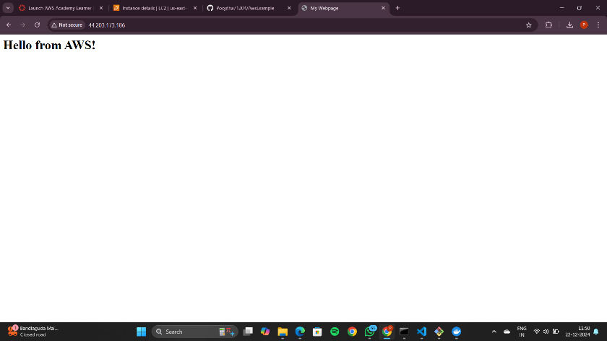

Now stop the running container:  
use the command: “sudo docker ps” which list the running containers 🡪 copy the container ID4

Use the command:  
sudo docker stop <Container ID> to stop the running container

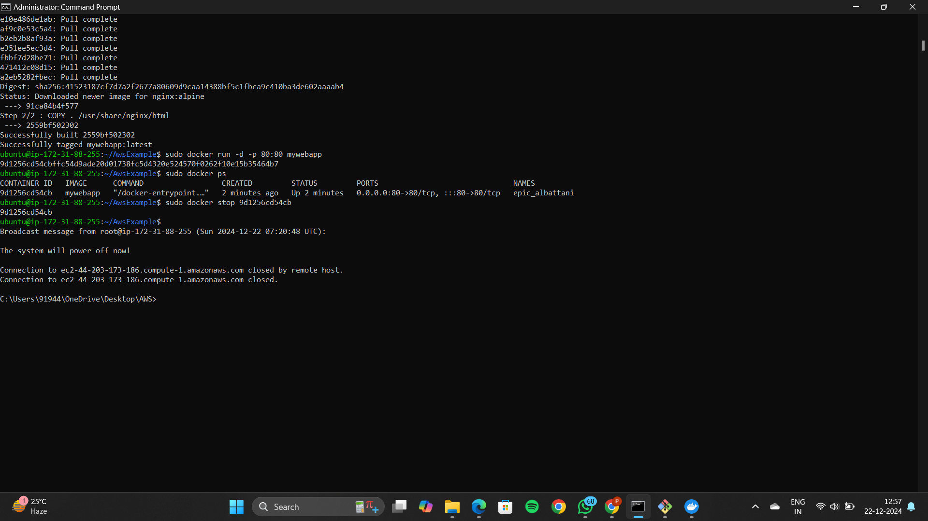

Go back to the AWS 🡪 click on the instance checkbox

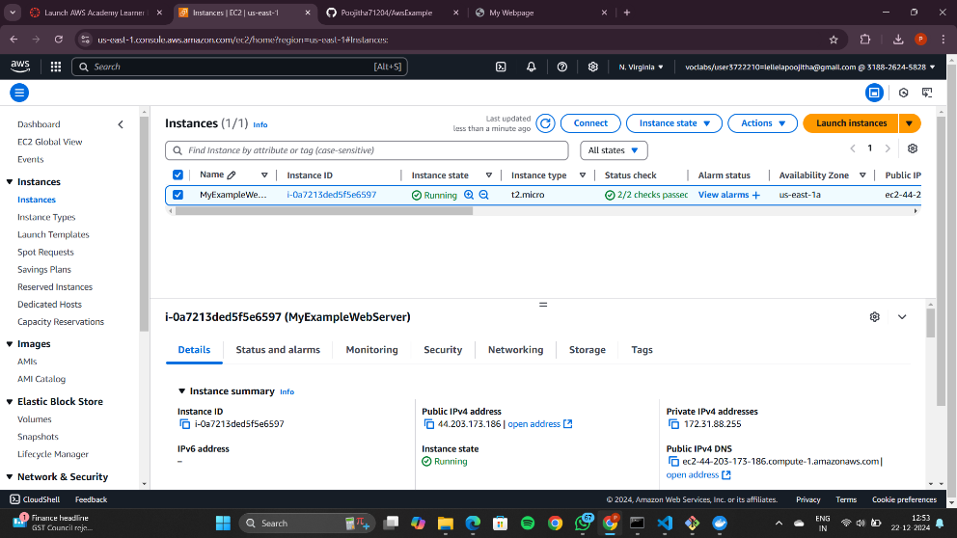

Go to Instance State and click on Terminate Instance

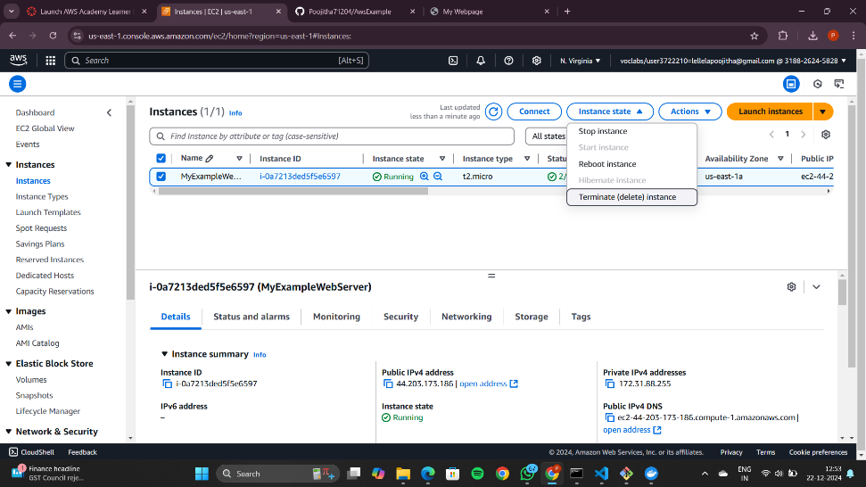

Click on terminate to delete the instance

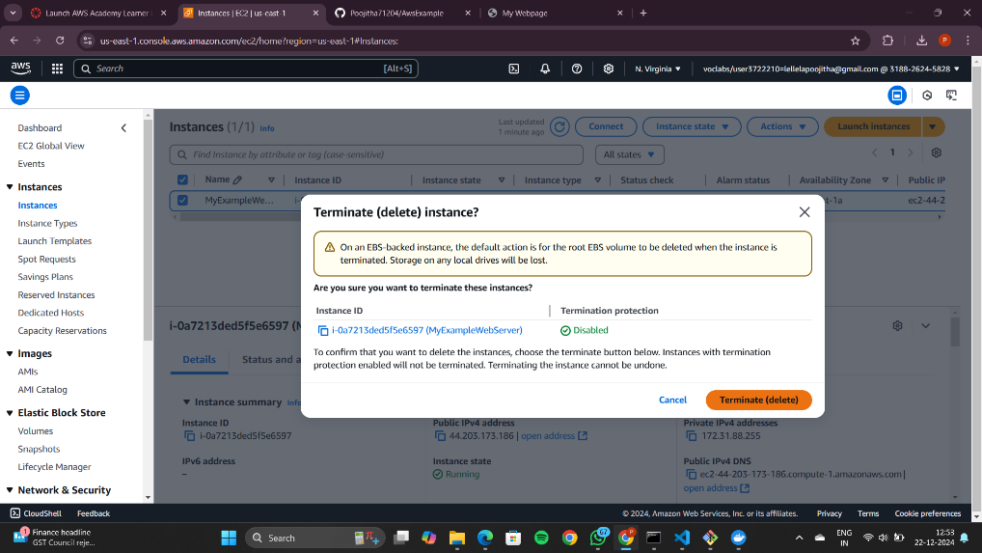

The instance is successfully terminated

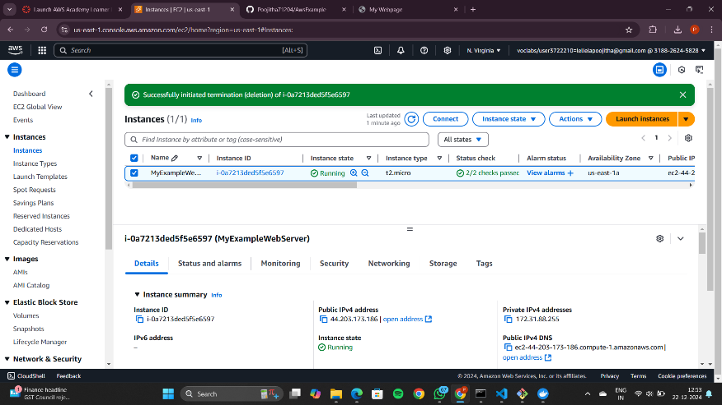

Reload the page to see that no instances are running

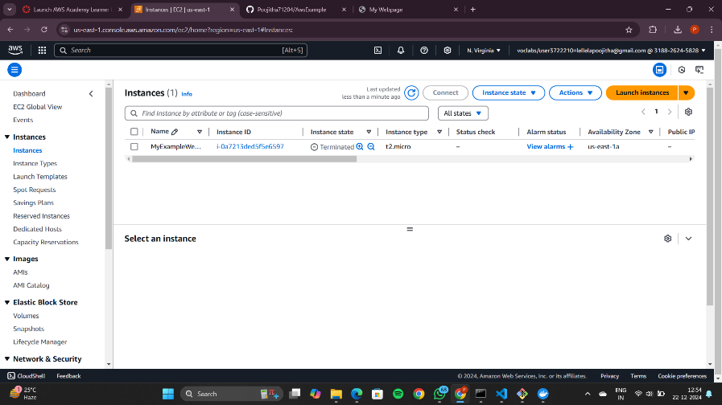

Now go to Aws academy learner lab and click End lab

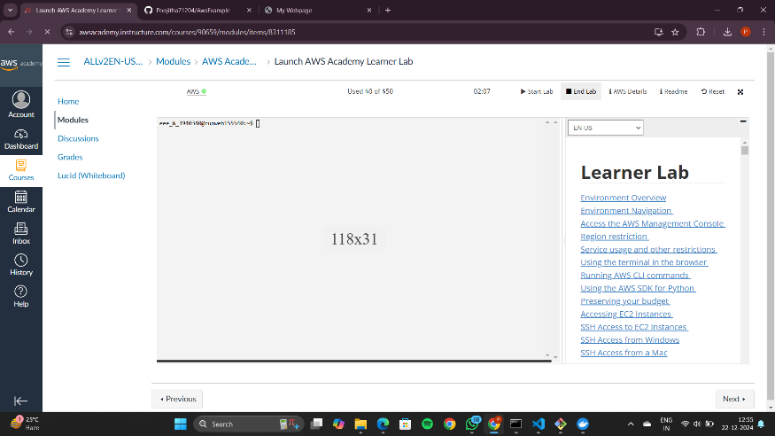

Click yes to end the lab

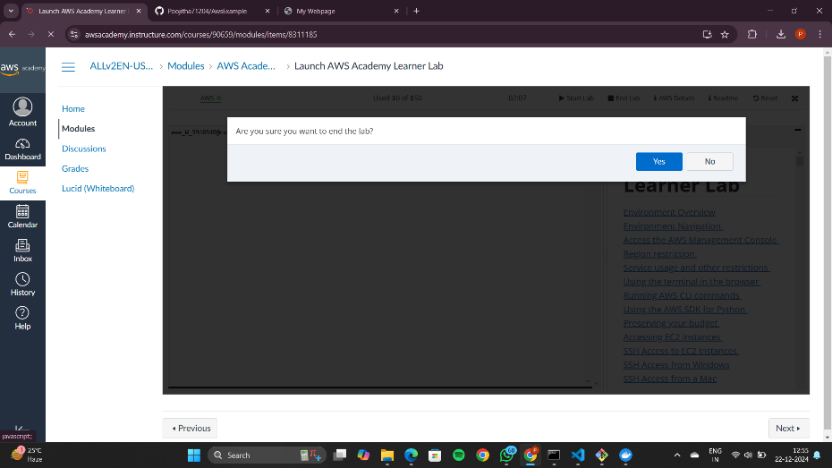

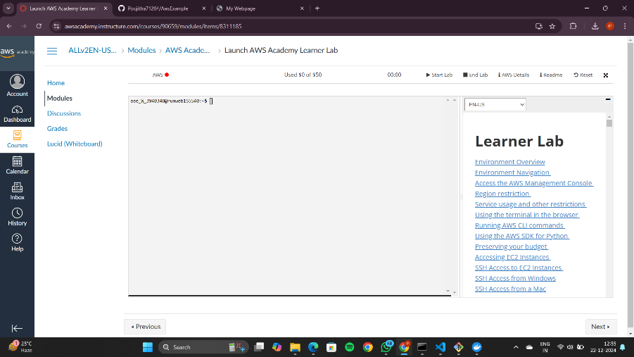

**AWS Project – To deploy a maven web project**

Enter to the AWS Dashboard

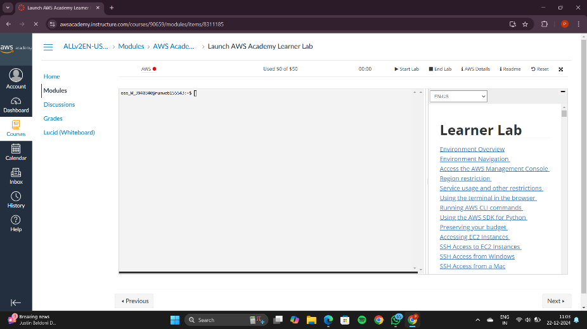

Click on start lab and wait until the red dot turns to green

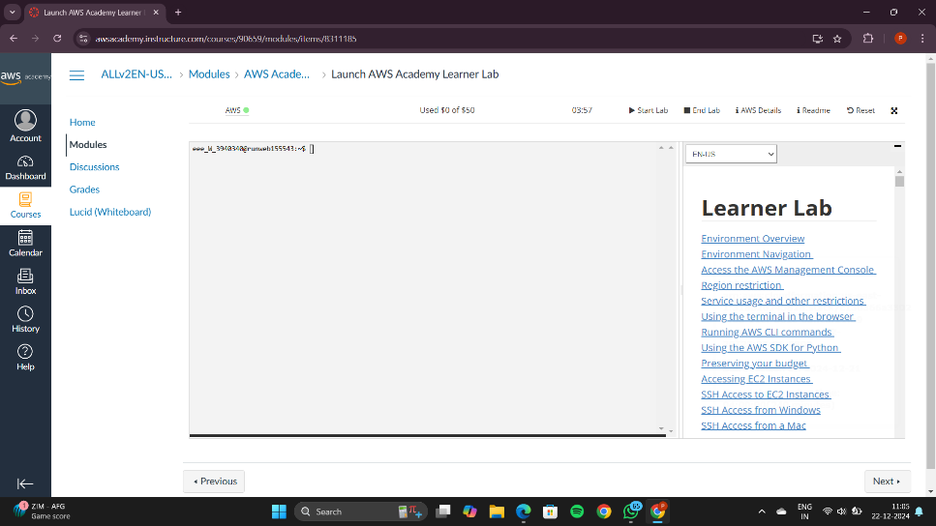

Go to the AWS and click on EC2

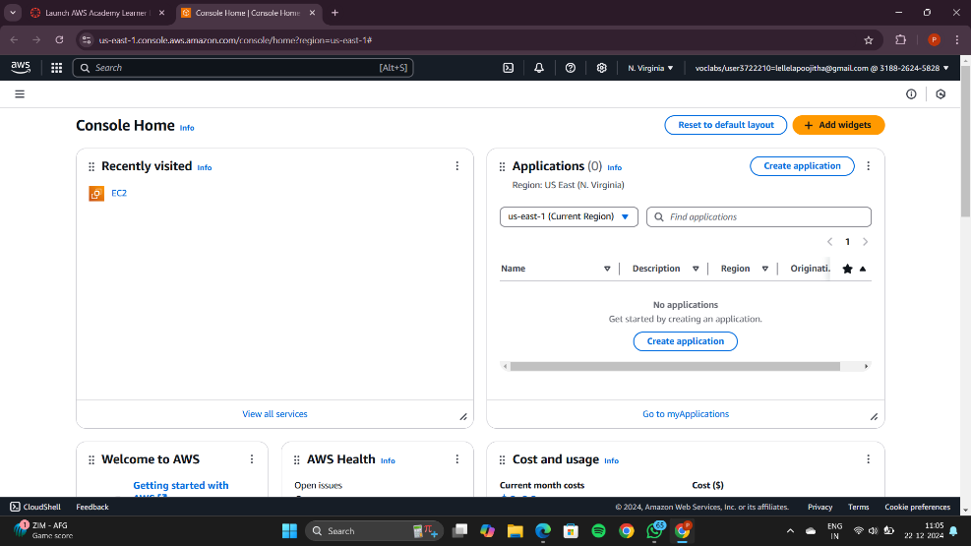

This is the EC2 Dashboard

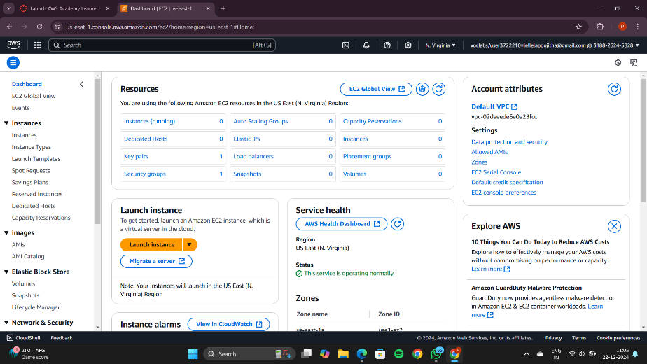

Now click on the Launch Instance button

You can view the page like this

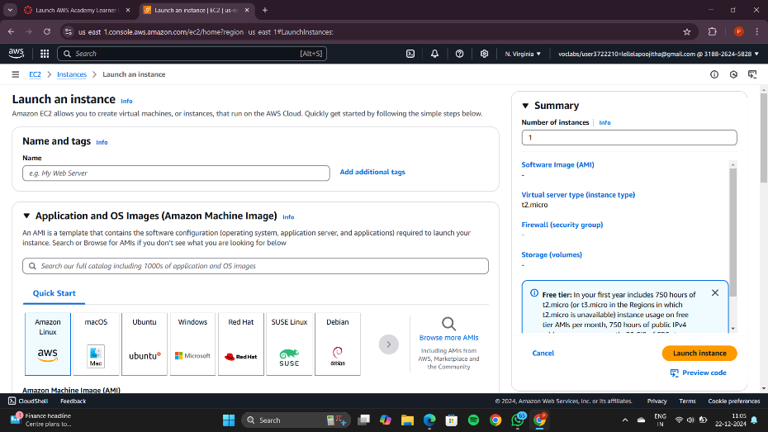

Now, add a name

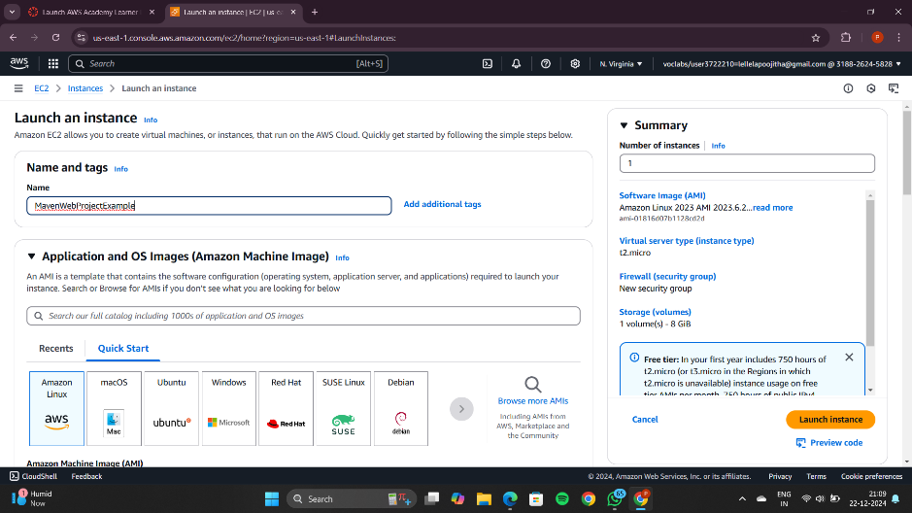

In the application and OS Images section, select ubuntu

And the Amazon Machine Image should be as it is

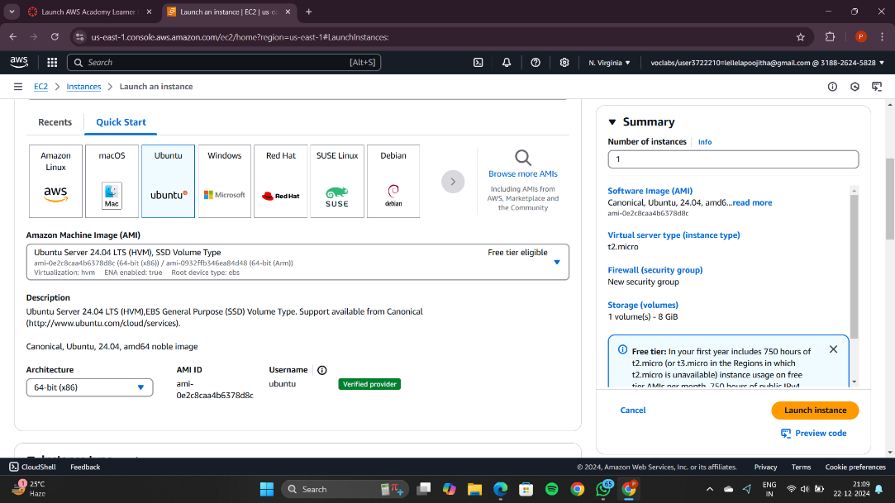

Now create a new key pair

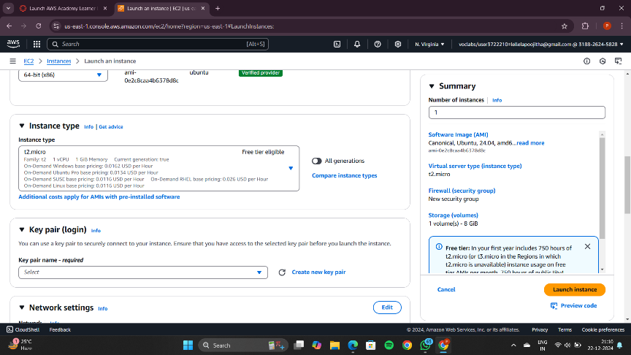

Give any name to the key pair and click on Create Key Pair

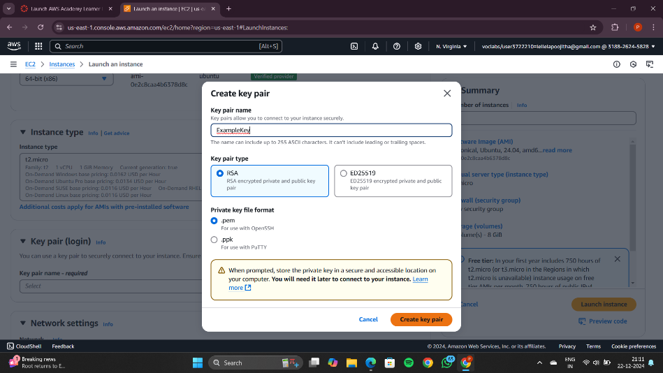

Move the downloaded .pem file to a new folder

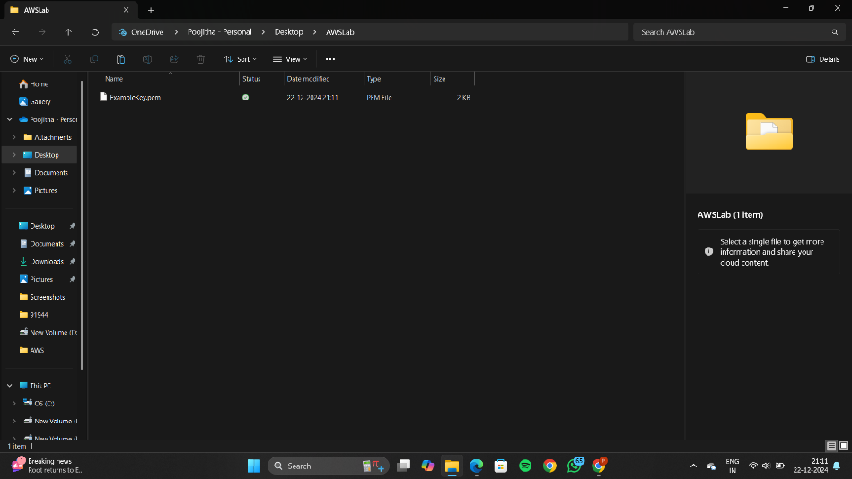

Make sure that the all the boxes should be checked under Network Settings

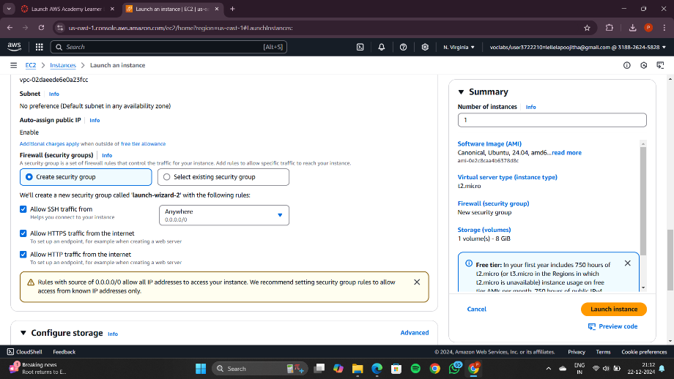

Now click the Launch Instance button present on bottom right corner

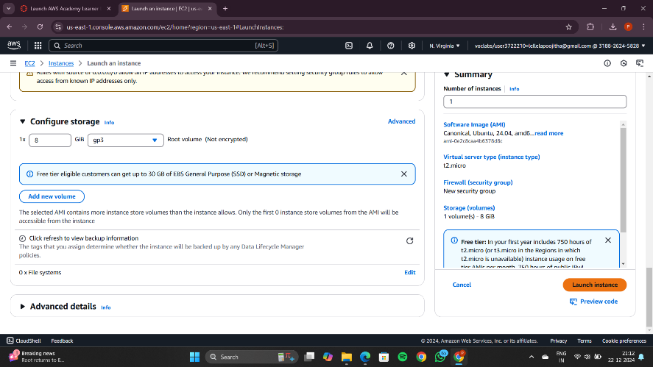

Wait until it turns green indicating the instance has launched

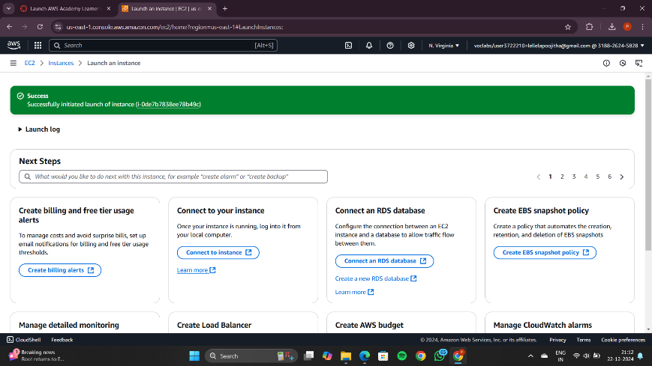

Now click on instances

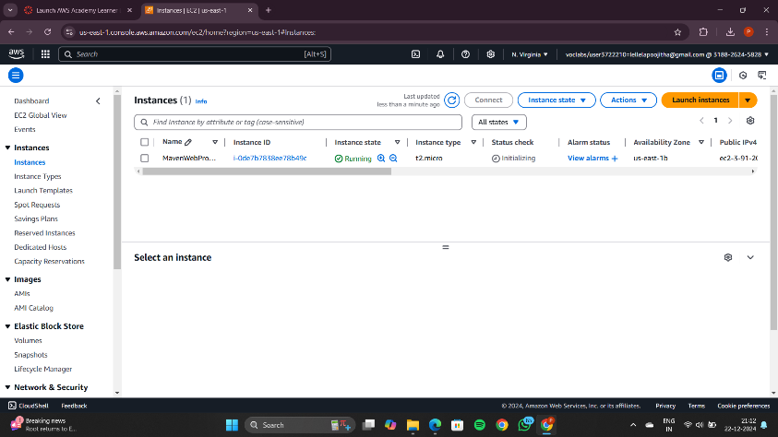

After 2 Minutes it should indicate the following message turning green

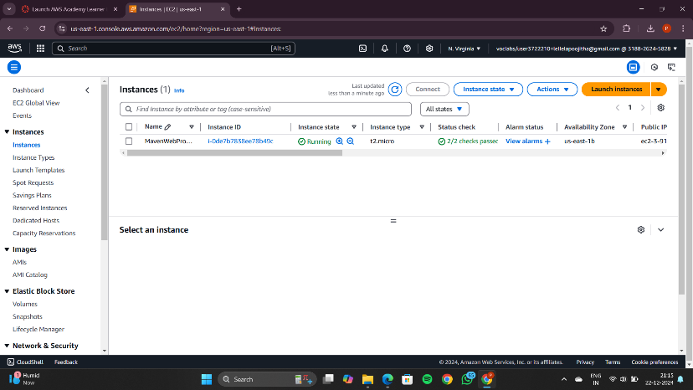

Click on the Instance MavenWebProjectExample and click on Connect

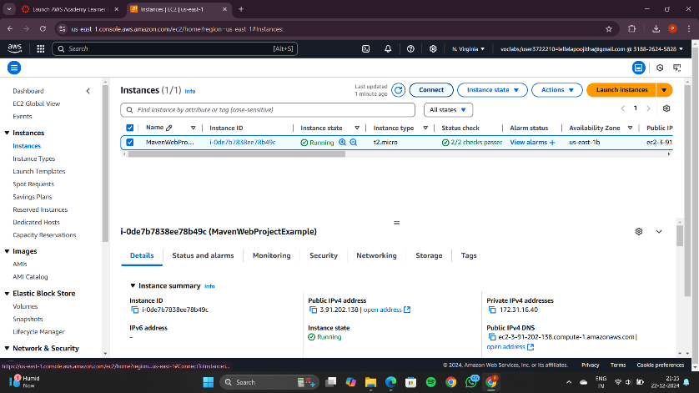

You will be redicted to the following page

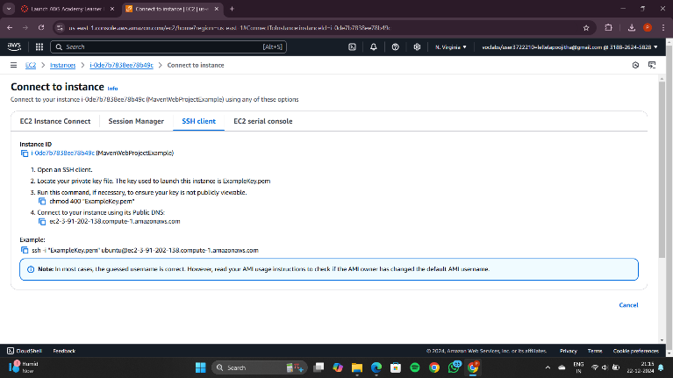

Open command prompt in administrator mode and move the directory where you have saved the .pem file

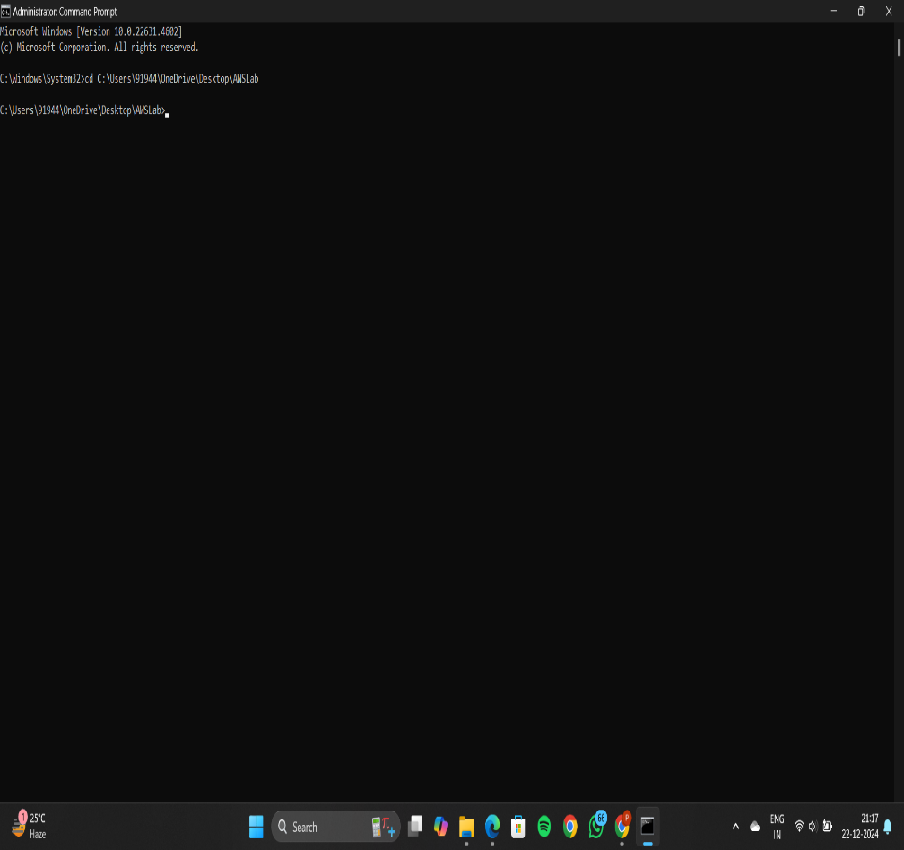

Copy the example command below

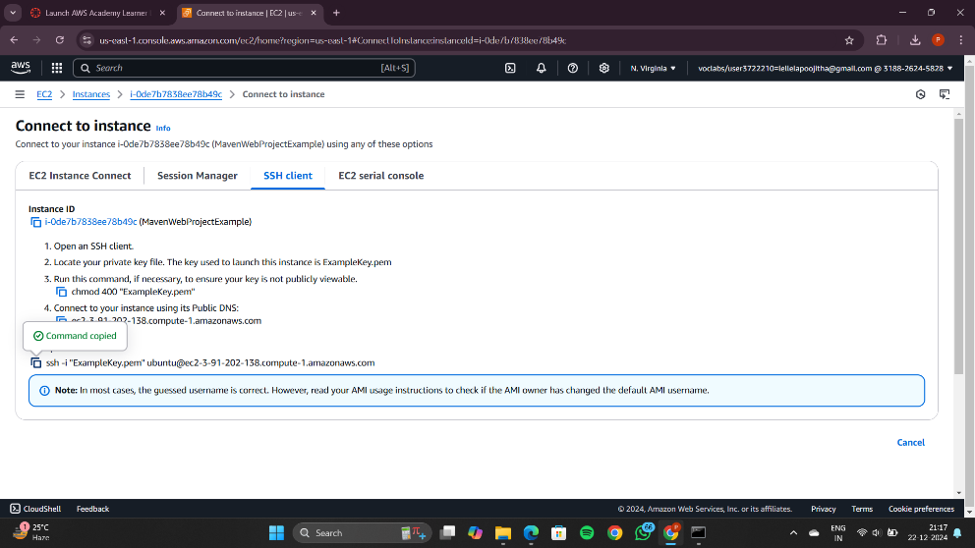

Paste the example command copied from the AWS instance

Type Yes to establish the connection

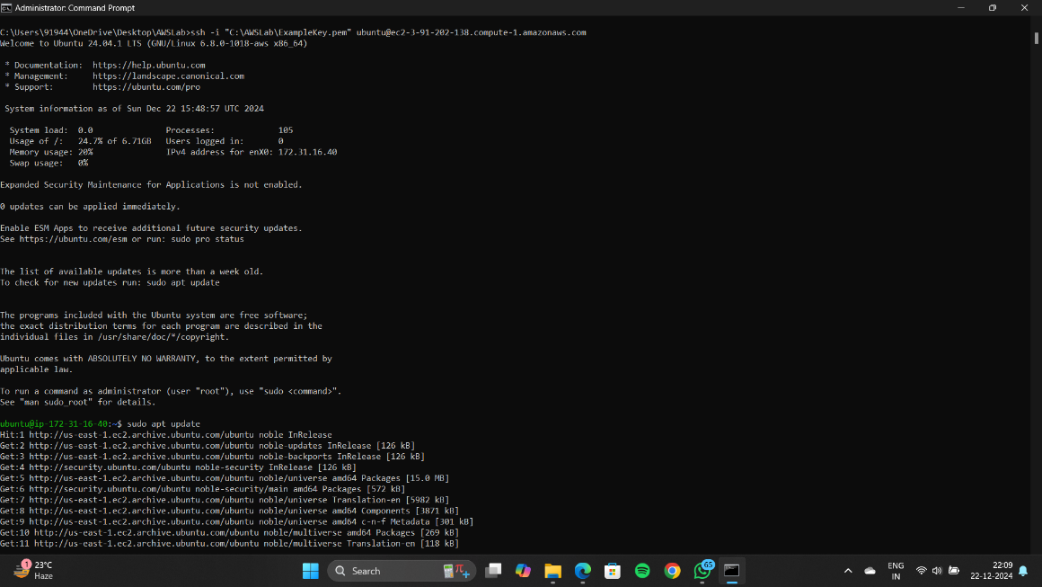

Update Ubuntu using the highlighted command: sudo apt update

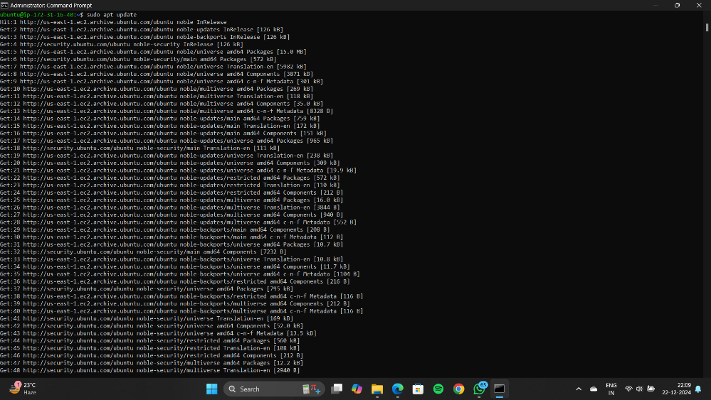

After updating Ubuntu install Docker using the command:   
sudo apt-get install docker.io  
Click Y to continue

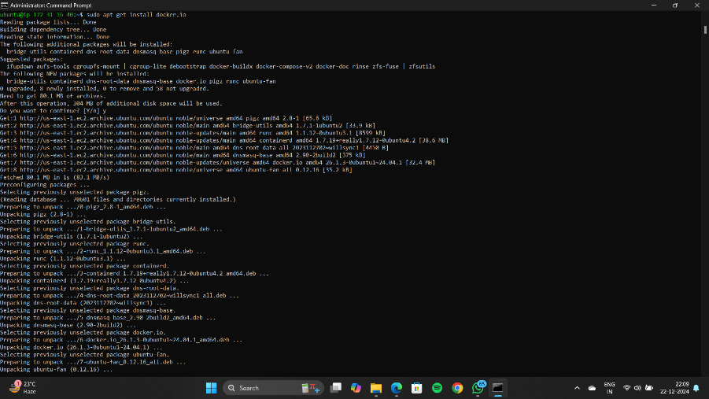

Install git using the following command:  
sudo apt install git

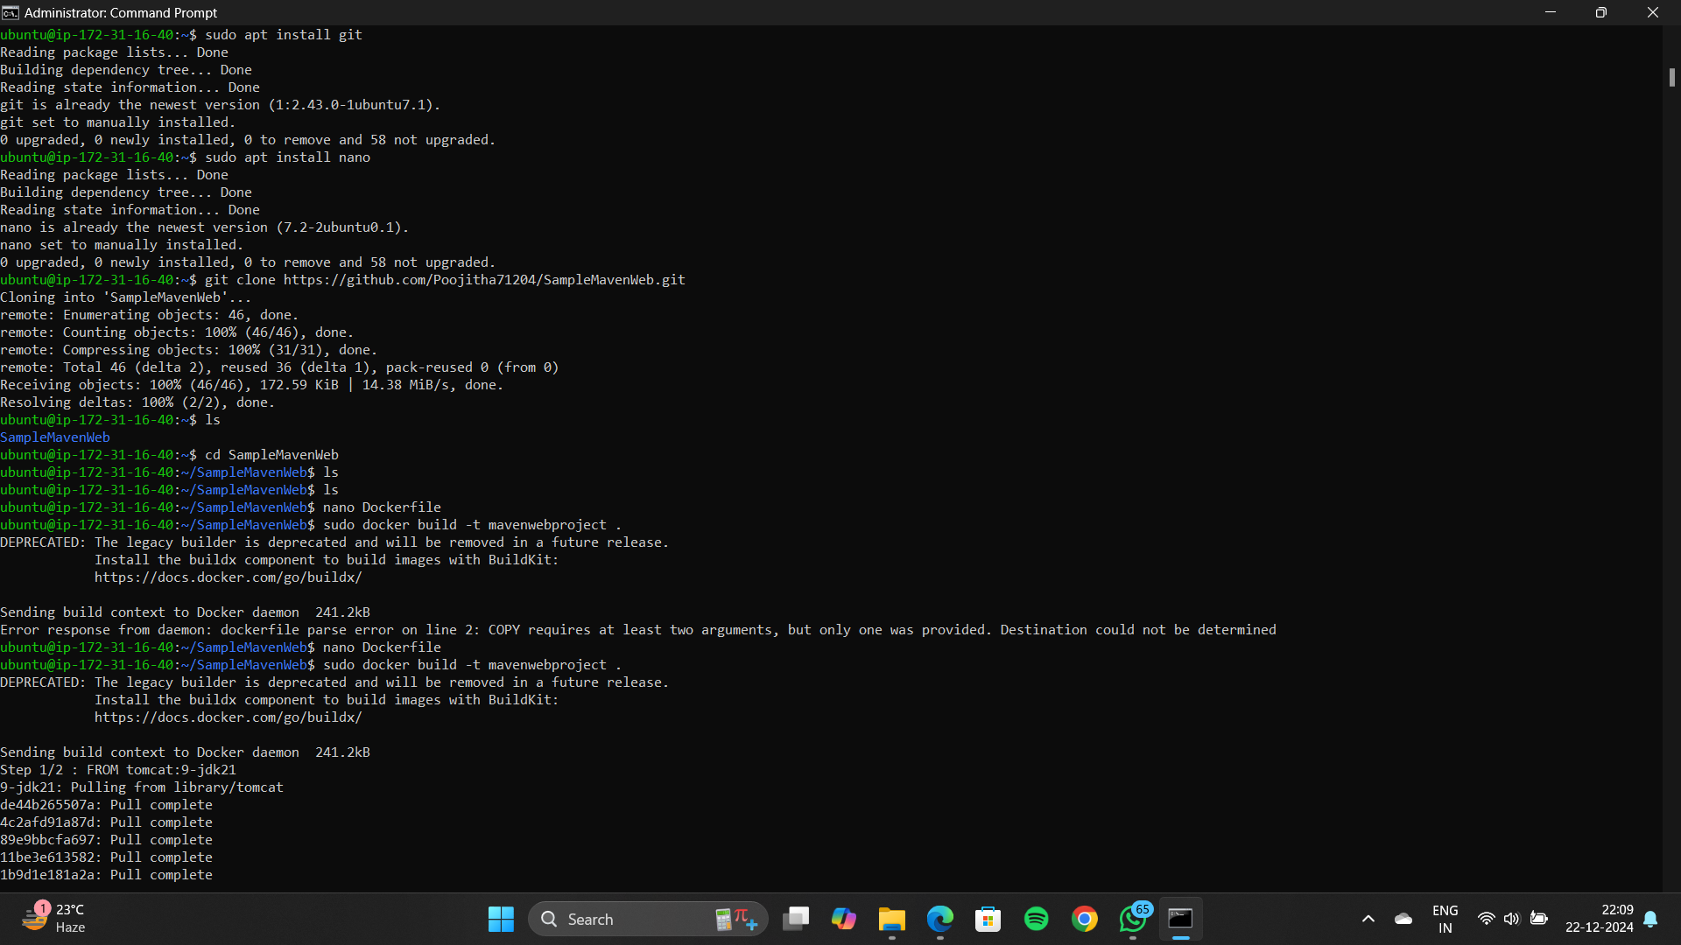

Now install nano editor using the command:  
sudo apt install nano



Go to the git hub dashboard where sample maven web project is created before

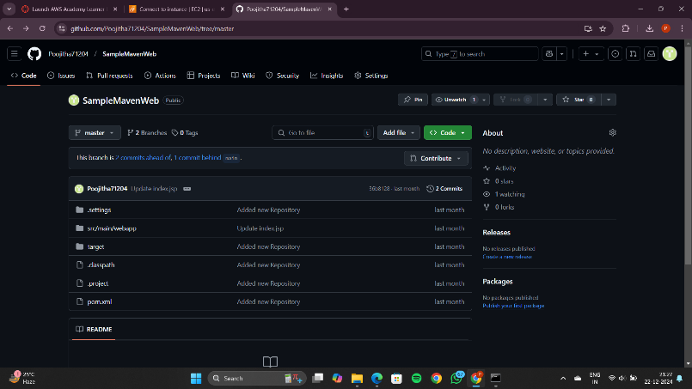

Make sure that the target folder contains .war file

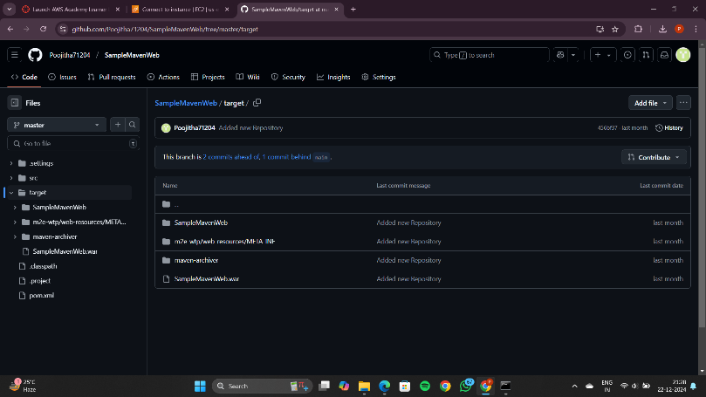

Copy the url from the git hub and paste it in the command prompt

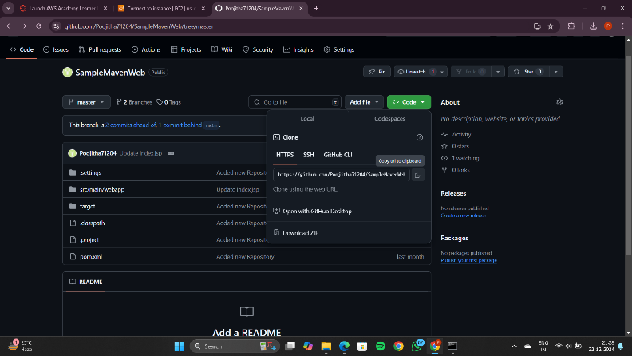

Type ls It should give the repository name

Go to the directory where the repository is present



Create a file Dockerfile



Press ctrl+o , Enter , ctrl+s ,ctrl+x to exit form the below file

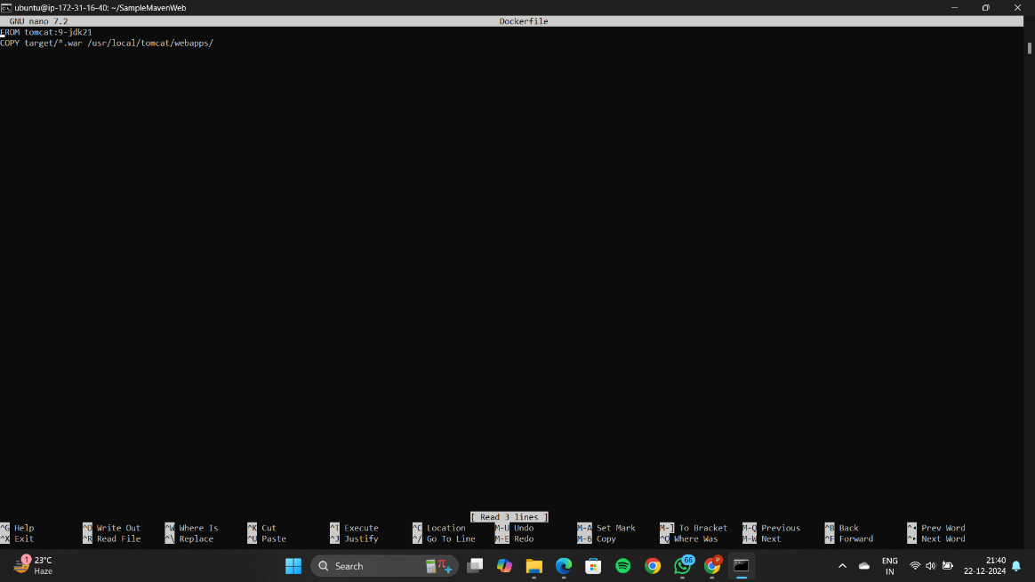

To build the project type the command : sudo docker build -t mavenwebproject .

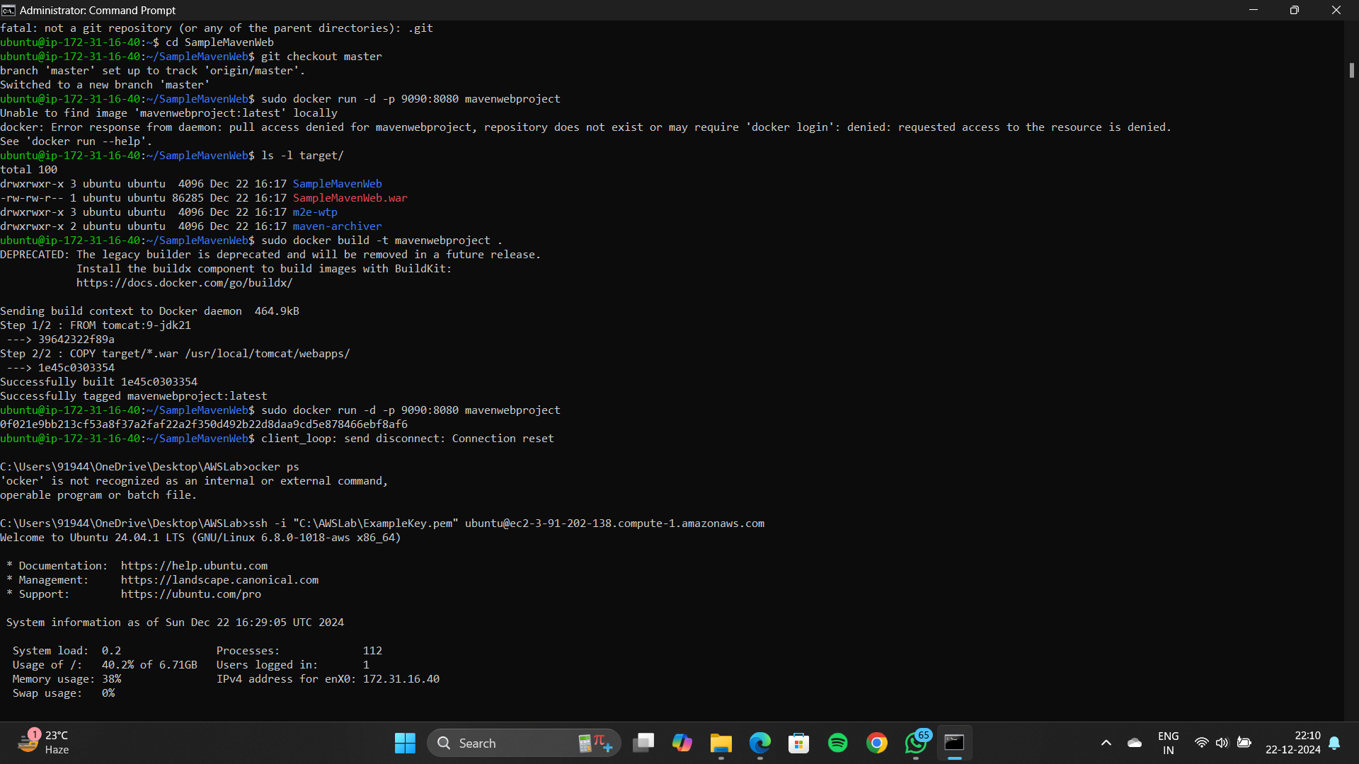

To visit the project in a browser type the following command

sudo docker run -d -p 9090:8080 mavenwebproject



Go to the instances page and copy the ipv4 address

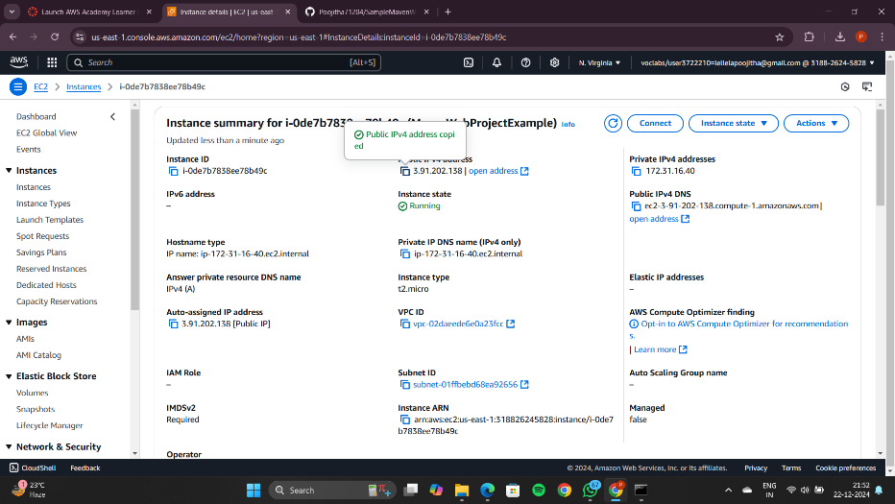

Open a new tab and type the copies address along with :9090/SampleMavenWeb

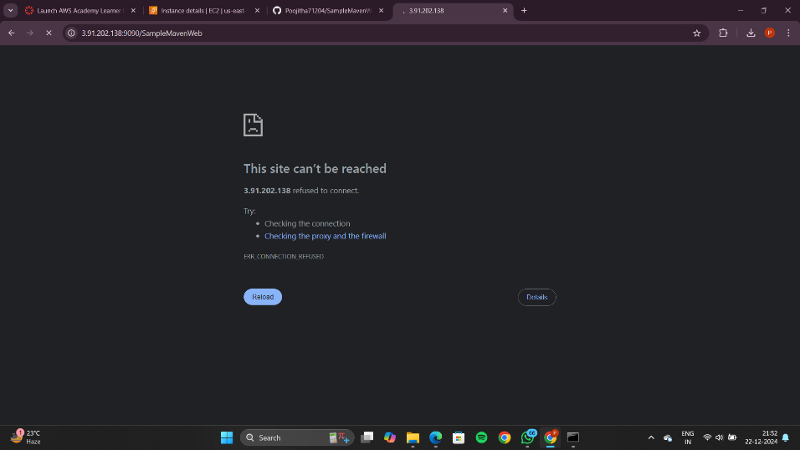

If this is giving a error go to the instances , scroll down for security button

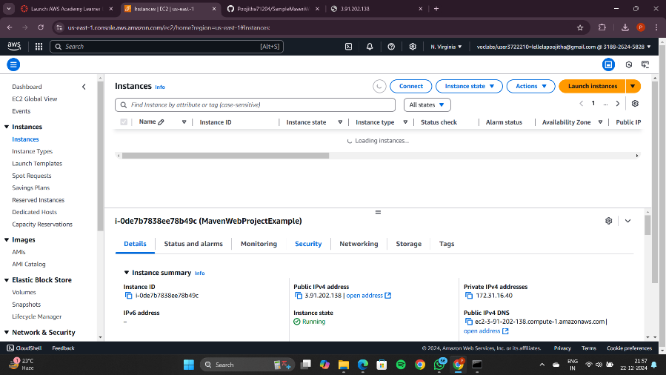

Scroll down and check if the prot 9090 is present in the inbound rules

If it is not present, add the port manually

Check for security groups and click the below link

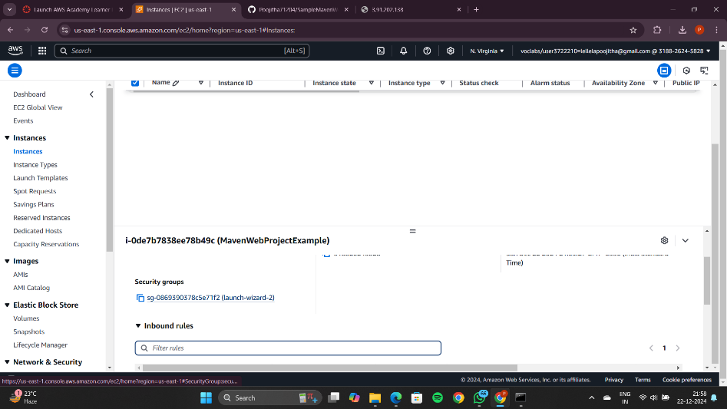

Click on add rule

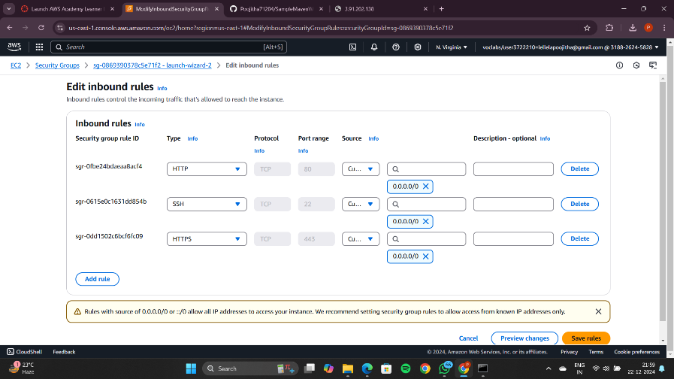

Add 9090 port number and select 0.0.0.0/0

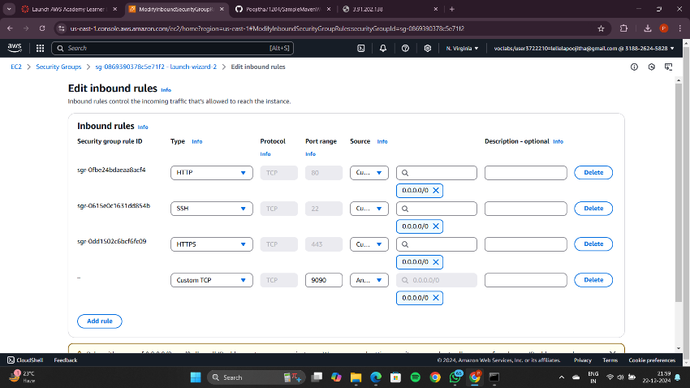

Click on save rules button present in the bottom right corner

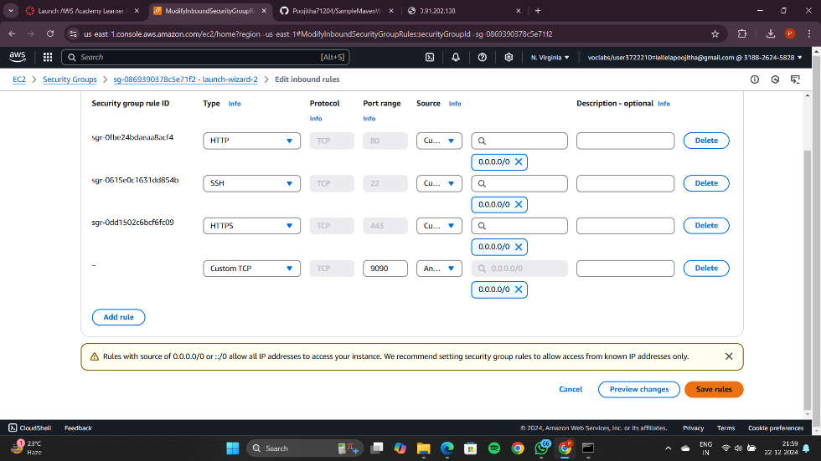

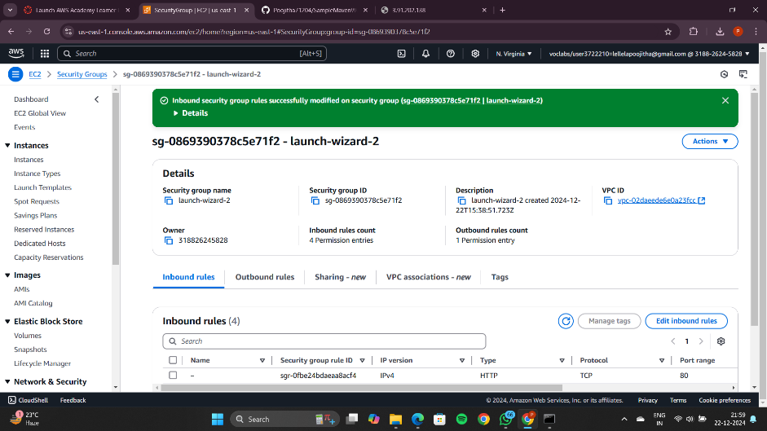

Now you can see port 9090 in the inbound rules

You can now refresh the page where you have entered the ipv4 address

You can see the message which you have created in the maven web project

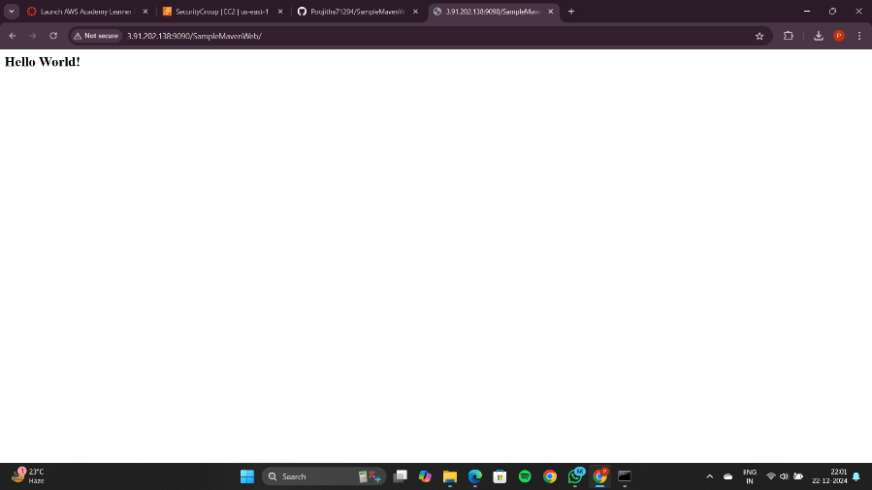

Now go to instances page and click on instance state and select terminate instance

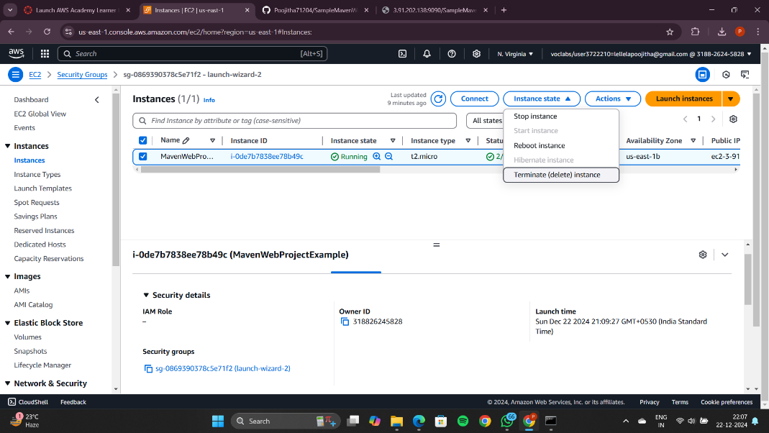

Click on terminate(delete)

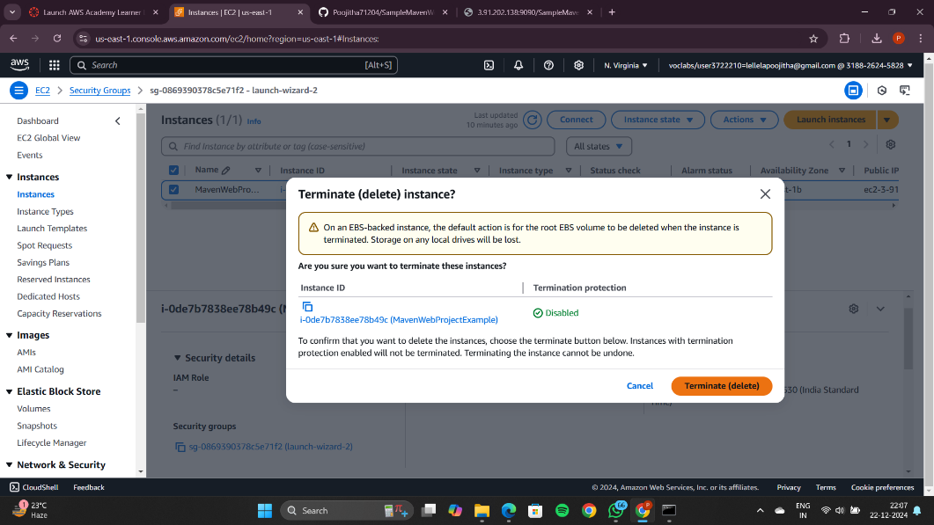

Wait until the message turns to terminated

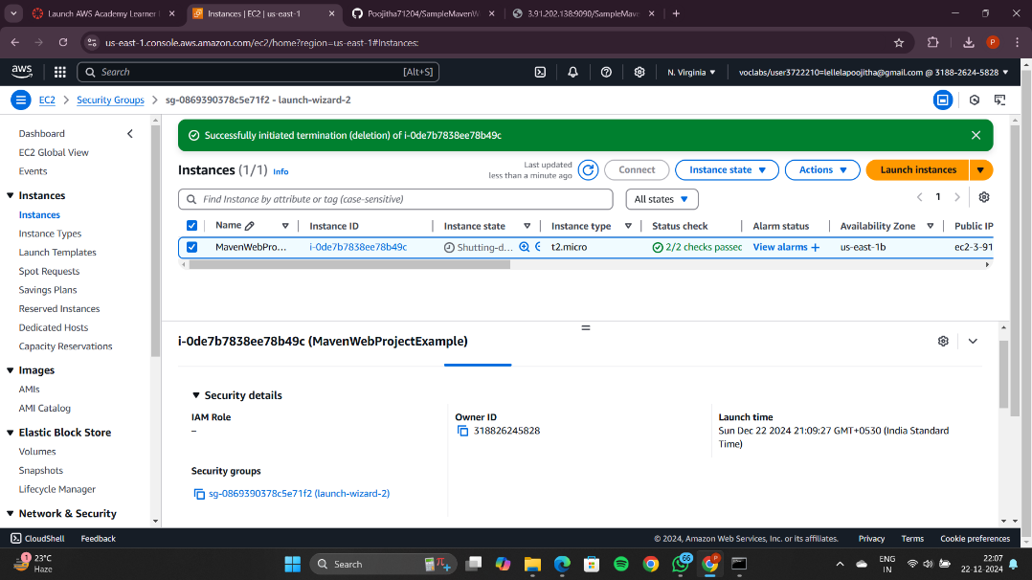

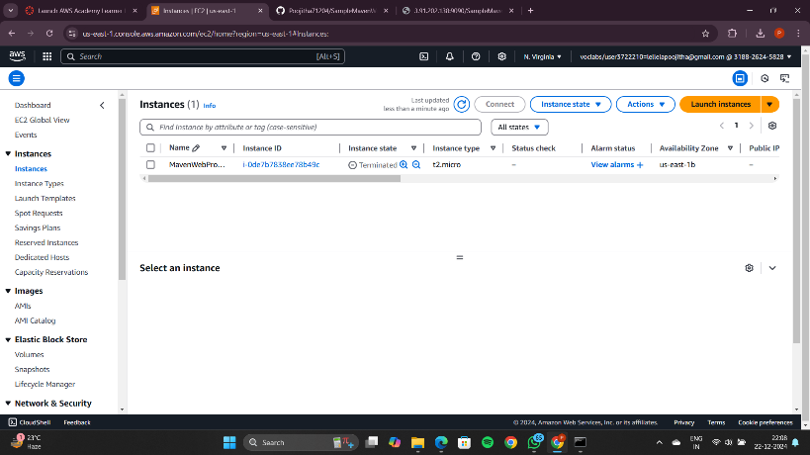

Now go to AWS lab click on end lab, click yes

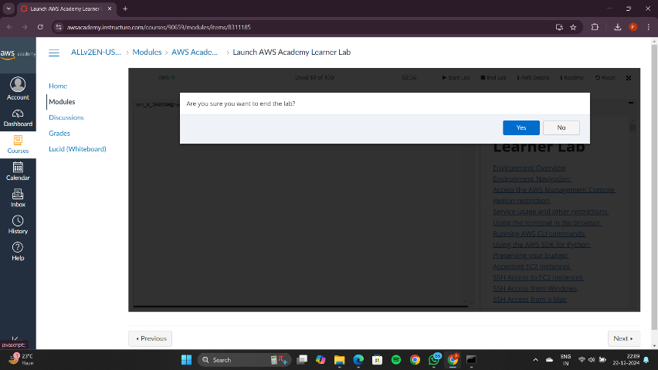

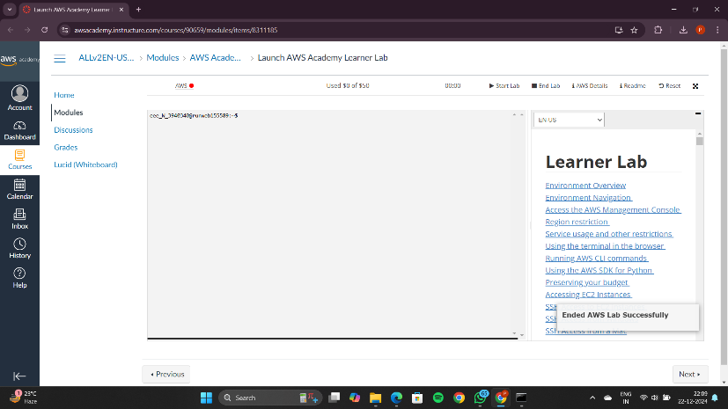

Docker ps

sudo docker stop

exit

